

***Customer Churn Analysis***

***In association with Data Trained Academy Batch: 1843***

End-To-End machine learning project in Data Science for beginners*.*

I am going to write about a complete end-to-end project for Customer Churn Analysis which should serve as a guiding path for many Data Science aspirants.

I have written down all the techniques in the form of sub-topics that I will be explaining one by one. And those sub-topics are as follows:  
  
1.      Problem Definition.  
2.      Data Analysis.  
3.      EDA Concluding Remark.  
4.      Pre-Processing Pipeline. 5.      Building Machine Learning Models.  
6.      Concluding Remarks.

Let’s start with the problem definition

**Introduction:**

Customer Churn is one of the most important and challenging problems for businesses such as Credit Card companies, cable service providers, SASS and telecommunication companies worldwide. Even though it is not the most funto look at, customer churn metrics can help businesses improve customer retention.

Thanks to Data Science and Machine Learning, which has been very useful in many industries that have managed to bring accuracy or detect negative incidents. Here in this blog, I have created a Machine Learning model to comparing several customer churn prediction models

Here various features have been used like InternetServic,OnlineSecurity,DeviceProtection,

TechSupport,StreamingTV,StreamingMovies,PaperlessBilling,PaymentMethod,MonthlyCharges,TotalCharges.In total the dataset has 21 columns and 7043 entries rows of data are present. Using all these previously acquired information and analysis done with the data I have achieved a good model that has 87.41 % accuracy Let’s see what are the steps involved to attain this accuracy.

Various visualization techniques have also been used to understand the Correlation, Multicollinearity and importance of the features with respect to the algorithms

**Hardware & Software Requirements & Tools Used:**

### Hardware used:

* Processor: Core i5 -10300H CPU @ 2.50GHz
* RAM: 8 GB
* Operating System: 64-bit
* ROM/SSD: 512 TB SSD
* Graphics: NVIDIA GeForce GTX 1650 Ti

**Software requirement**:

* Anaconda Navigator - Jupyter Notebook

**Libraries Used**:

* Numpy
* Pandas
* Matplotlib
* Seaborn
* Scipy
* Date Time
* Scikit Learn

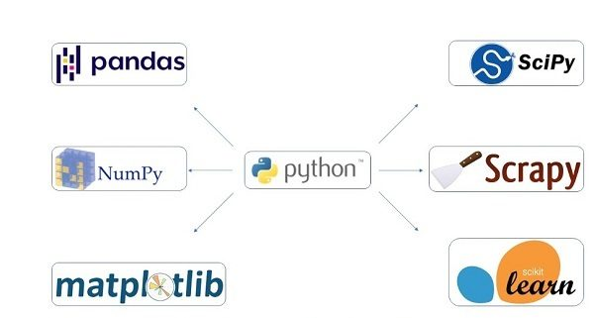

**1.Problem Statement:**

Customer churn is when a company’s customers stop doing business with that company. Businesses are very keen on measuring churn because keeping an existing customer is far less expensive than acquiring a new customer. New business involves working leads through a sales funnel, using marketing and sales budgets to gain additional customers. Existing customers will often have a higher volume of service consumption and can generate additional customer referrals.

Customer retention can be achieved with good customer service and products. But the most effective way for a company to prevent attrition of customers is to truly know them. The vast volumes of data collected about customers can be used to build churn prediction models. Knowing who is most likely to defect means that a company can prioritise focused marketing efforts on that subset of their customer base.

**2.** Data Analysis :

Data analysis is defined as a process of cleaning, transforming, and modeling data to discover useful information for business decision-making. The purpose of Data Analysis is to extract useful information from data and taking the decision based upon the data analysis.

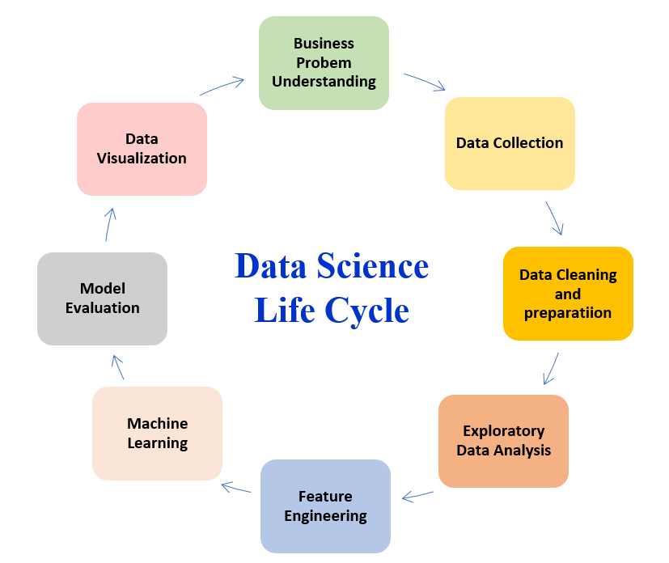

***lifecycle of a Machine Learning***

***Importing the necessary Libraries:***

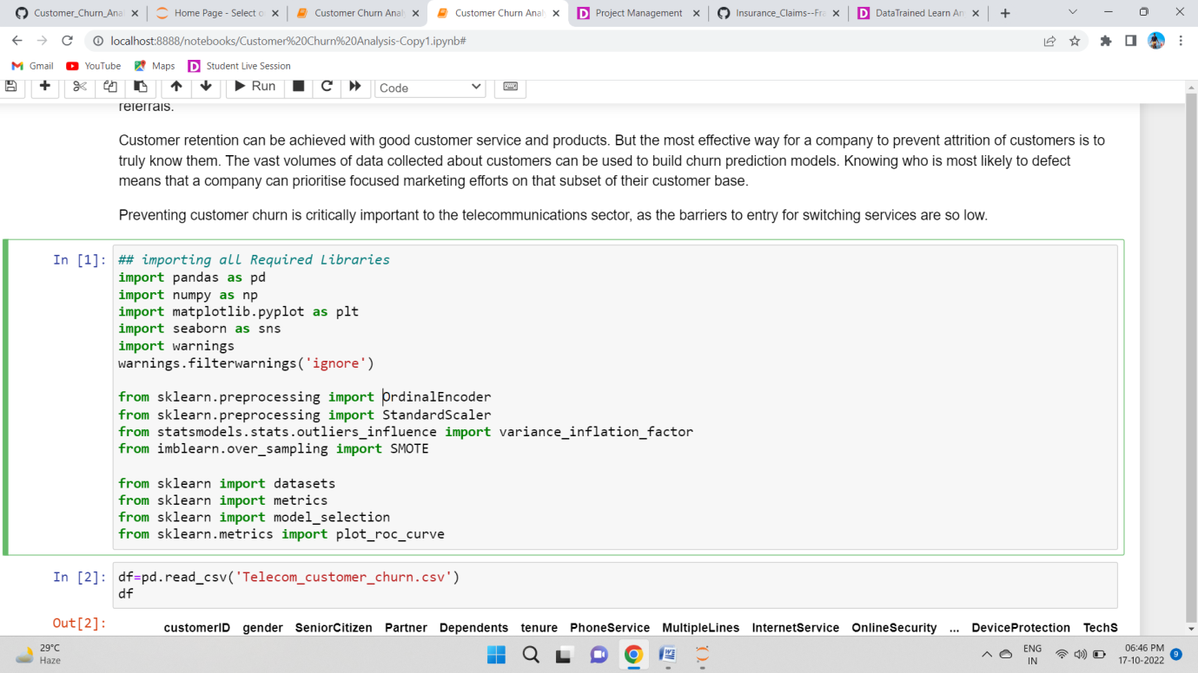

**Importing the Dataset**

Let’s import the dataset first.

Copied the raw data and saved it as a csv file on my local computer after which I imported the entire dataset on this Jupyter Notebook with the help of pandas.

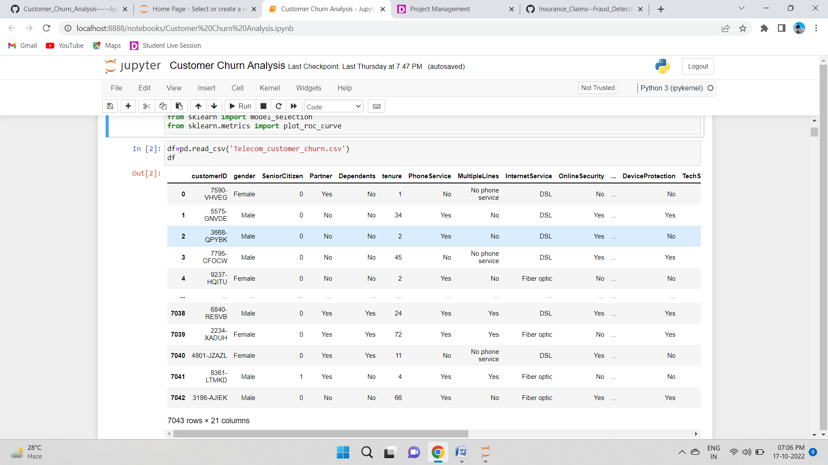

By looking at the dataset we can see that we have categorical as well as numerical data in the dataset.

Our target variable churn is a categorical data hence it will be a classification model

Also we have identified that there is a feature column named customer id, which has no relevance in the prediction. It is just an unique id given to each customer, hence will consider dropping the column

**3.Exploratory Data Analysis (EDA)**

As per the lifecycle of the machine learning model we have already completed points 1 and 2. Now let’s move on to the point 3, 4, 5 and 6 which is the most crucial part of any machine learning model. If we prepare the dataset, analyze it and clean it in the best way possible the better model accuracy we will get, or the model can get over fitted or under fitted. We will discuss further all the steps that are used.

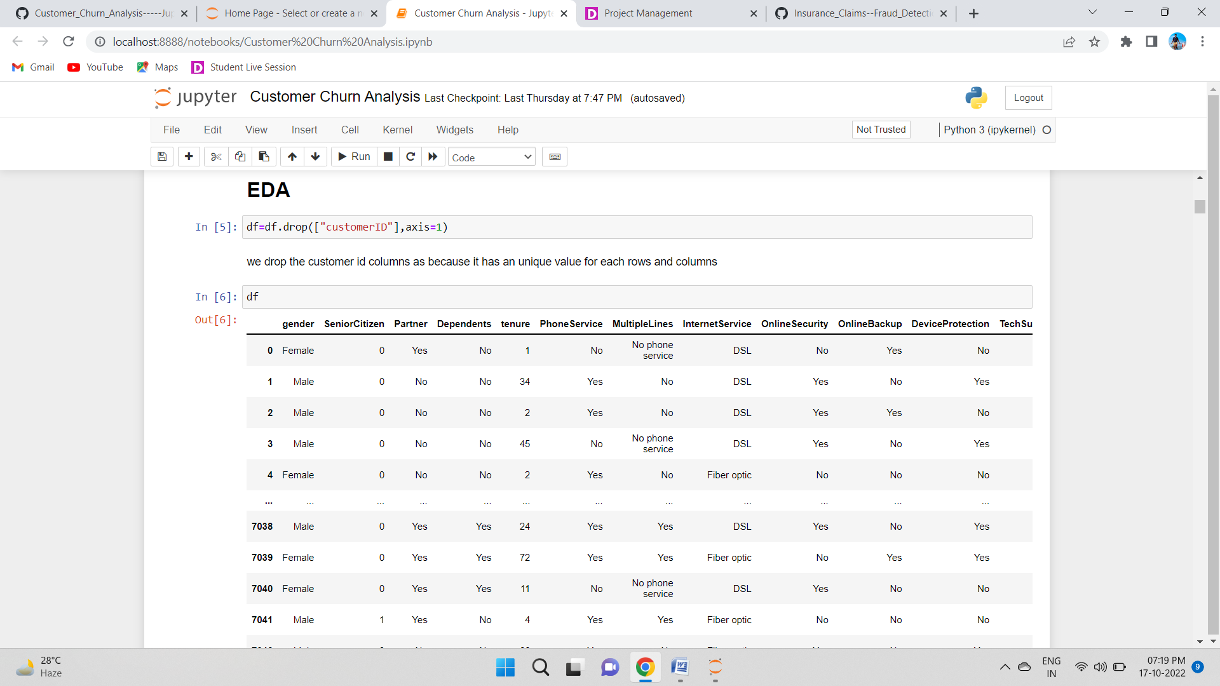

dropping the "customerID" column since it is just an unique id given to each customer

**Data Preparation:**

In this part we will firstly be exploring the data with some basic steps and then further proceed with some crucial analysis, like feature extraction, imputing and encoding.

Let’s start with checking shape, unique values, value counts, info etc.

After doing the analysis if we find any unnecessary columns in the dataset, we can drop those columns.

By using ‘df.shape’ we also figured out how many rows and columns we have. We have got the result that we have 7043 rows and 21 columns. PCA can be done

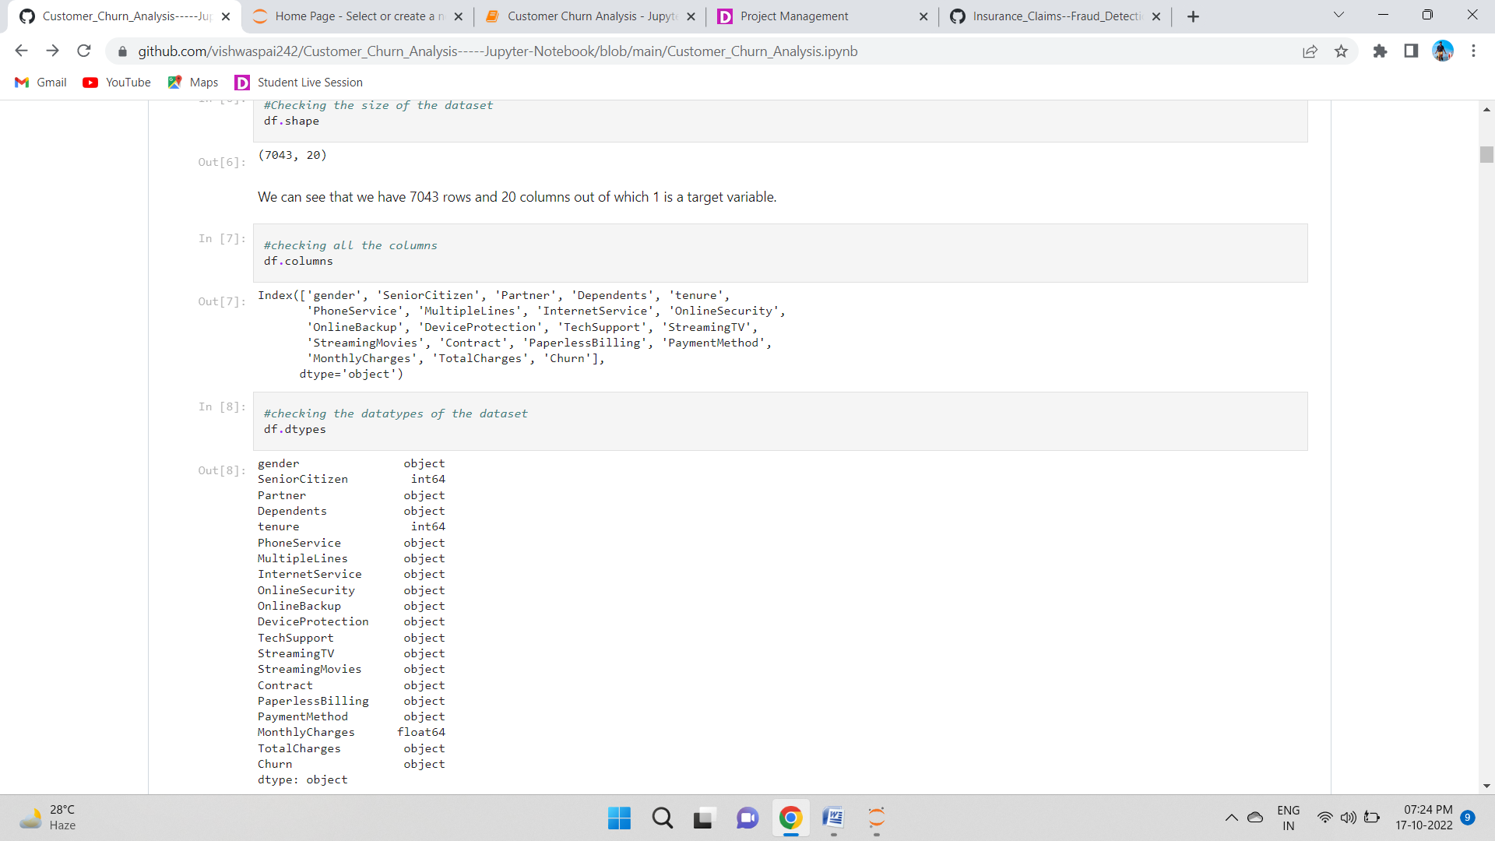

By using ‘df.columns’ all the columns in the dataset are listed as shown above.

The columns are under different categories as follows:

'gender', 'SeniorCitizen', 'Partner', 'Dependents', 'tenure', 'PhoneService', 'MultipleLines', 'InternetService', 'OnlineSecurity','OnlineBackup', 'DeviceProtection', 'TechSupport', 'StreamingTV',

'StreamingMovies', 'Contract', 'PaperlessBilling', 'PaymentMethod', 'MonthlyCharges', 'TotalCharges', 'Churn'

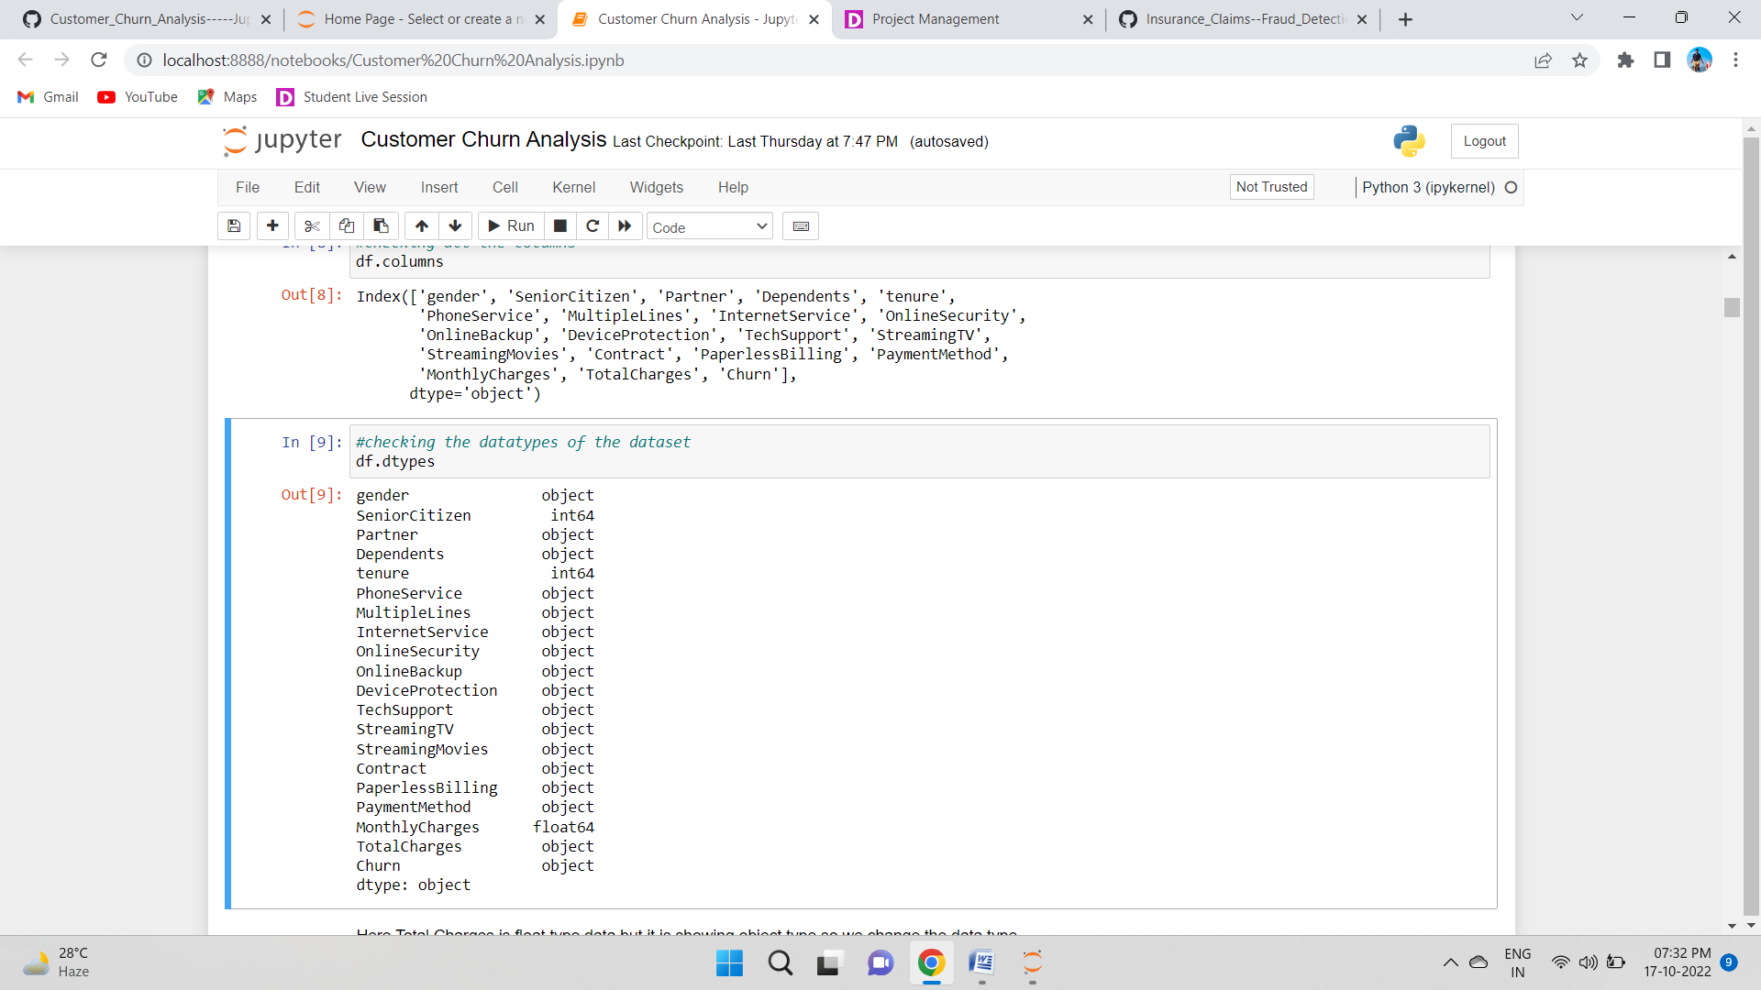

We can see that we have object and float datatypes. TotalCharges is a float type data but it is showing object type lets change the data type.

**Observations:**

* We can see that there are null values in the dataset.
* The dataset contains 3 different types of data namely integer data type, float data type and object data type.
* **Feature Extraction:**

The TotalCharges columns is in object data type that’s why we change this columns to numerical value

The object datatypes will be encoded later

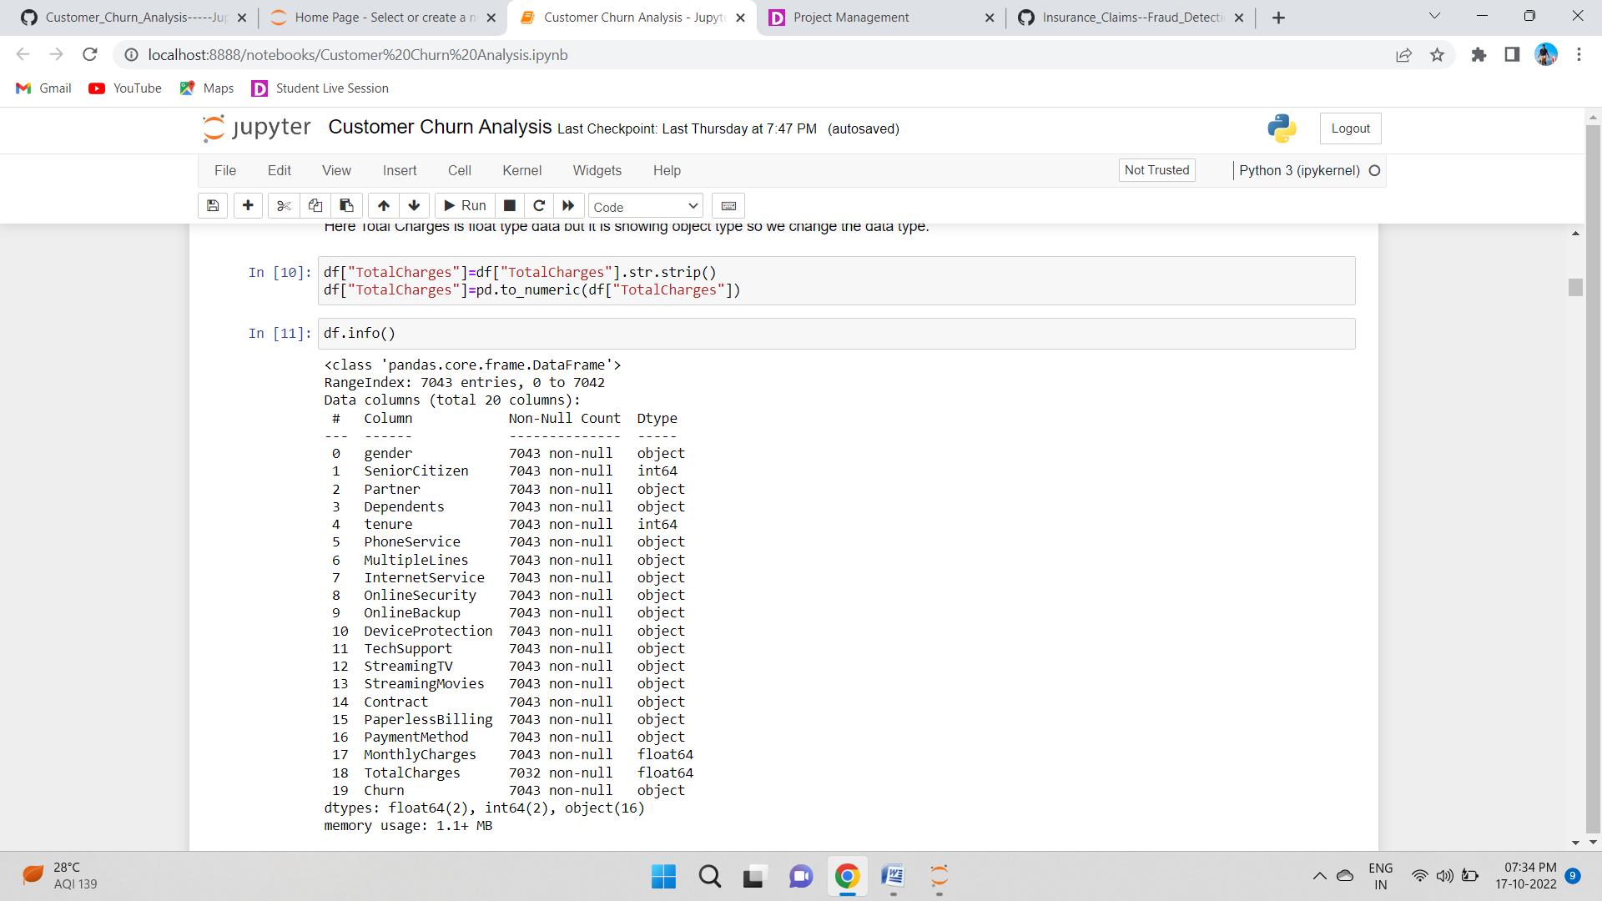

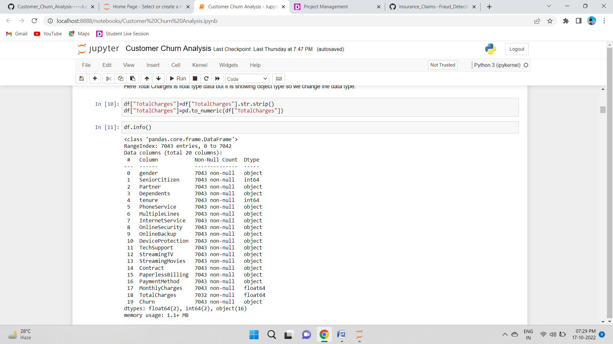

This gives the information about the dataset which includes indexing type, column Name, non-null values, dtypes and memory usage of the dataset.

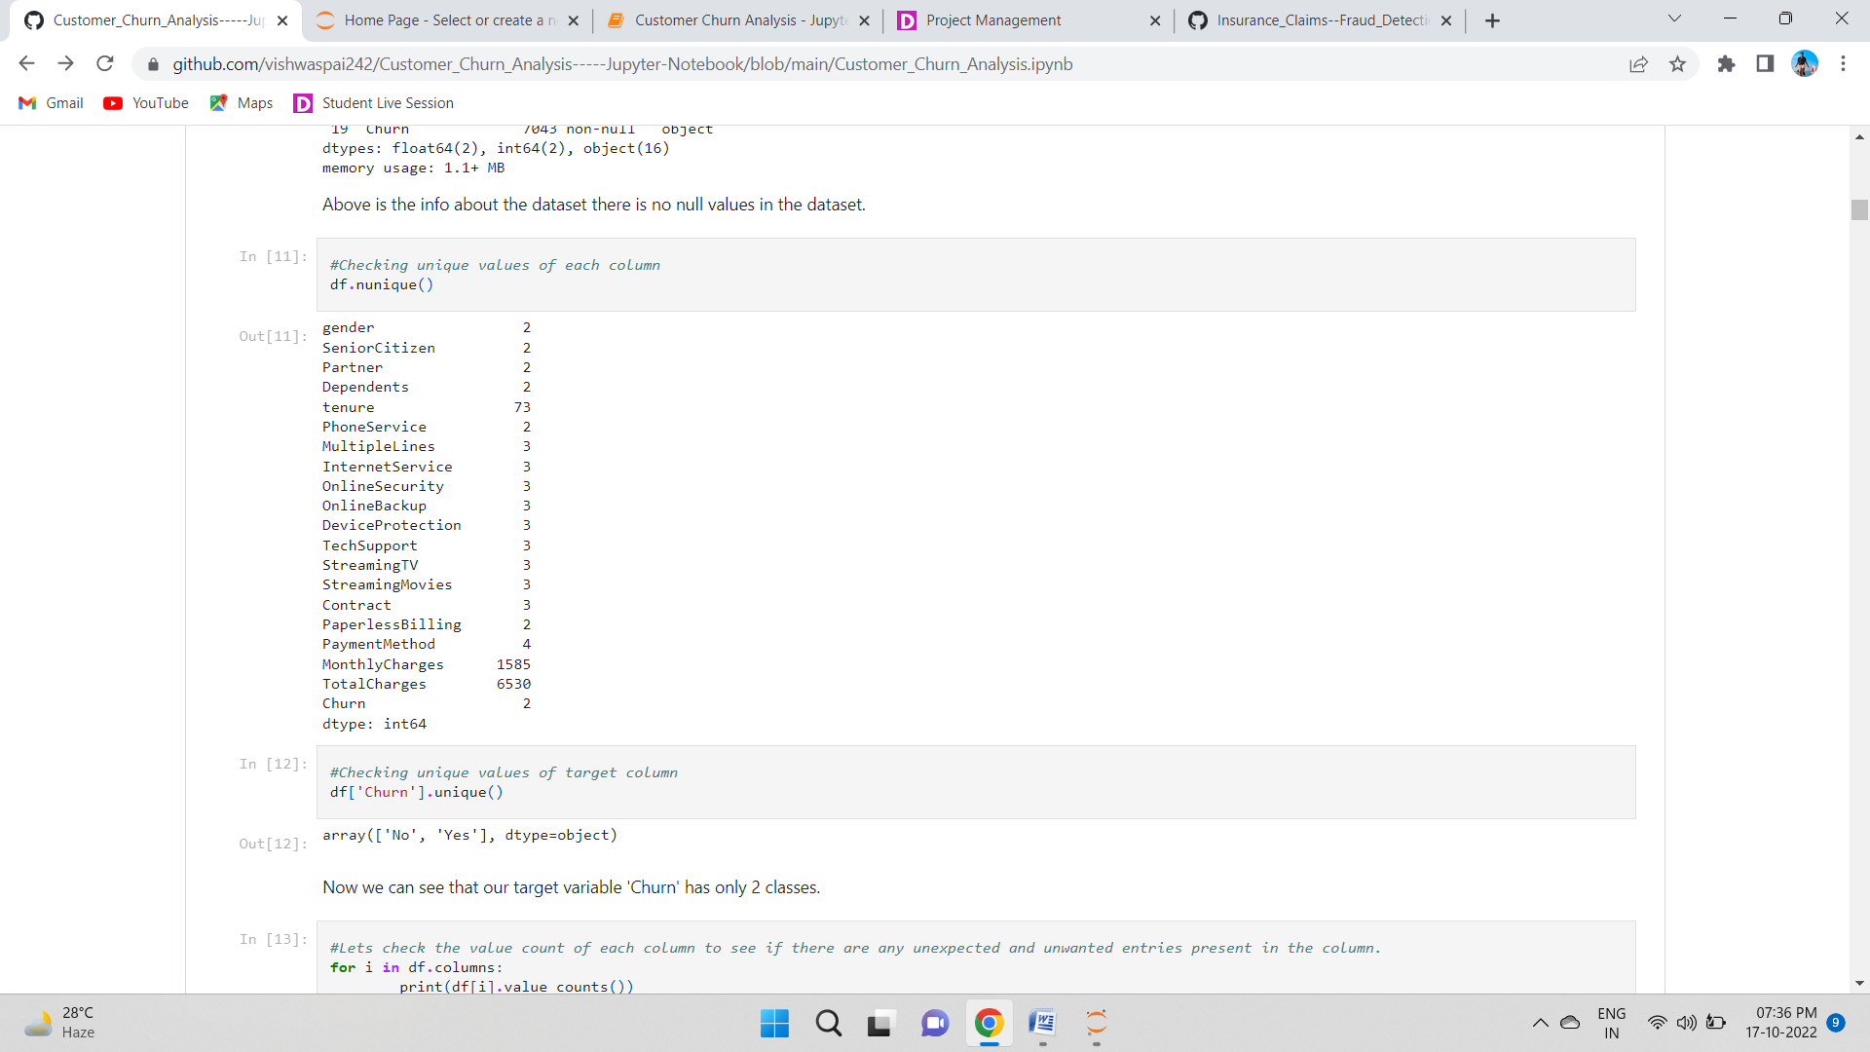

Here we use’ df.nunique’Checking unique values of each column



Using the df.nunique method wee checking the unique Value for our Target Column ’Churn’ and we can see that our target variable 'Churn' has only 2 classes.

**Lets check the value count of each column to see if there are any unexpected and unwanted entries present in the column.**

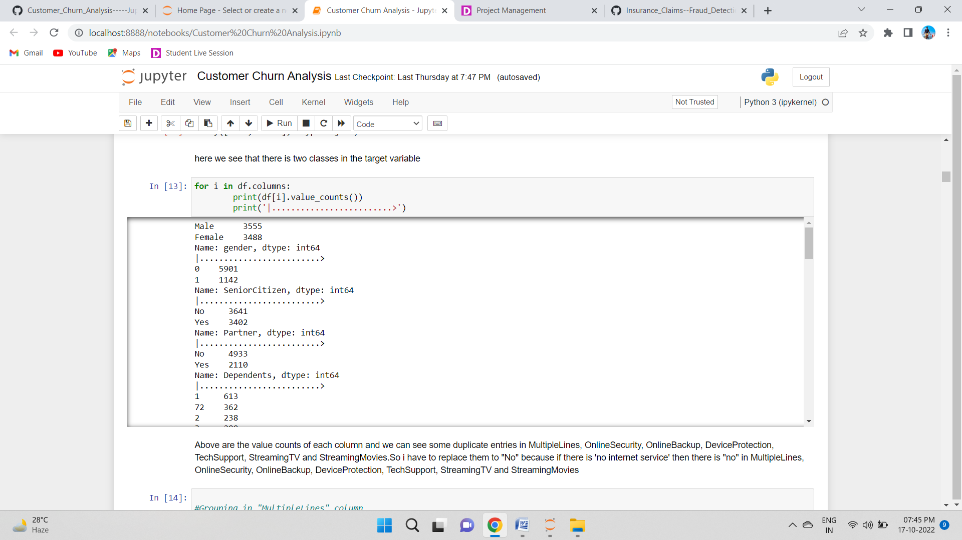

Using the value_count() method we can see the value counts of each column and we can see some duplicate entries in MultipleLines, OnlineSecurity, OnlineBackup, DeviceProtection, TechSupport, StreamingTV and StreamingMovies.So i have to replace them.

Lets go with "No" for "No internet Service".If "no internet service" then there is "no" in MultipleLines, OnlineSecurity, OnlineBackup, DeviceProtection, TechSupport, StreamingTV and StreamingMovies.So lets replace all these entries with 'No'.

**Grouping entries of MultipleLines, OnlineSecurity, OnlineBackup, DeviceProtection, TechSupport, StreamingTV and StreamingMovies column**

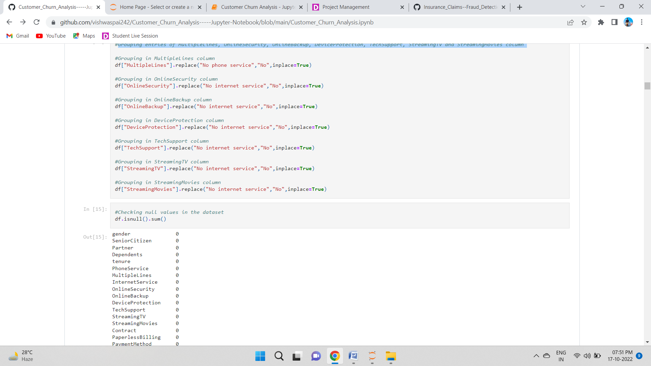

**Using df.replace method we replace all these entries with 'No'.**

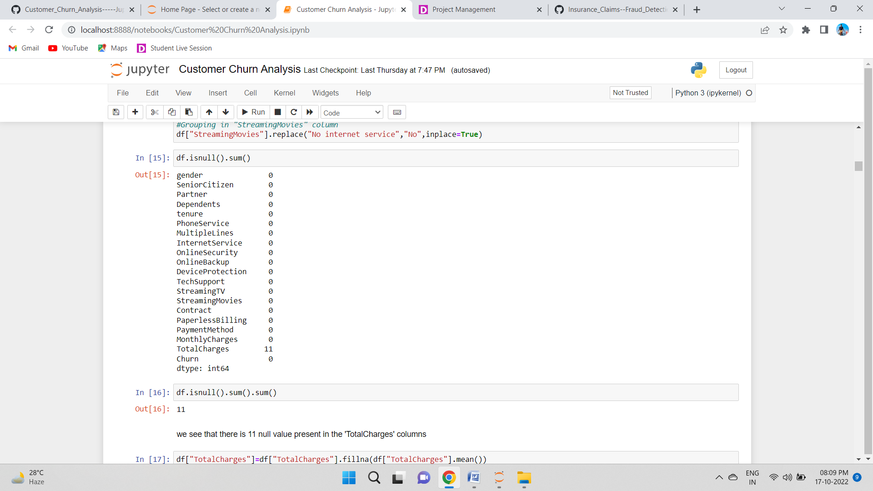

**We can see there are 11 null values in the 'Total Charges' feature.**

## Treating Null Values

*Replacing nan values of TotalCharges column with it's mean*

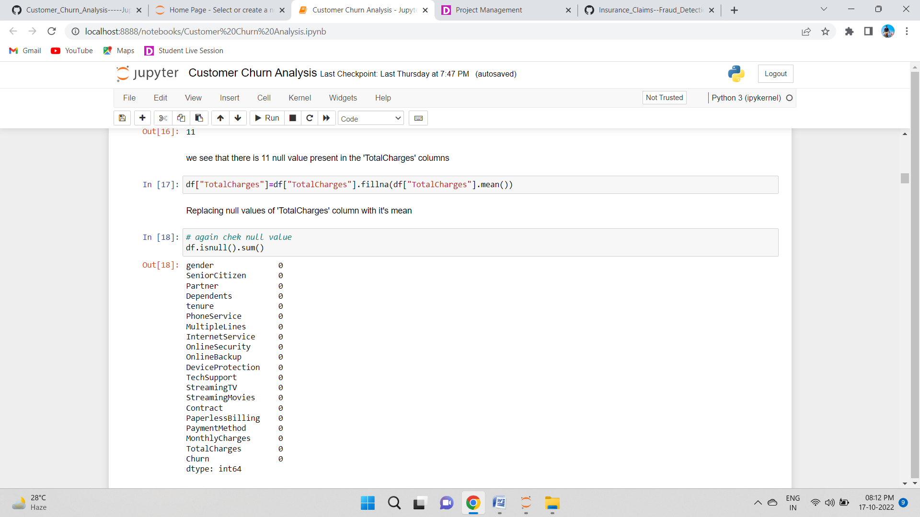

Let’s chek is there any null value present in our data set

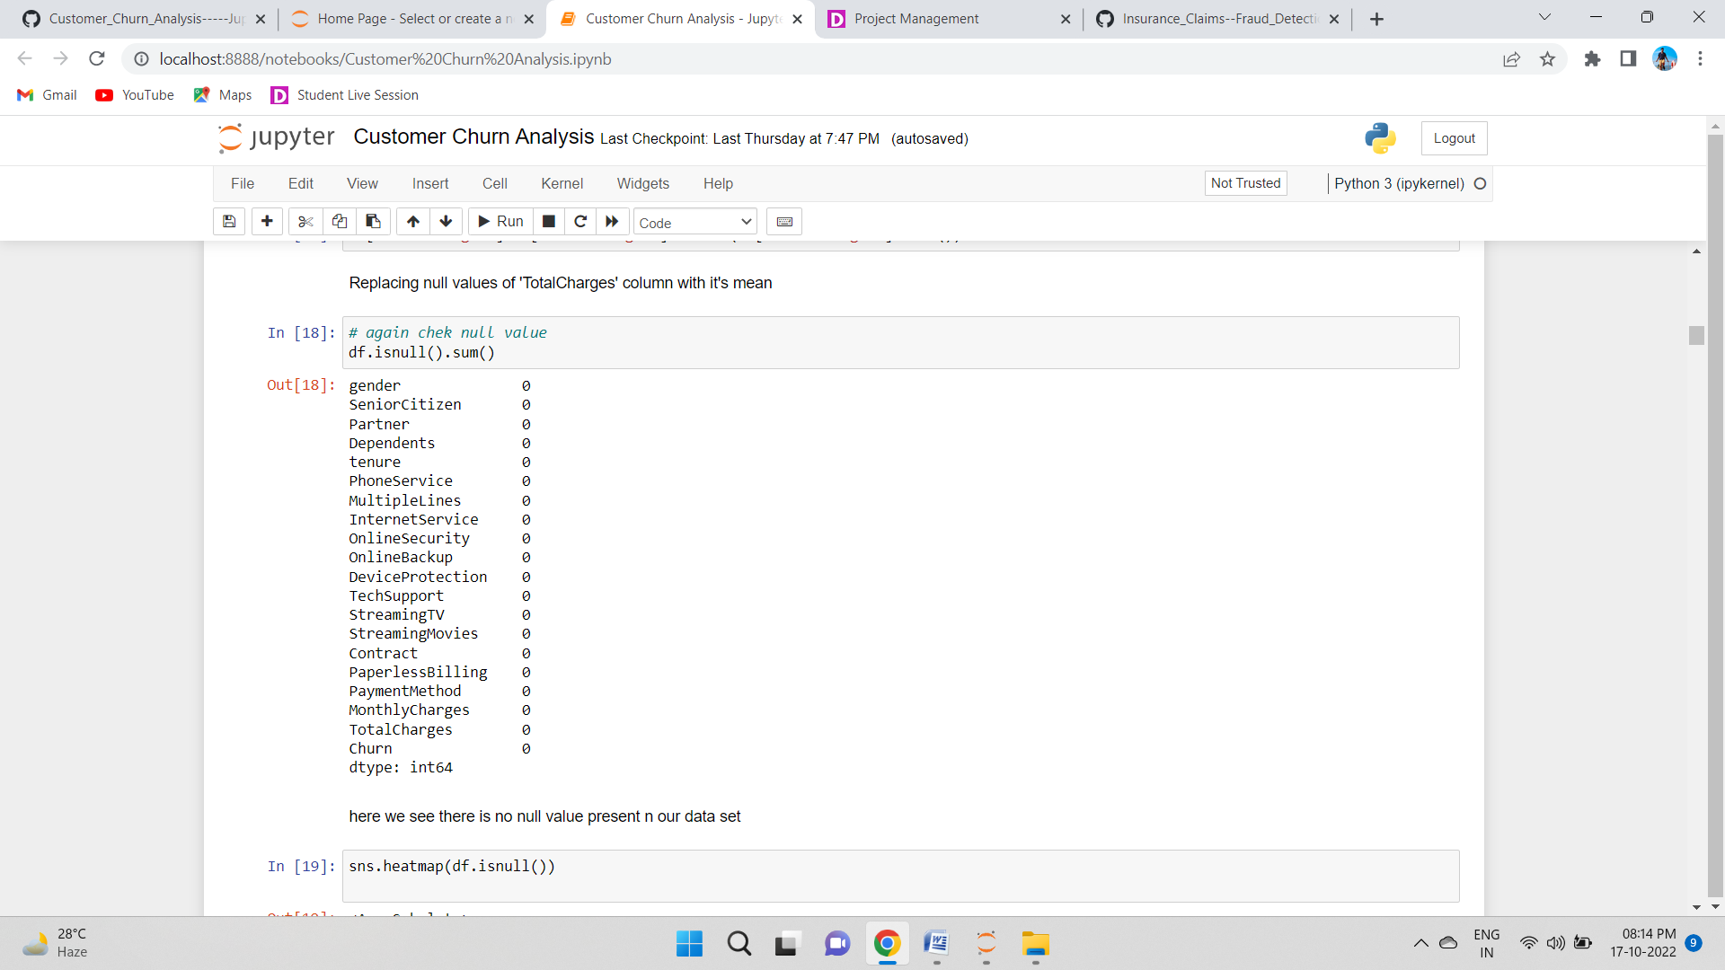

Lets check The Null Value using heatmap using this code

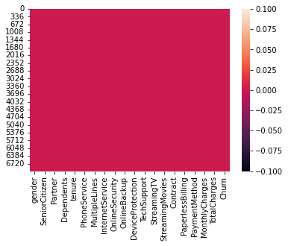

Now we can clearly see that we have no null values in the dataset

Now We go to our next Phase

## *Statistical Summary of the Dataset*

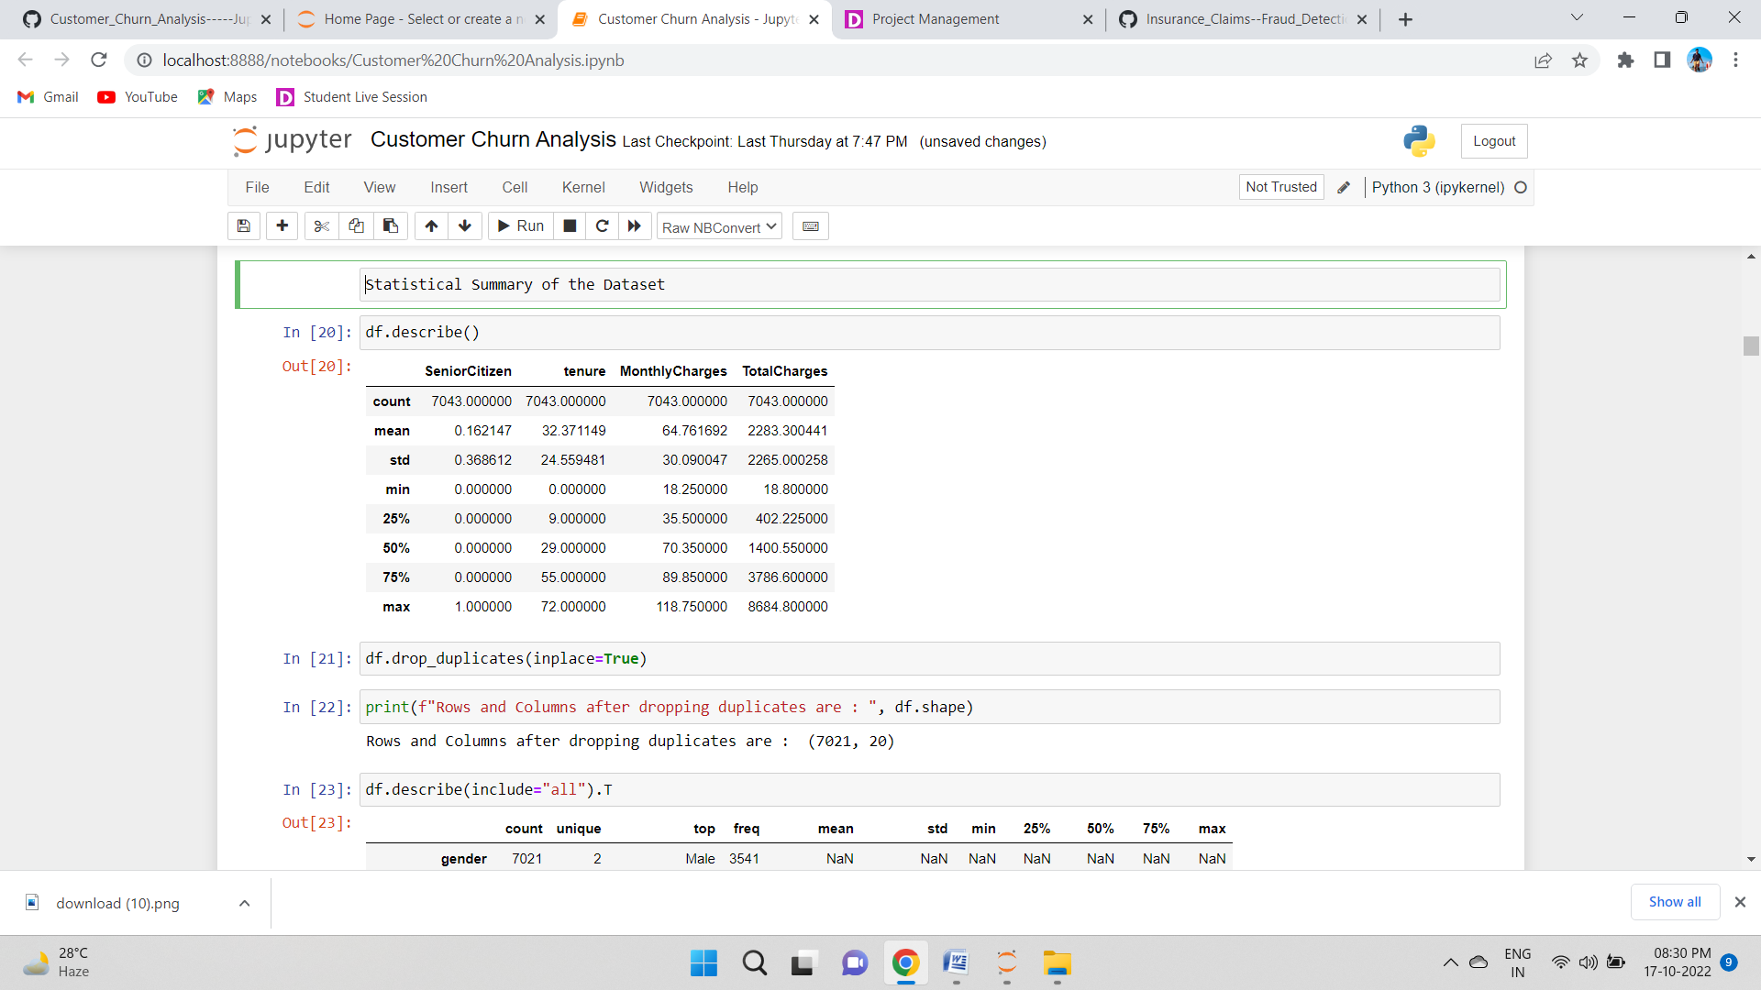

Above are the statistics about the numerical columns.describe by default takes only numerical columns.There is some difference between the mean and 2nd quantile value which means there are some outliers.



With the drop_duplicates option I am getting rid of all the duplicate values present in our dataset.

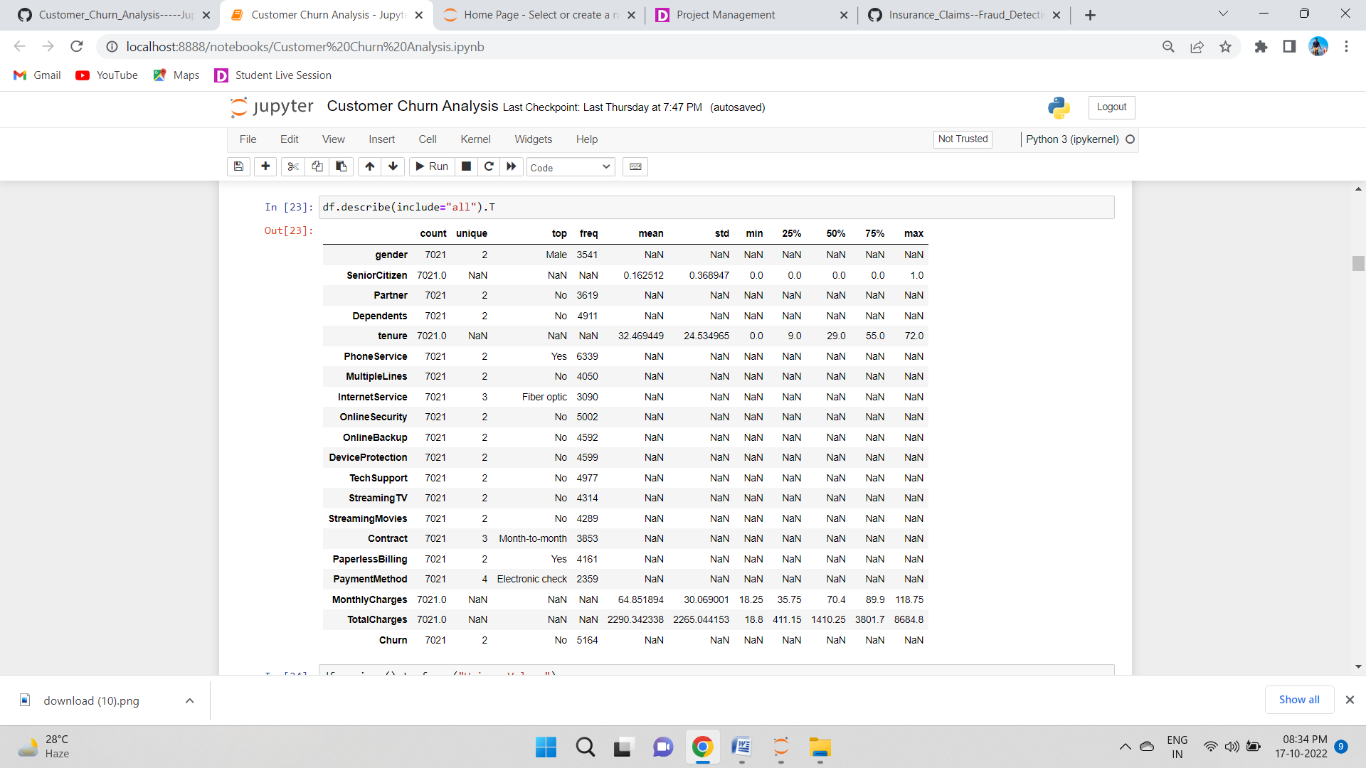

Here I am using the "describe" method along with its parameter "all" to include each and every column present in our dataset irrespective of them being numeric or text data. I have also used the transpose option to make sure that we are able to see the column information properly without having to scroll through multiple times.



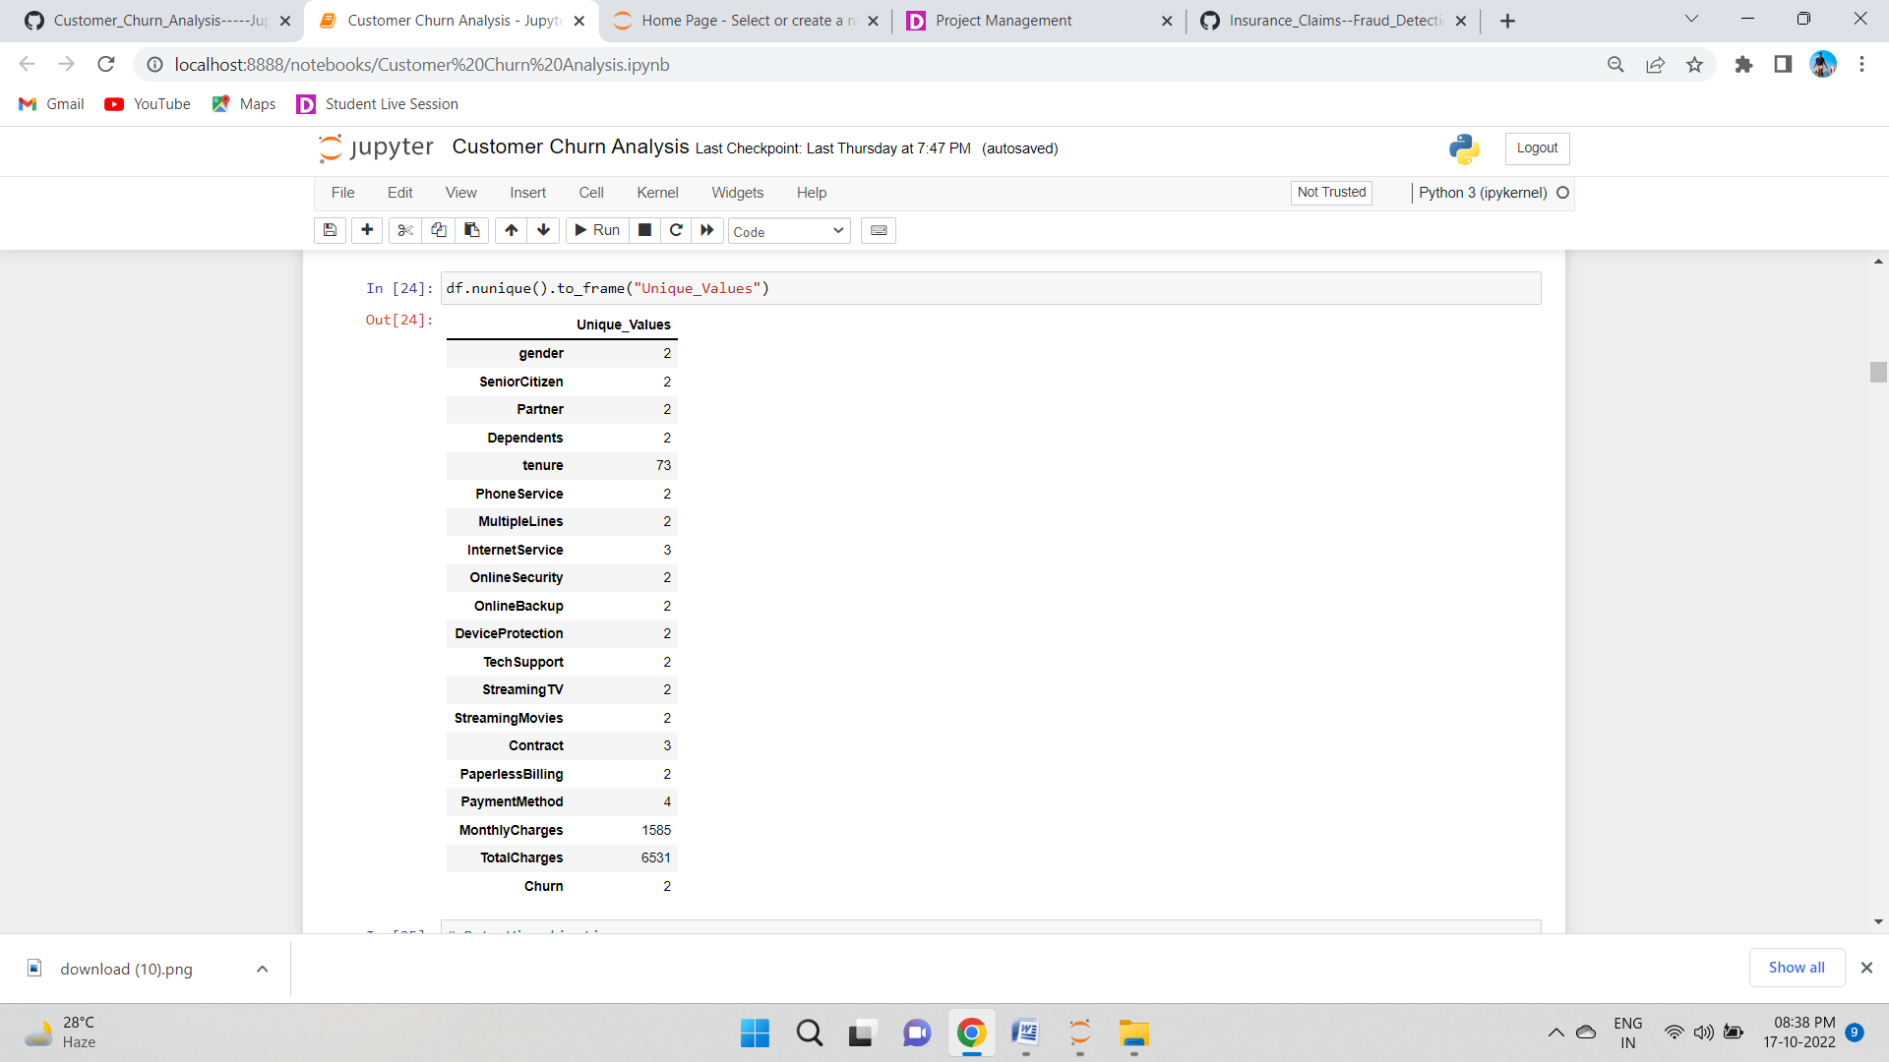

With the usage of nunique method we can see the total number of unique values present in all the columns

Data Visualization:

**Preparing for Visualization**

We will look into the categorical and numerical columns so that we can create two different lists and visualize the features accordingly.

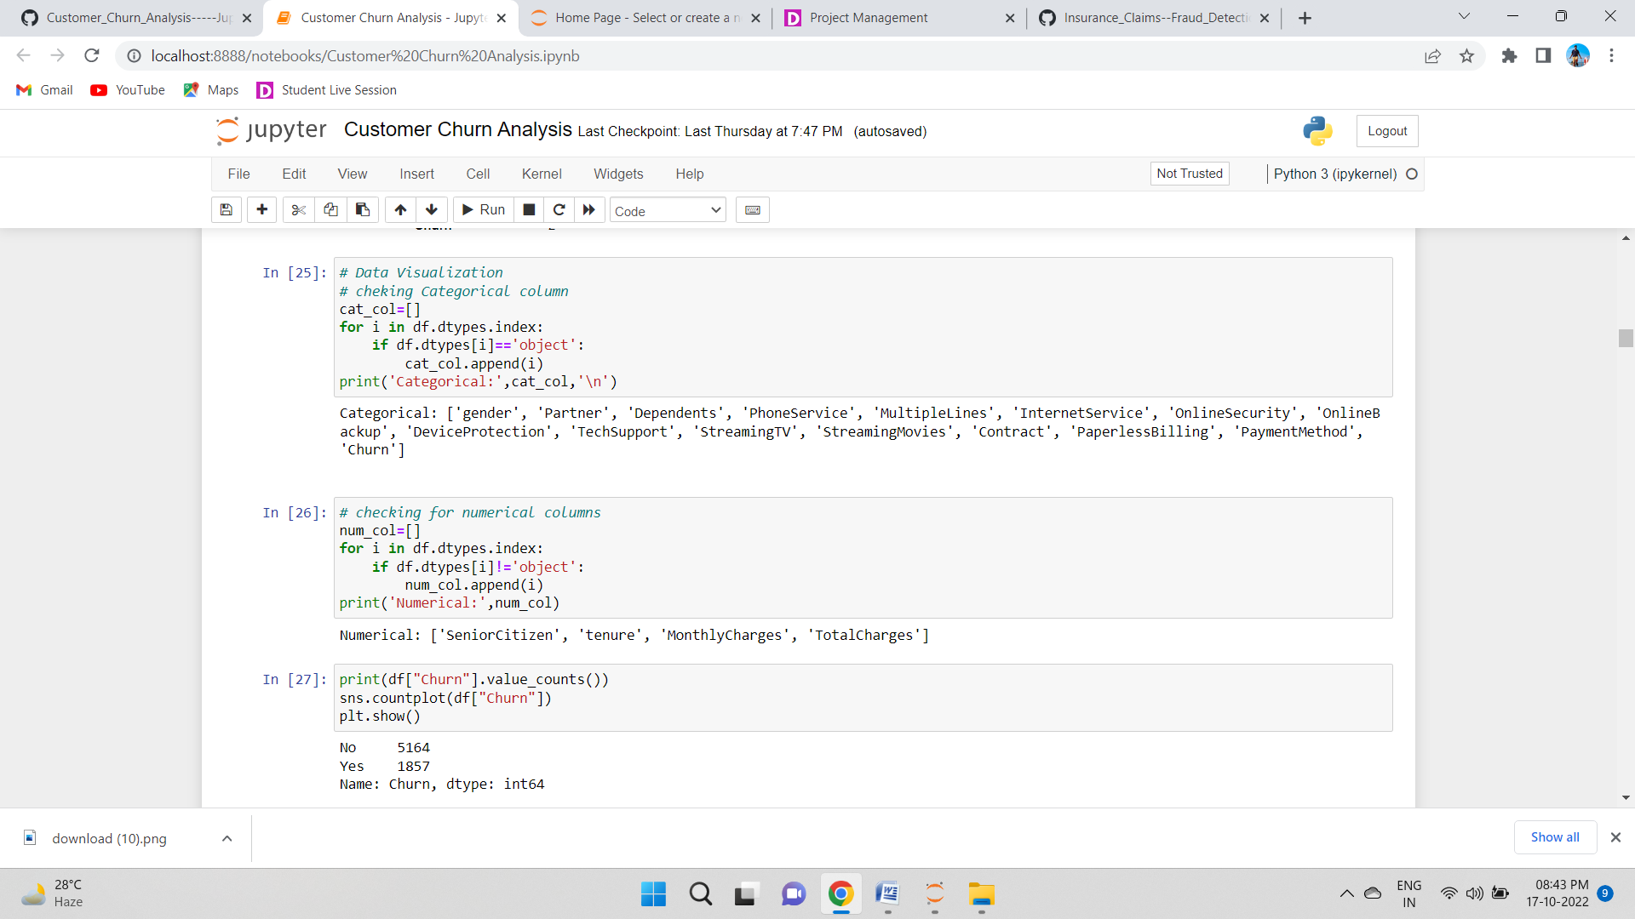

**Univariate Analysis for categorical columns**

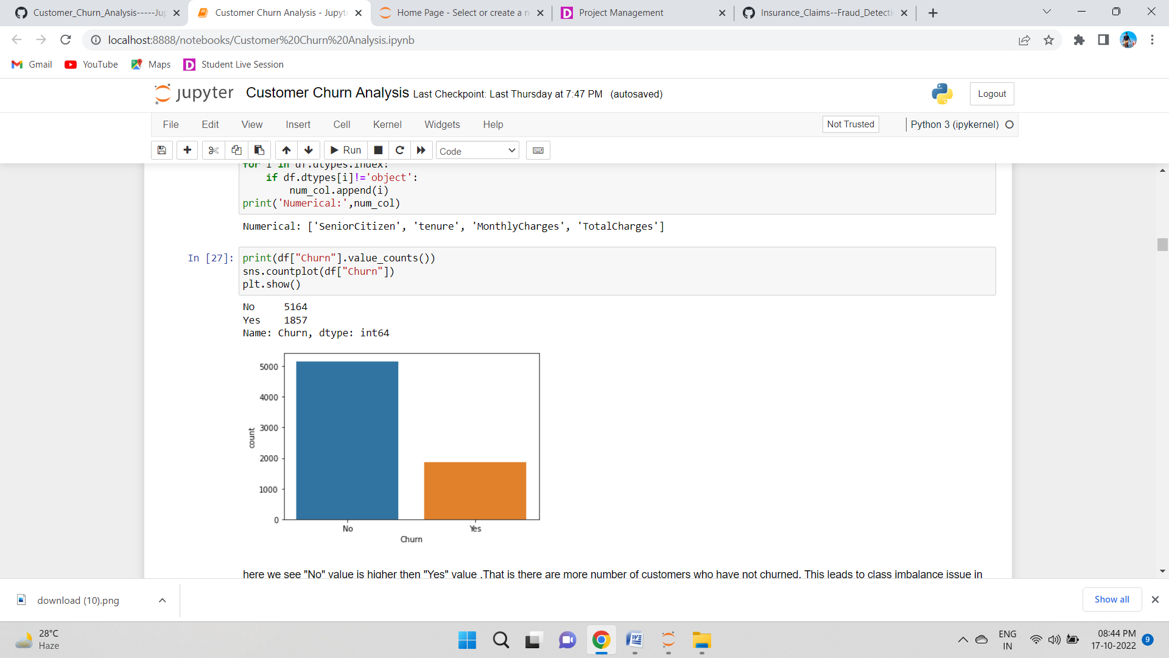

From the count plot we can observe that the count of "No Churn" are high compared to the count of "Yes Churn". That is there are more number of customers who have not churned. This leads to class imbalance issue in the data, we will rectify it by using oversampling method in later part.

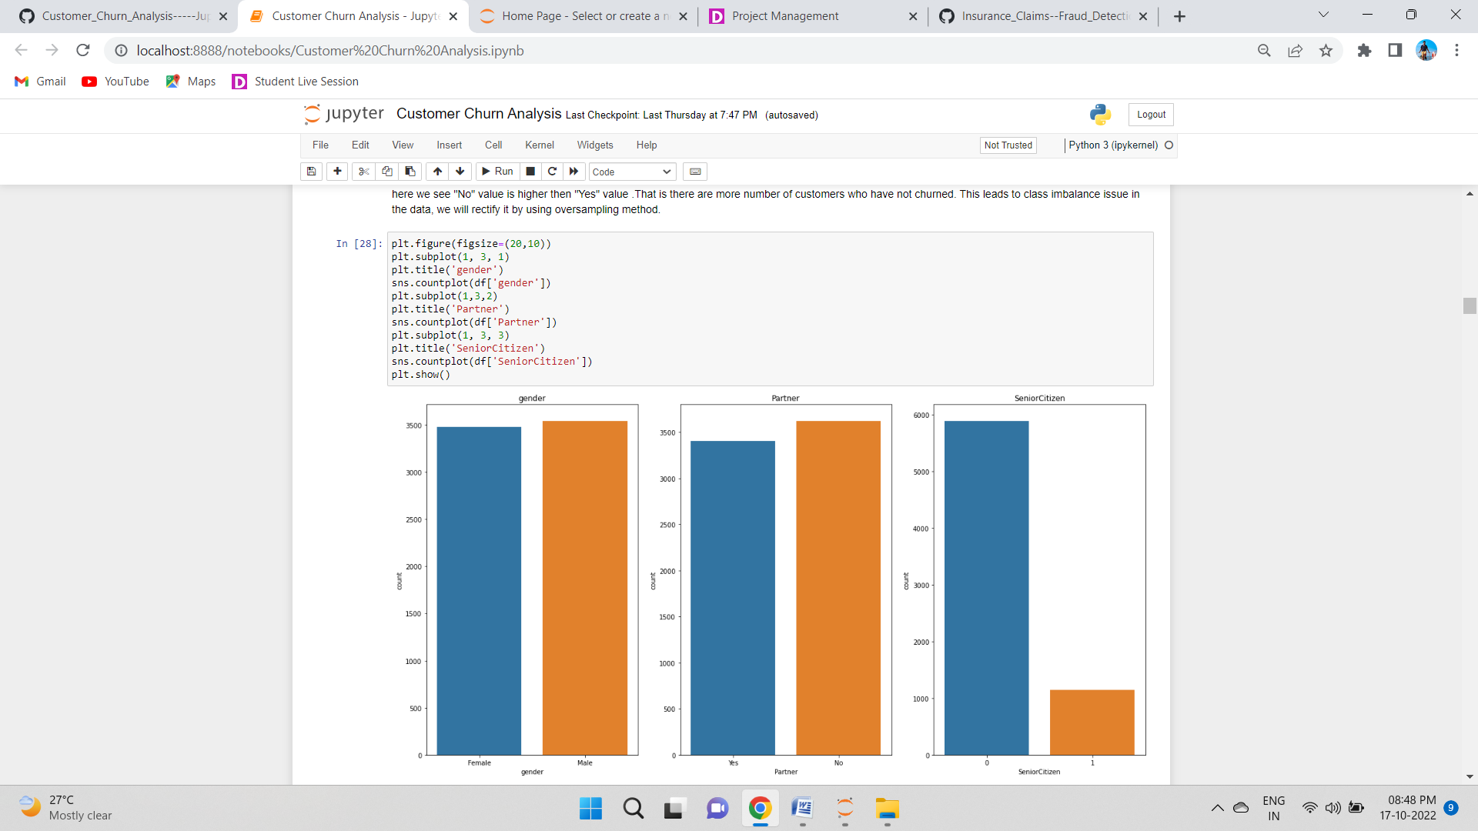

Both the genders has same count almost and having partner or not also has same count. In senior citizen we see low number in senior citizen

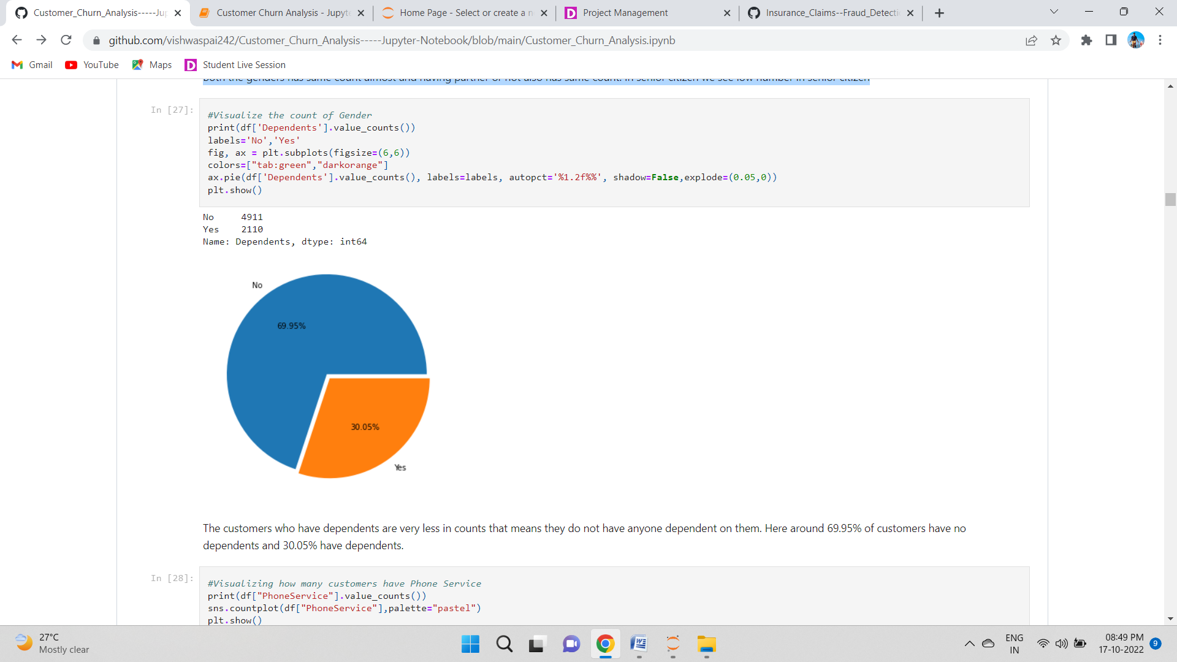

The customers who have dependents are very less in counts that means they do not have anyone dependent on them. Here around 69.95% of customers have no dependents and 30.05% have dependents.

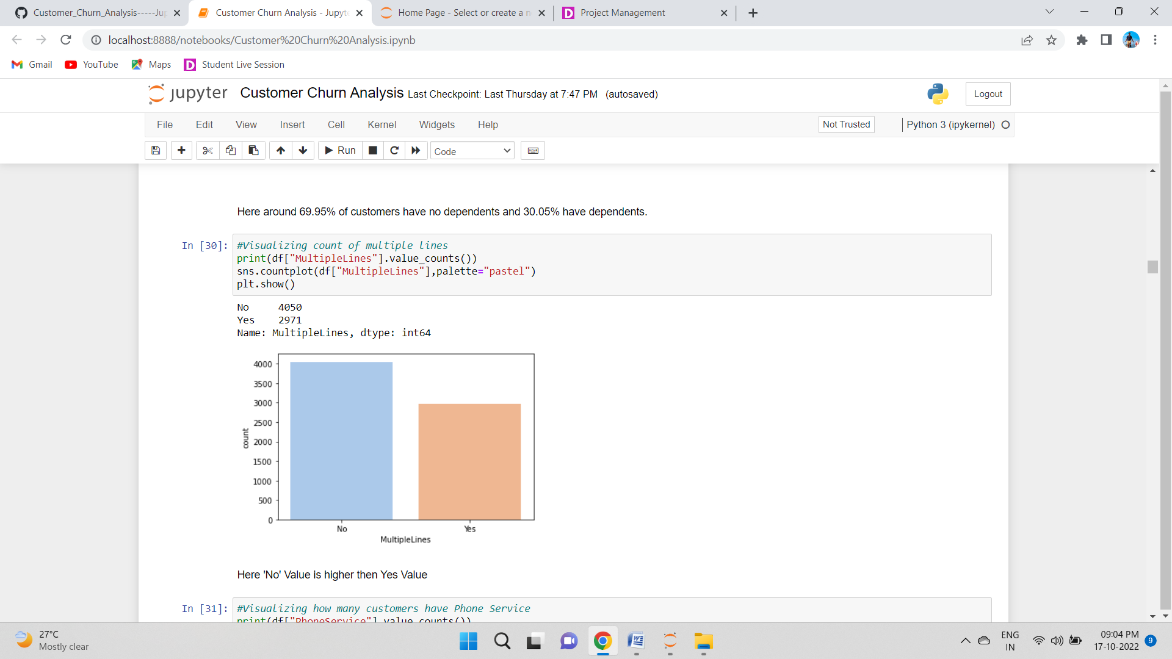 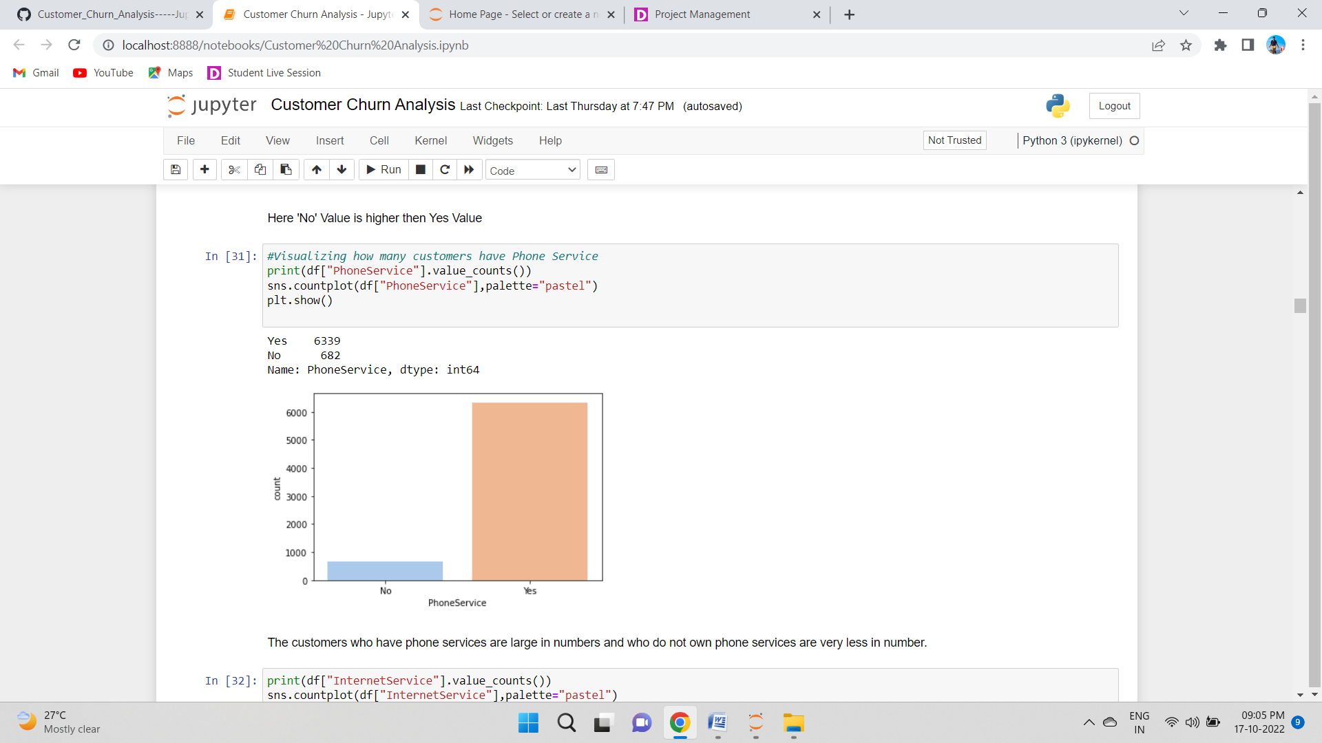 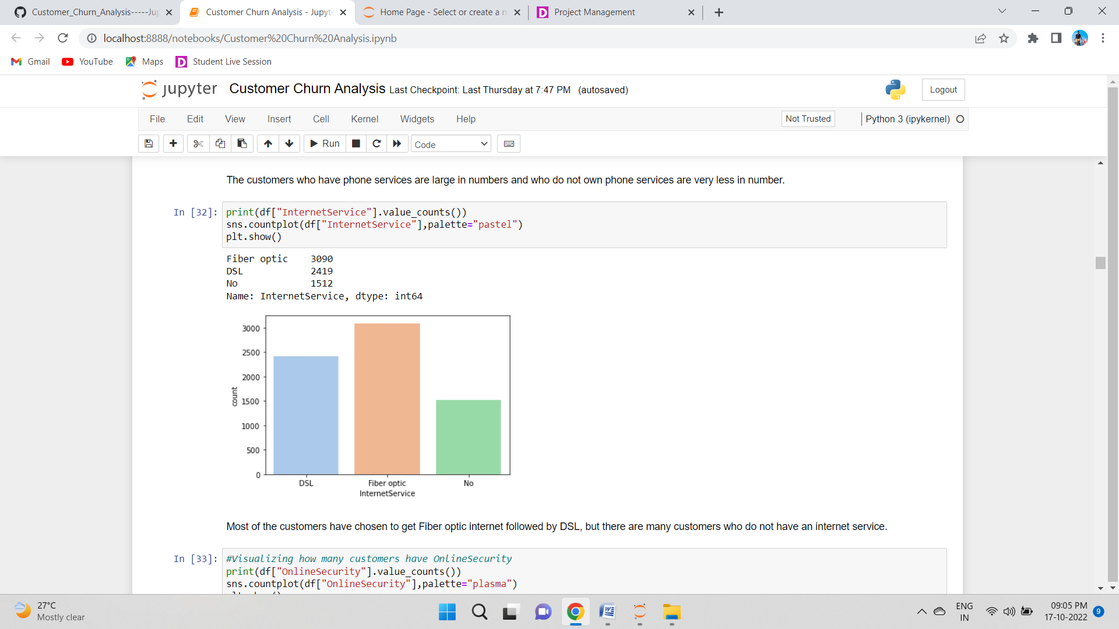

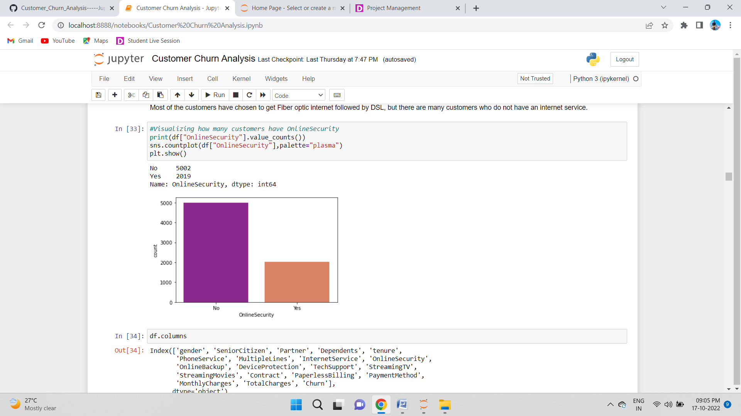 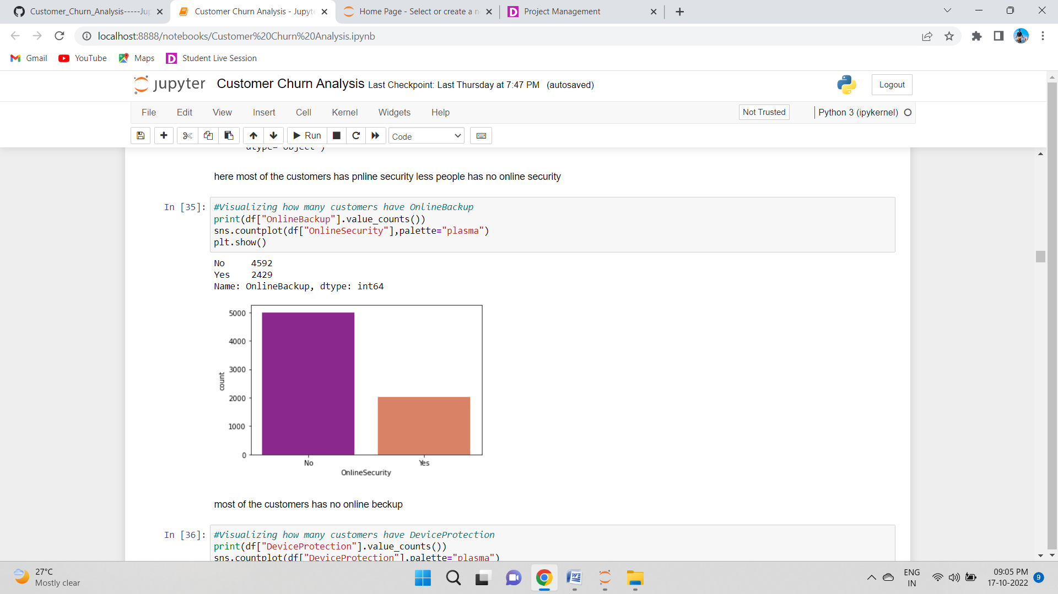 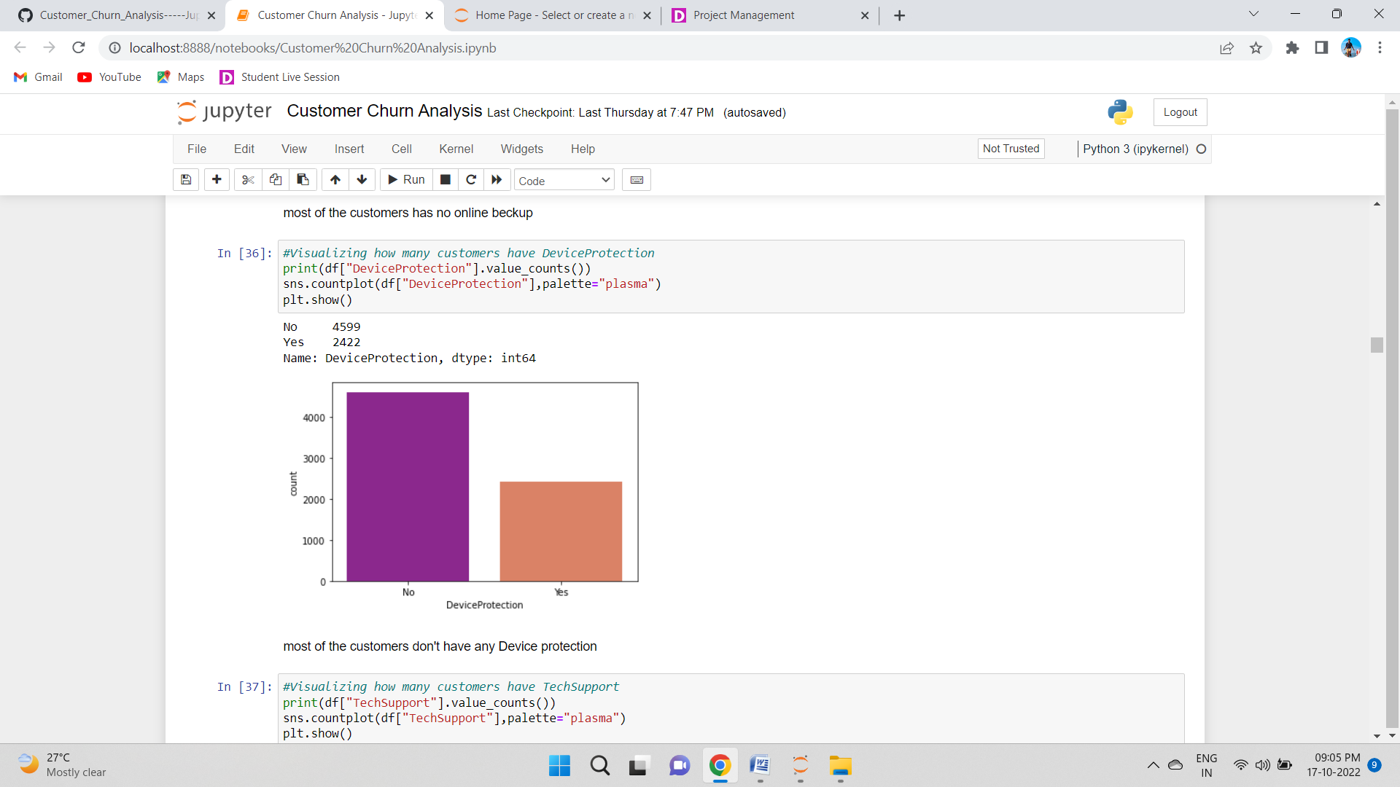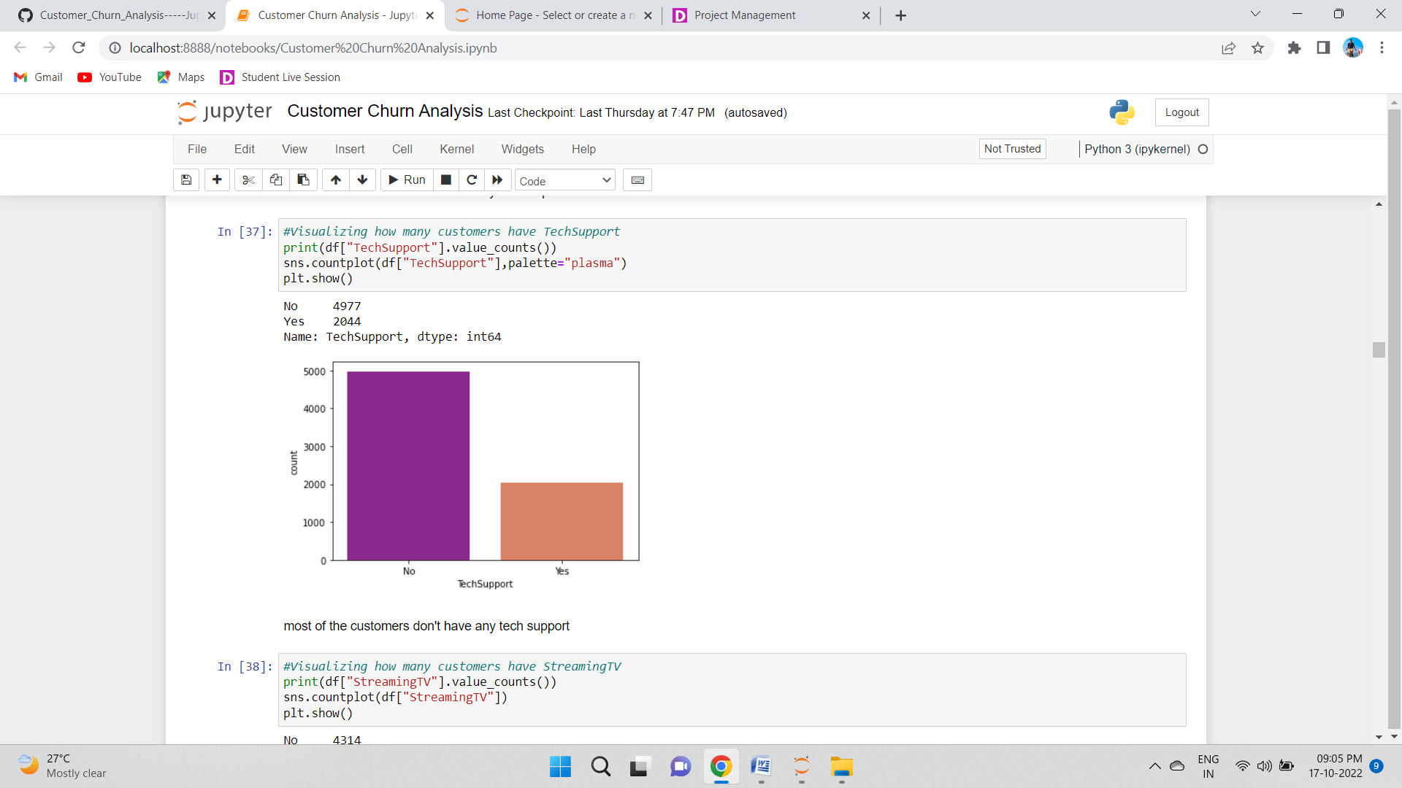 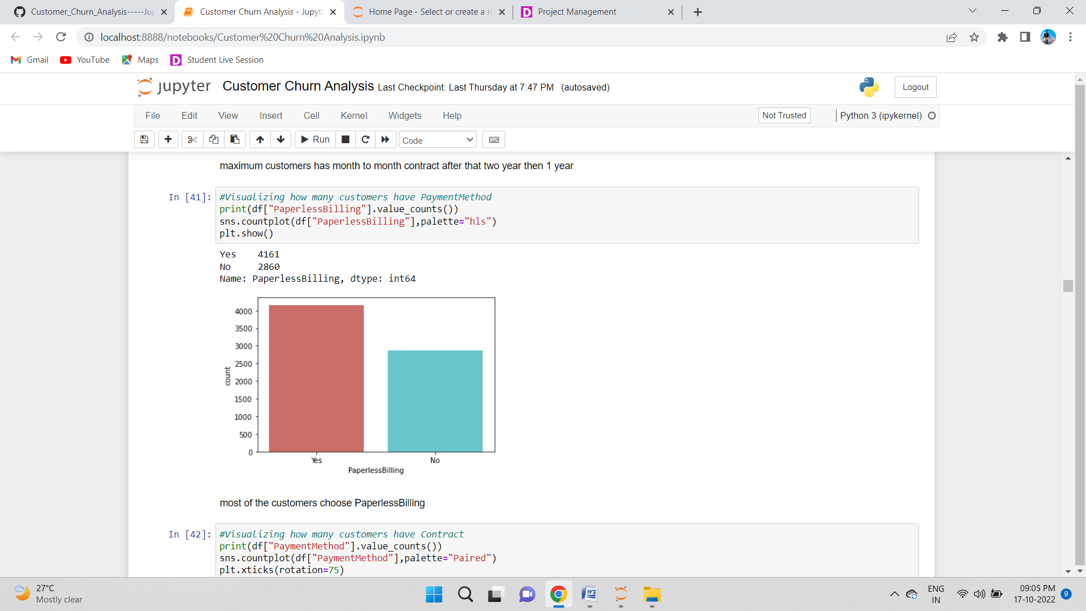 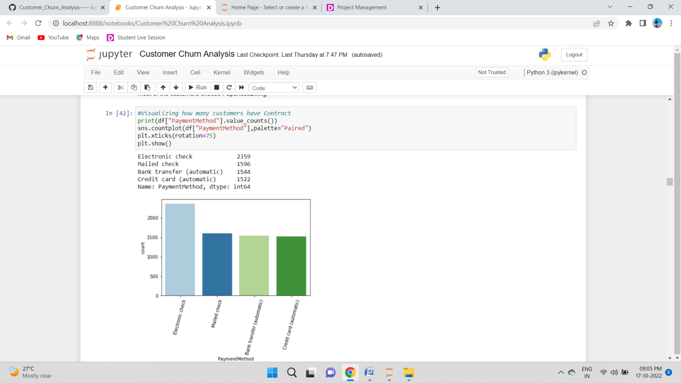

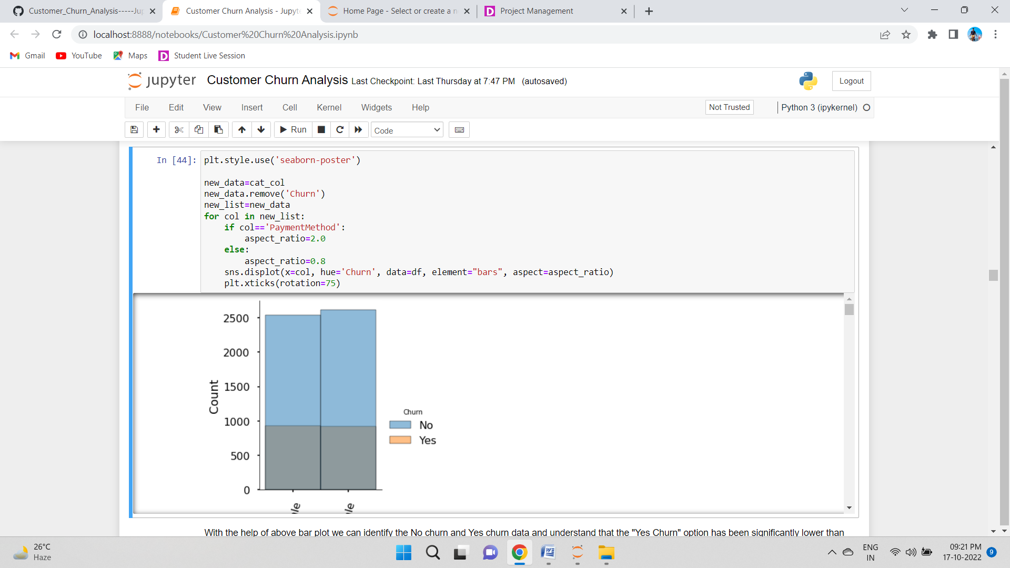

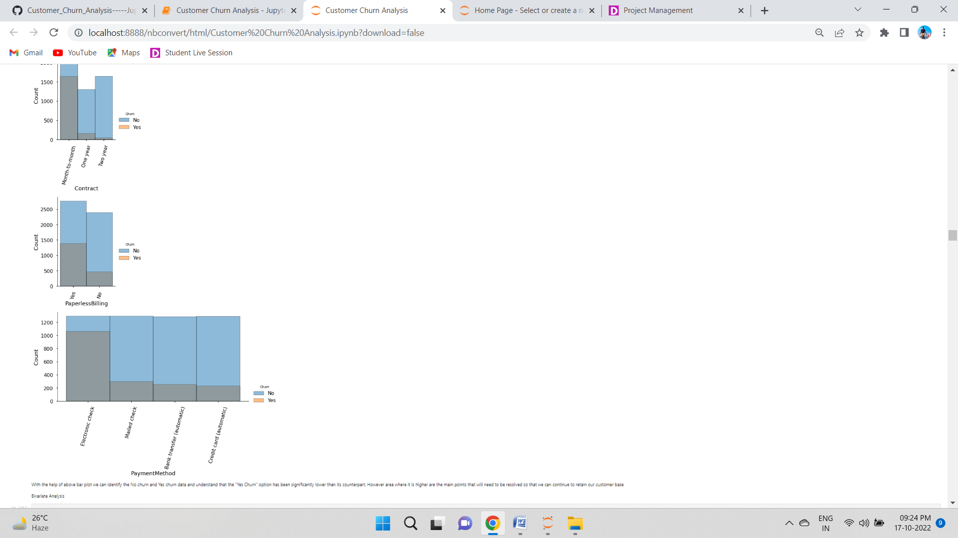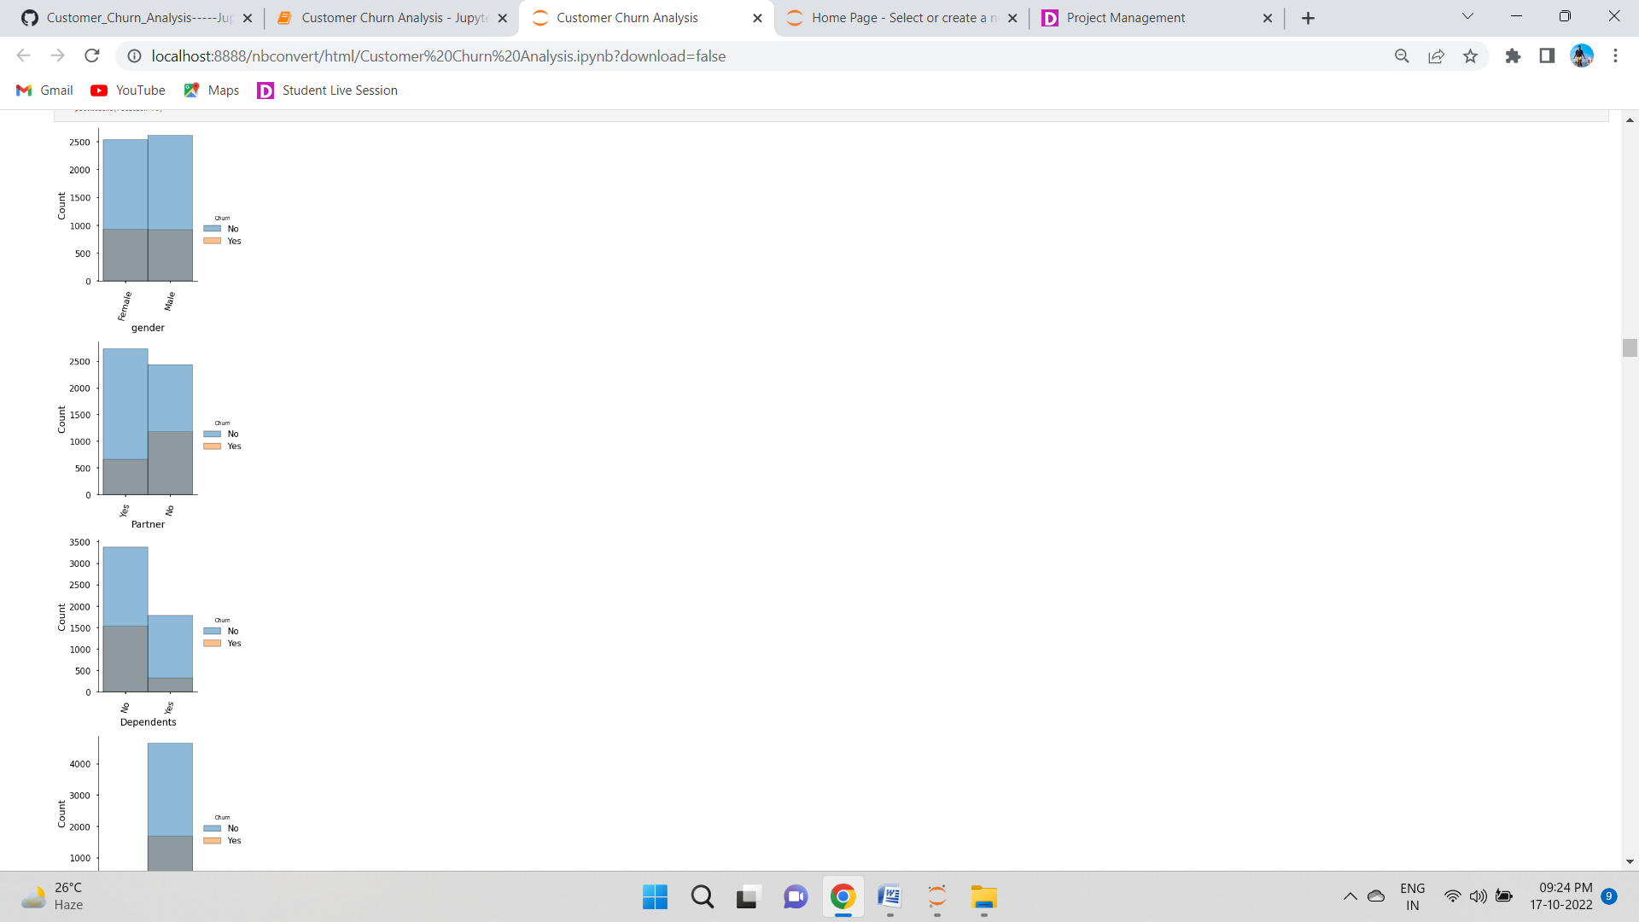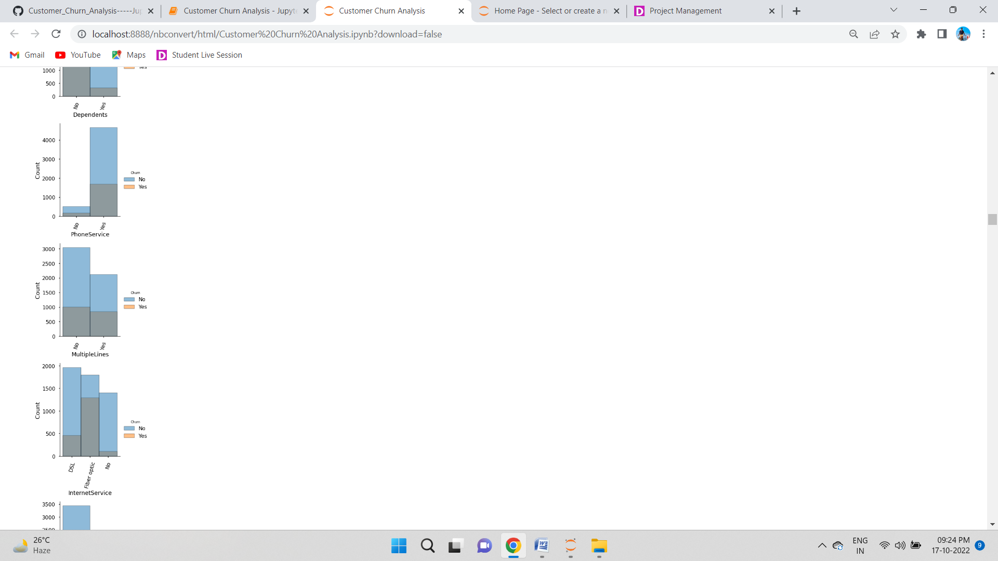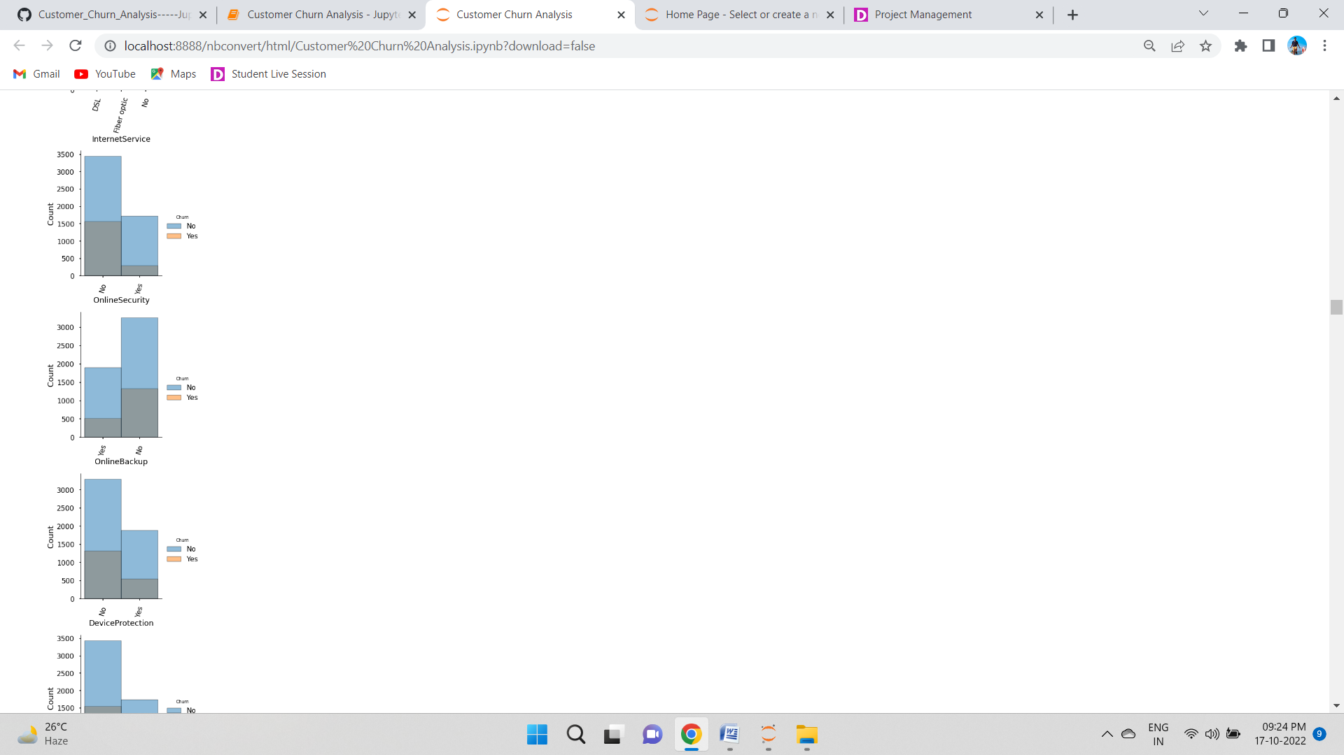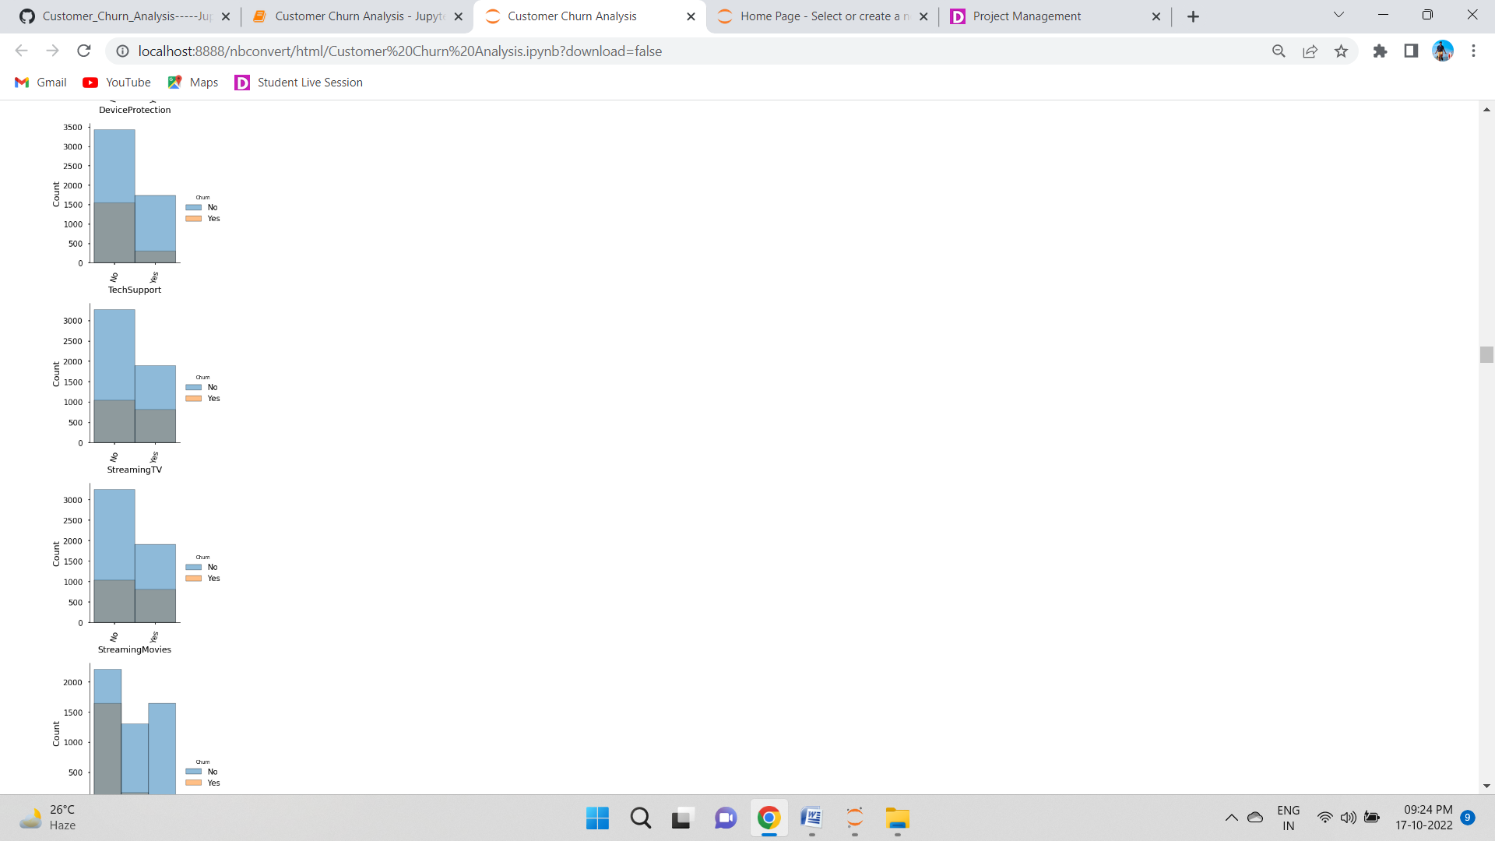

With the help of above bar plot we can identify the No churn and Yes churn data and understand that the "Yes Churn" option has been significantly lower than its counterpart. However area where it is higher are the main points that will need to be resolved so that we can continue to retain our customer base

## Bivariate Analysis

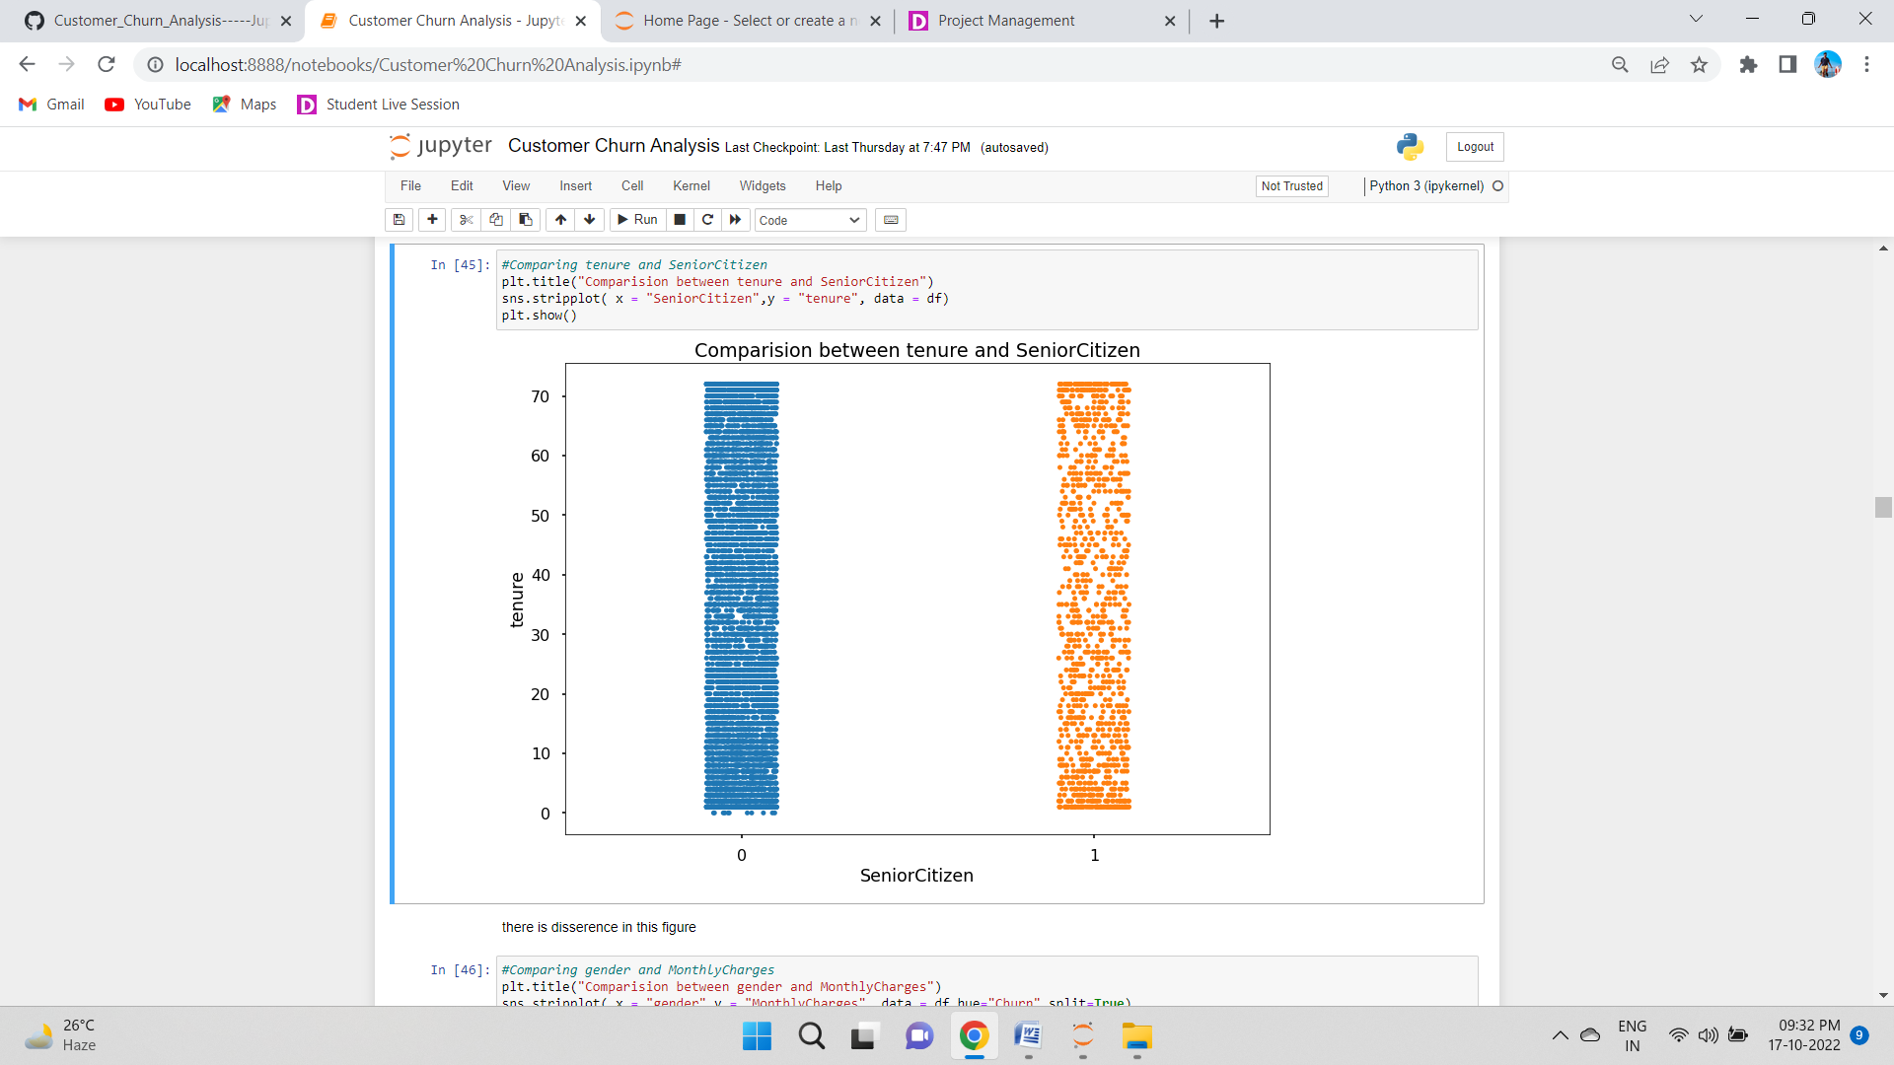

There is no significant difference between the features.

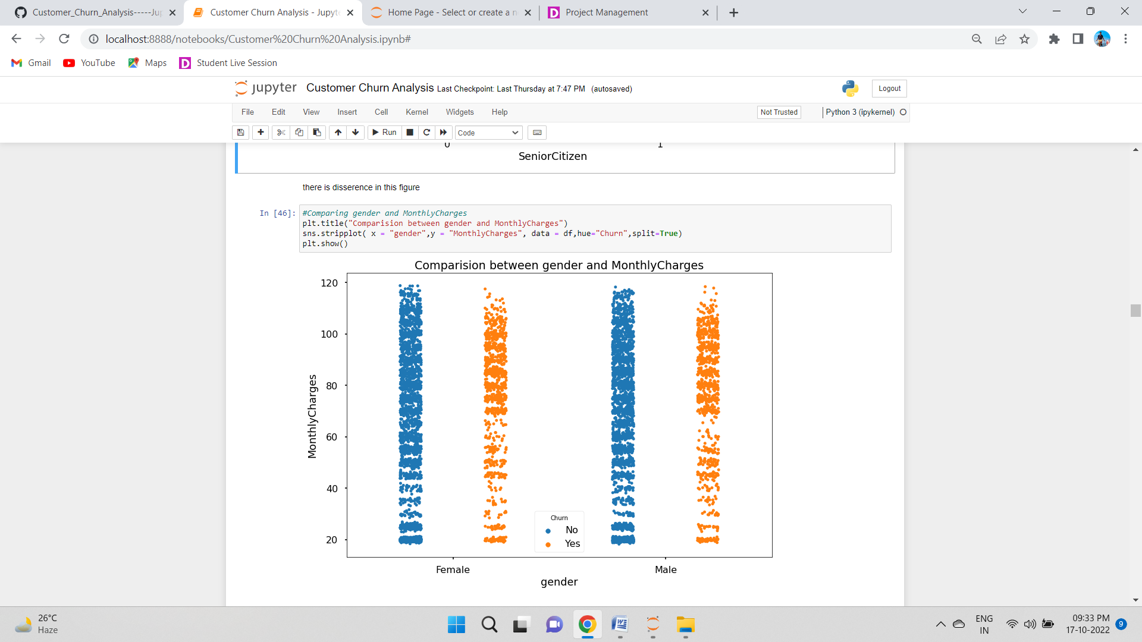

Most both male and female customers with monthly charges above 70 have high chances of getting churned.

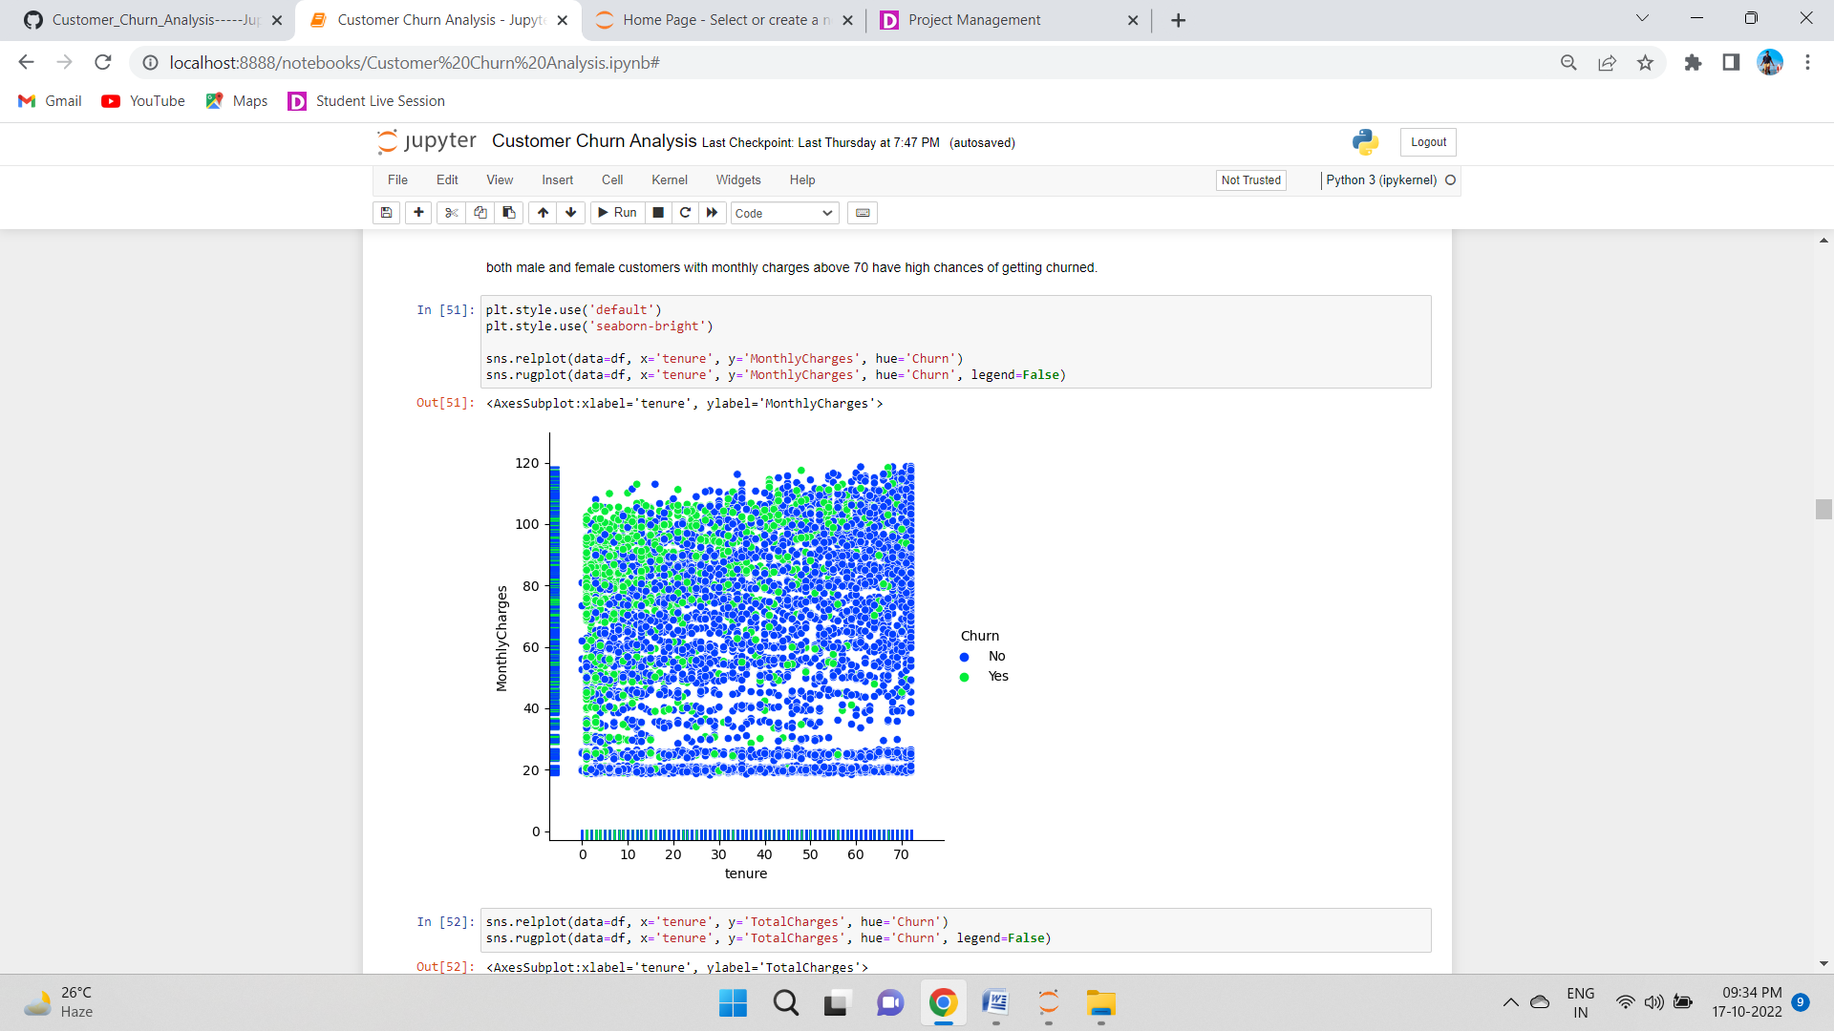 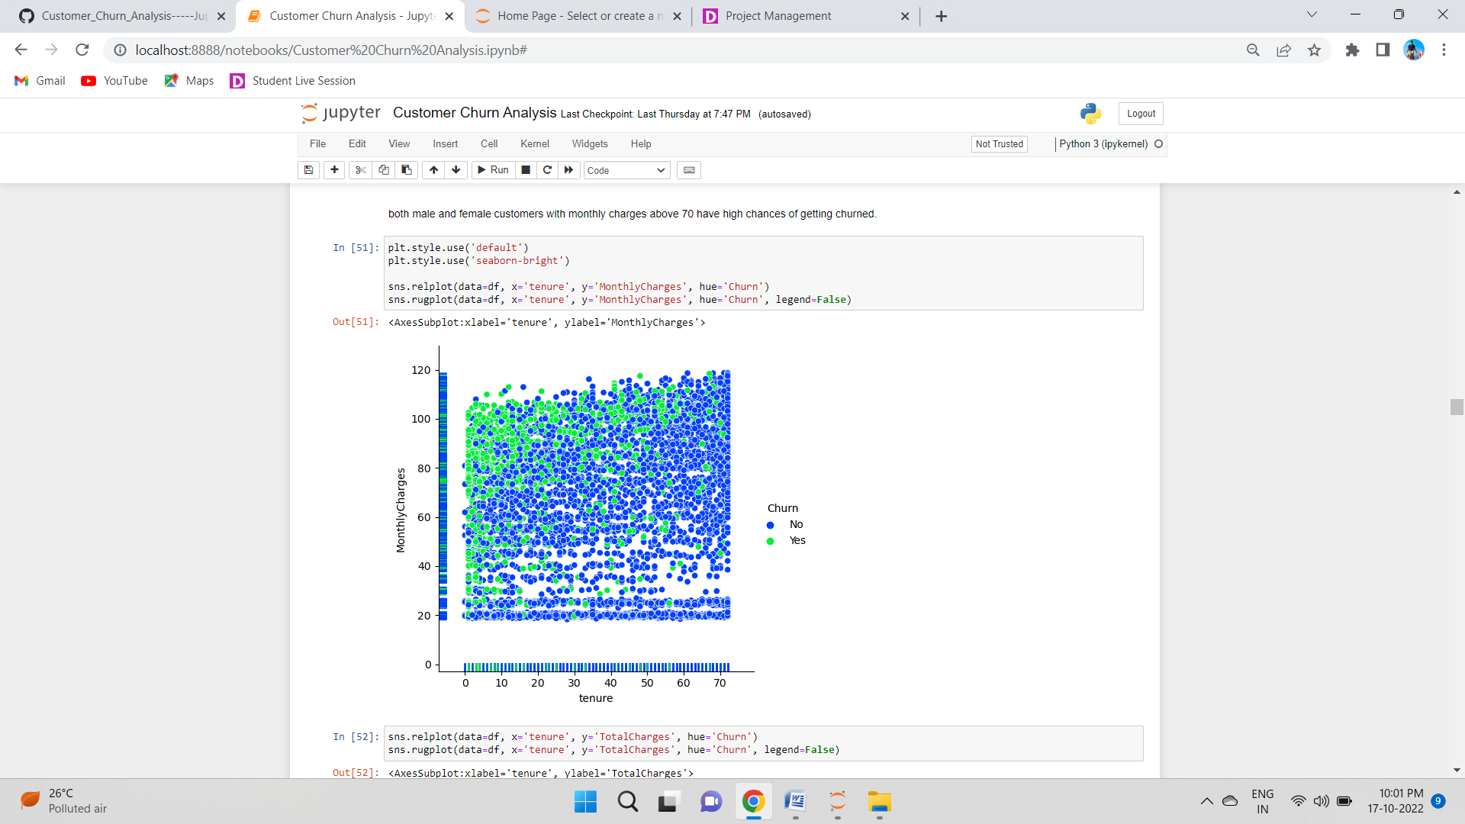

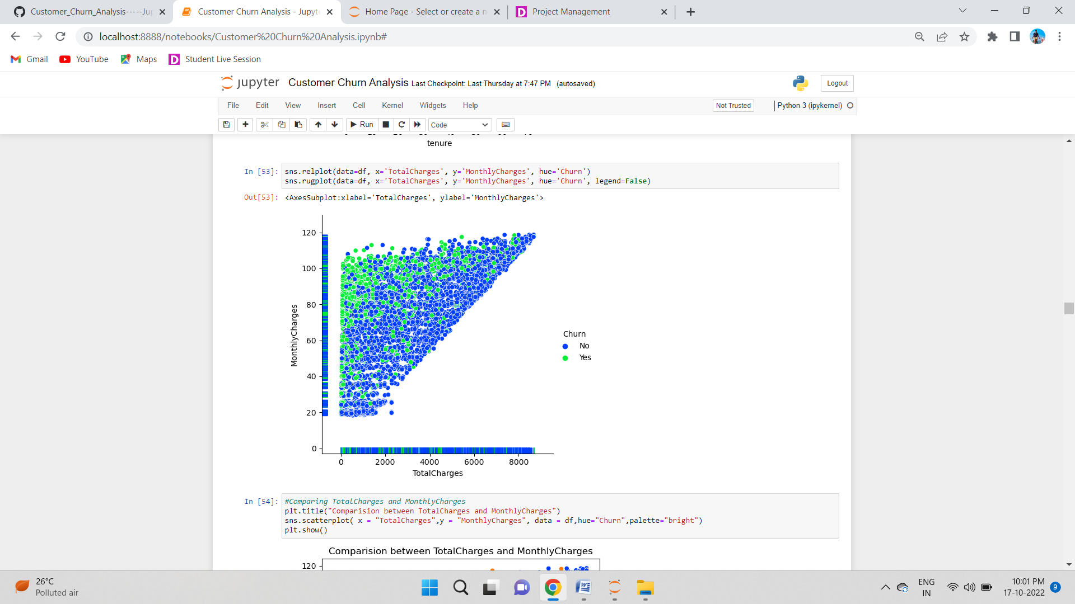

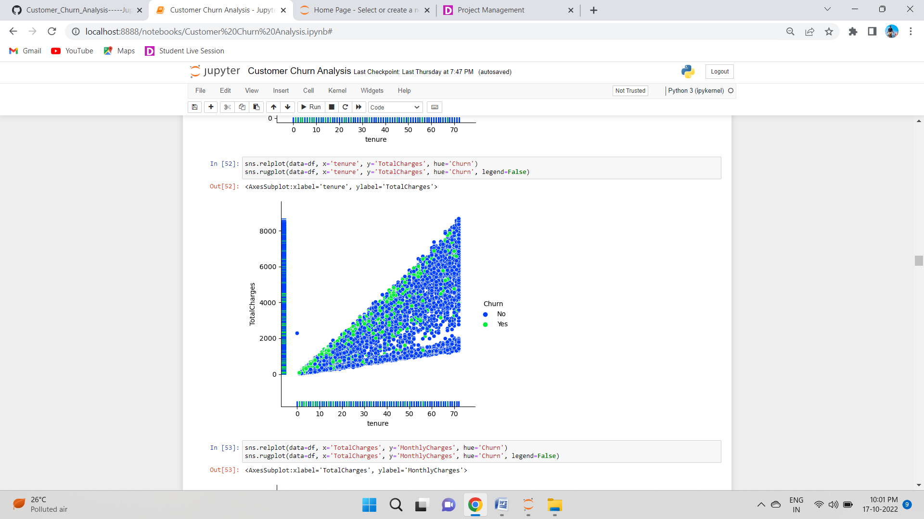

The above plot shows us that people with high monthly charges tend to leave the service and are not able to contribute much to the total charges. Similarly if a customer has chosen to stick around with the reasonable monthly charges then there is a steep increase with the total charges as well.

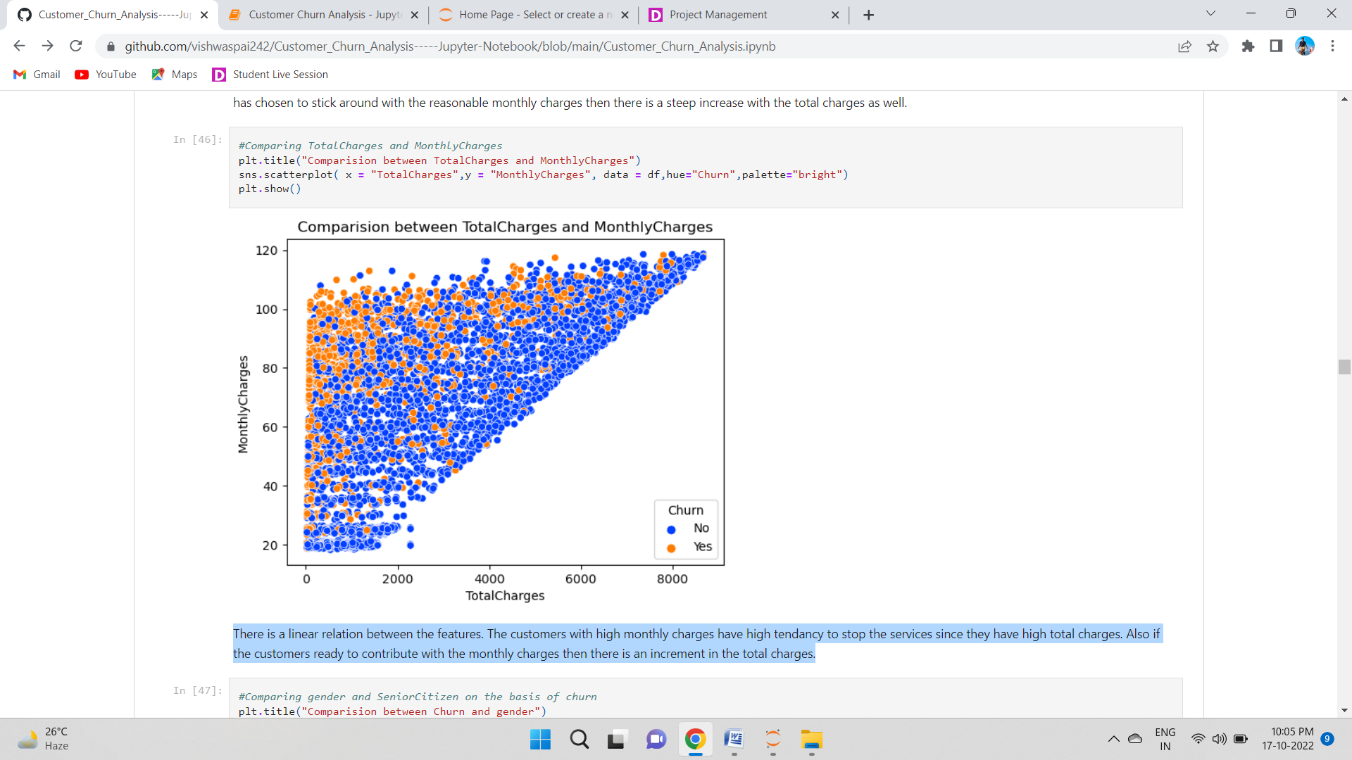

There is a linear relation between the features. The customers with high monthly charges have high tendancy to stop the services since they have high total charges. Also if the customers ready to contribute with the monthly charges then there is an increment in the total charges.

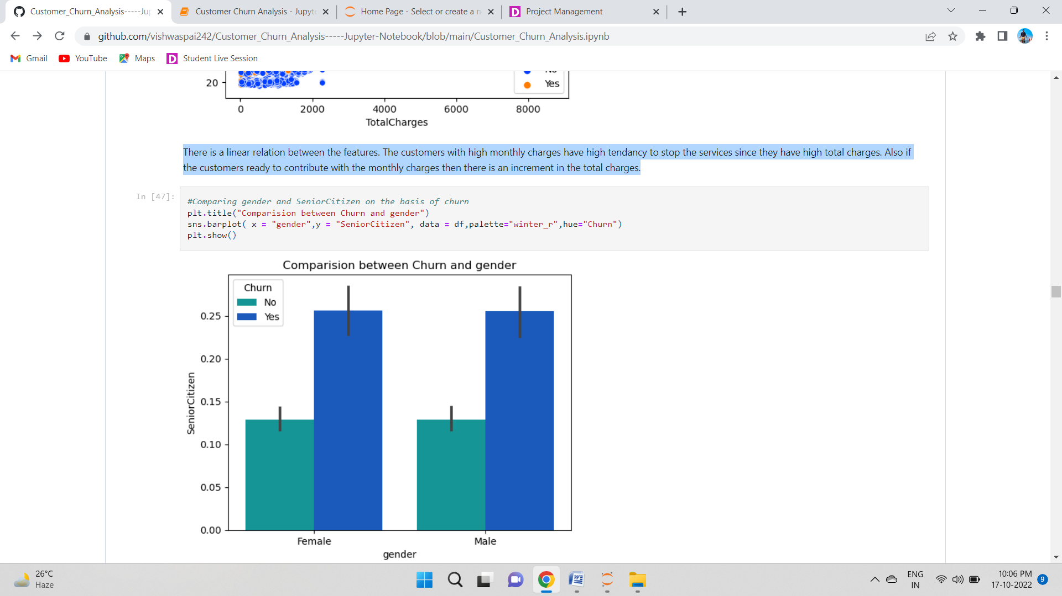

There is no significant difference between the columns. The customer's churns remains unaffected in gender and SeniorCitizen case.

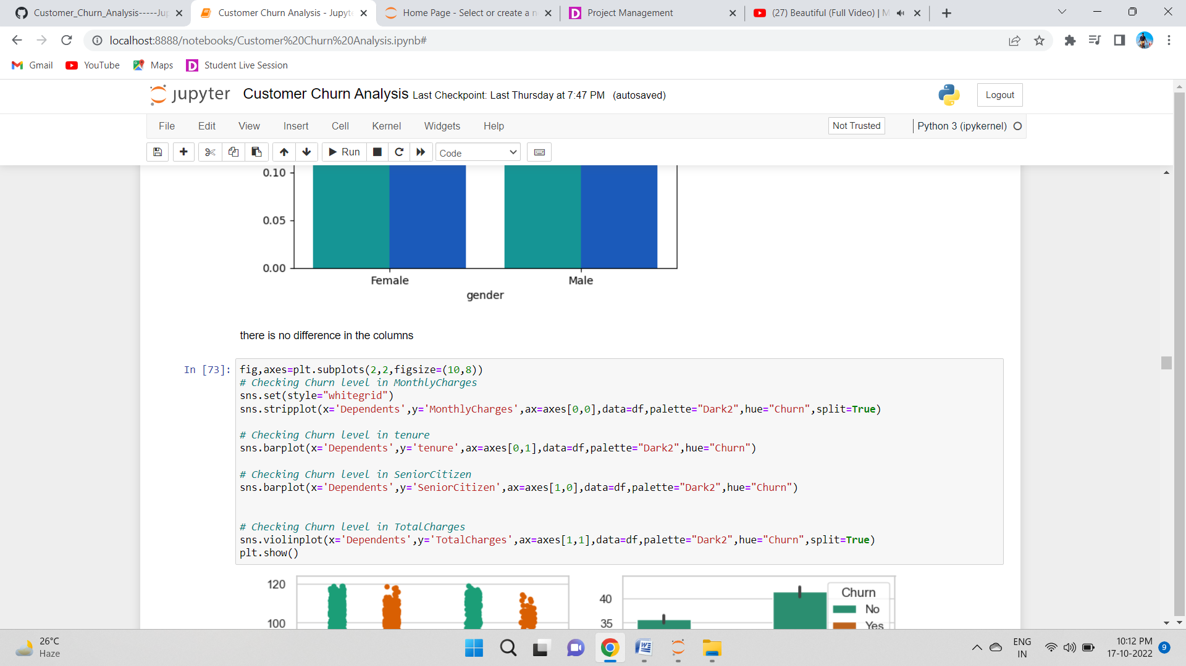

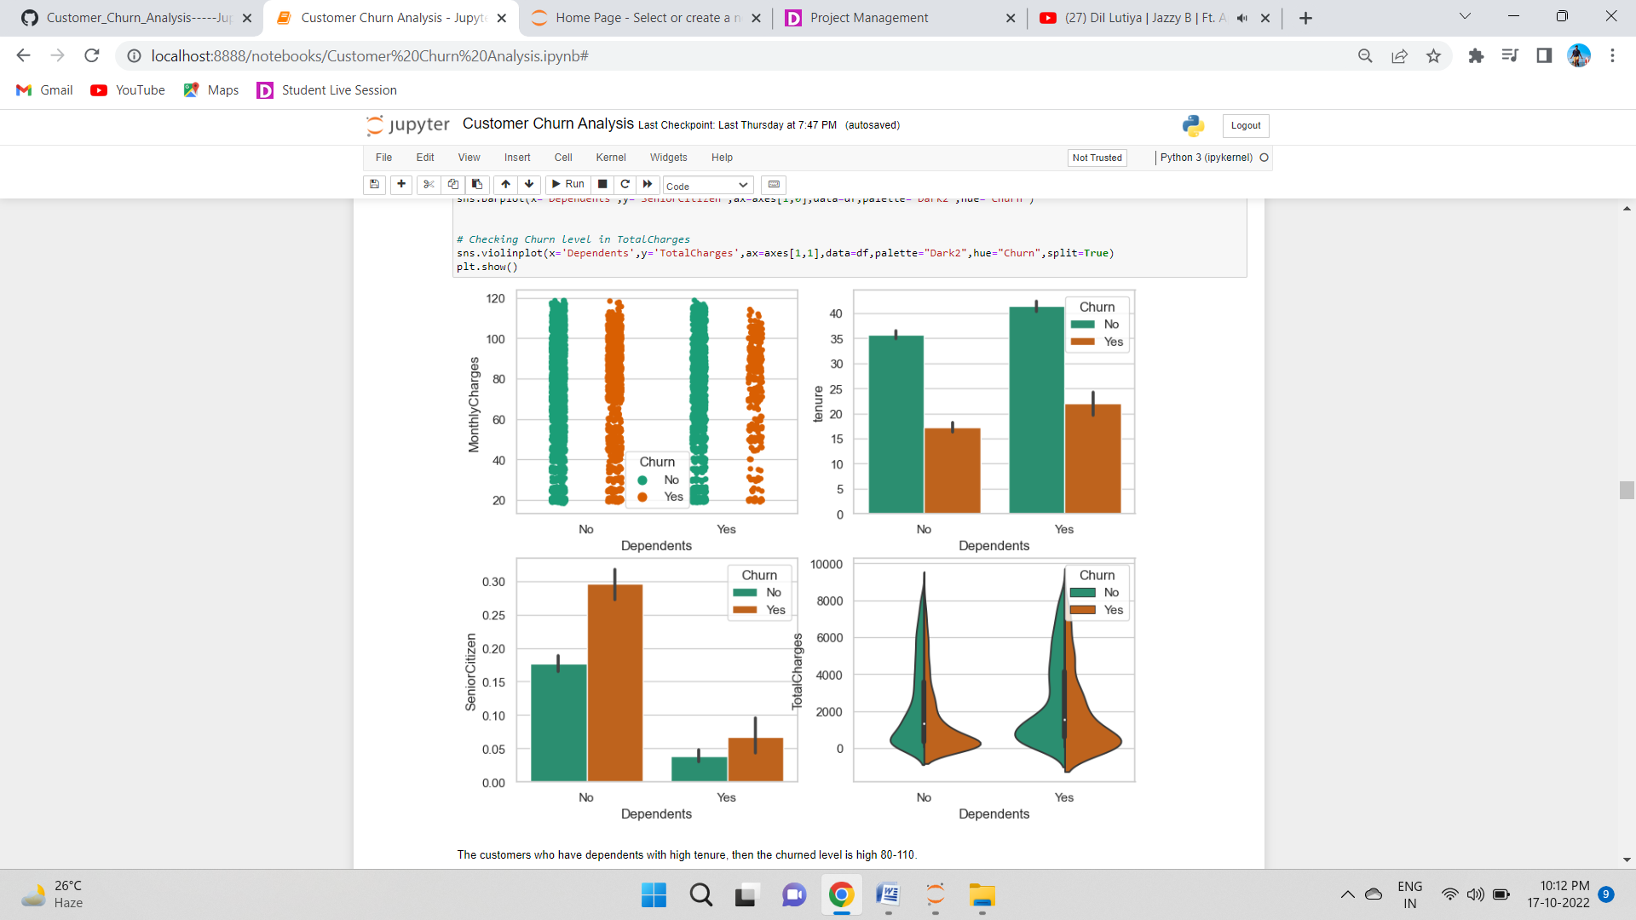

### >The customers who have dependents with high tenure, then the churned level is high 80-110.

### >The customers who have total charges in the range of 0-2000 with dependents then the chance of getting churned is high.

### >The customers having Monthly charges between 80-110 with dependents have high churn rate and when the customers have no dependents and having monthly charges around 20 then the ratio of churn is very high.

### >If the customer is a senior citizen and have no dependents then there is a tendancy of getting churned.

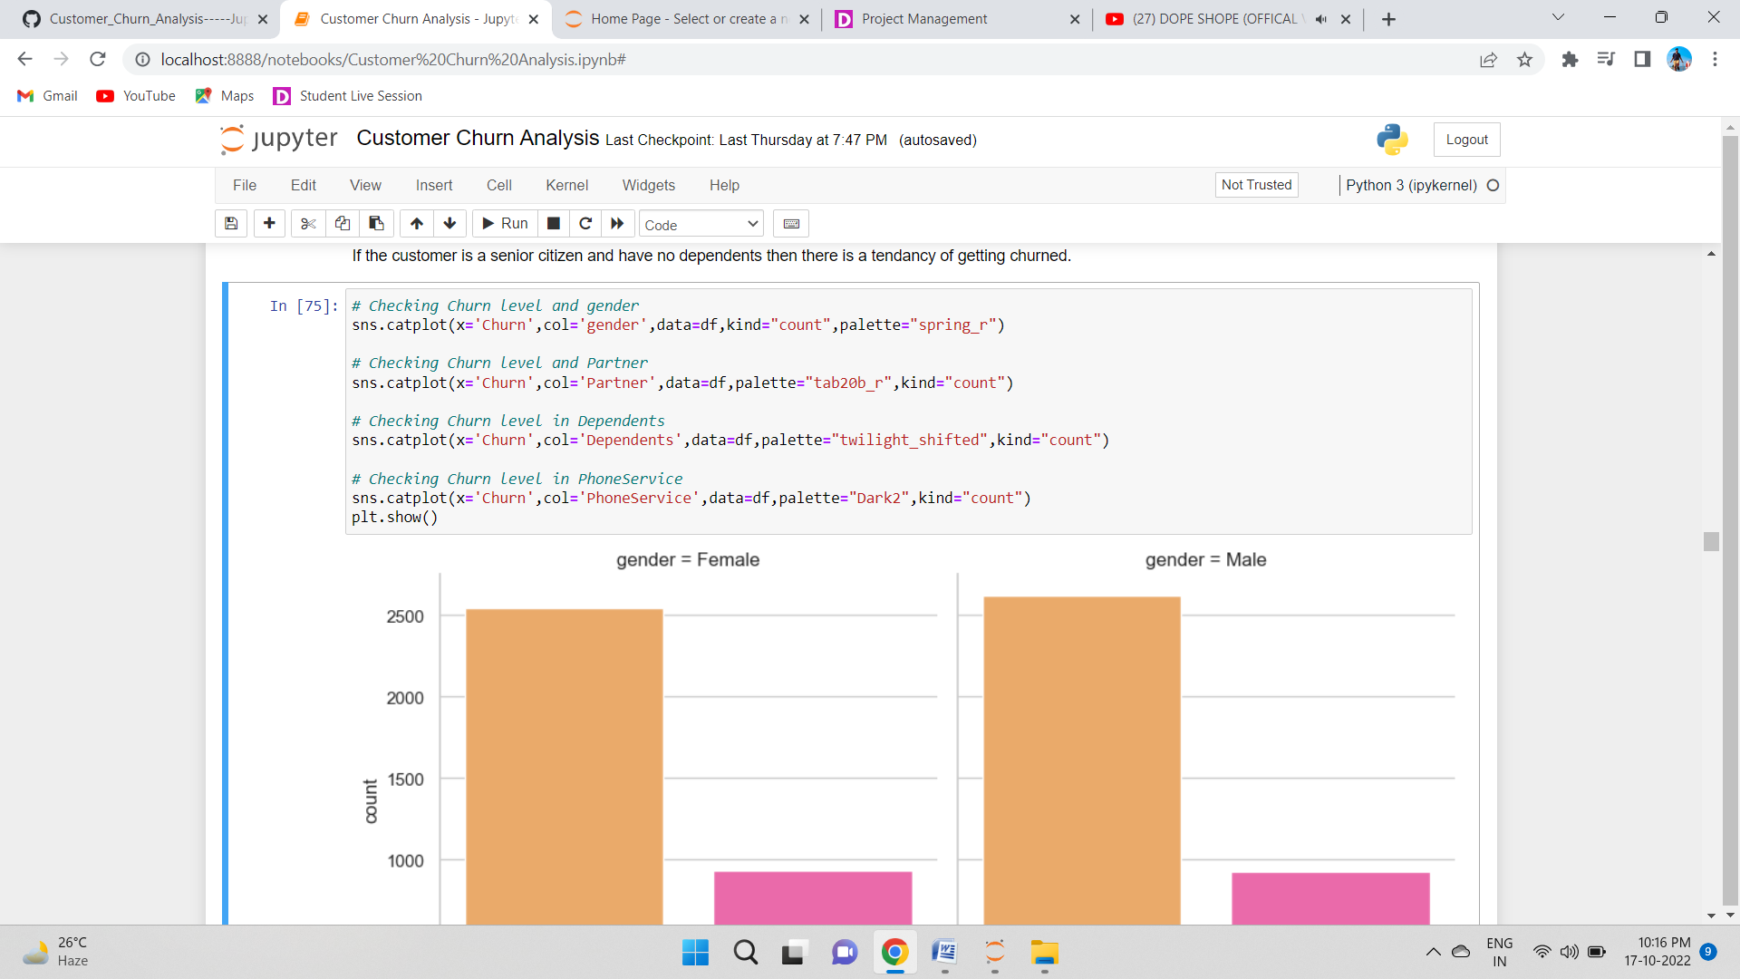

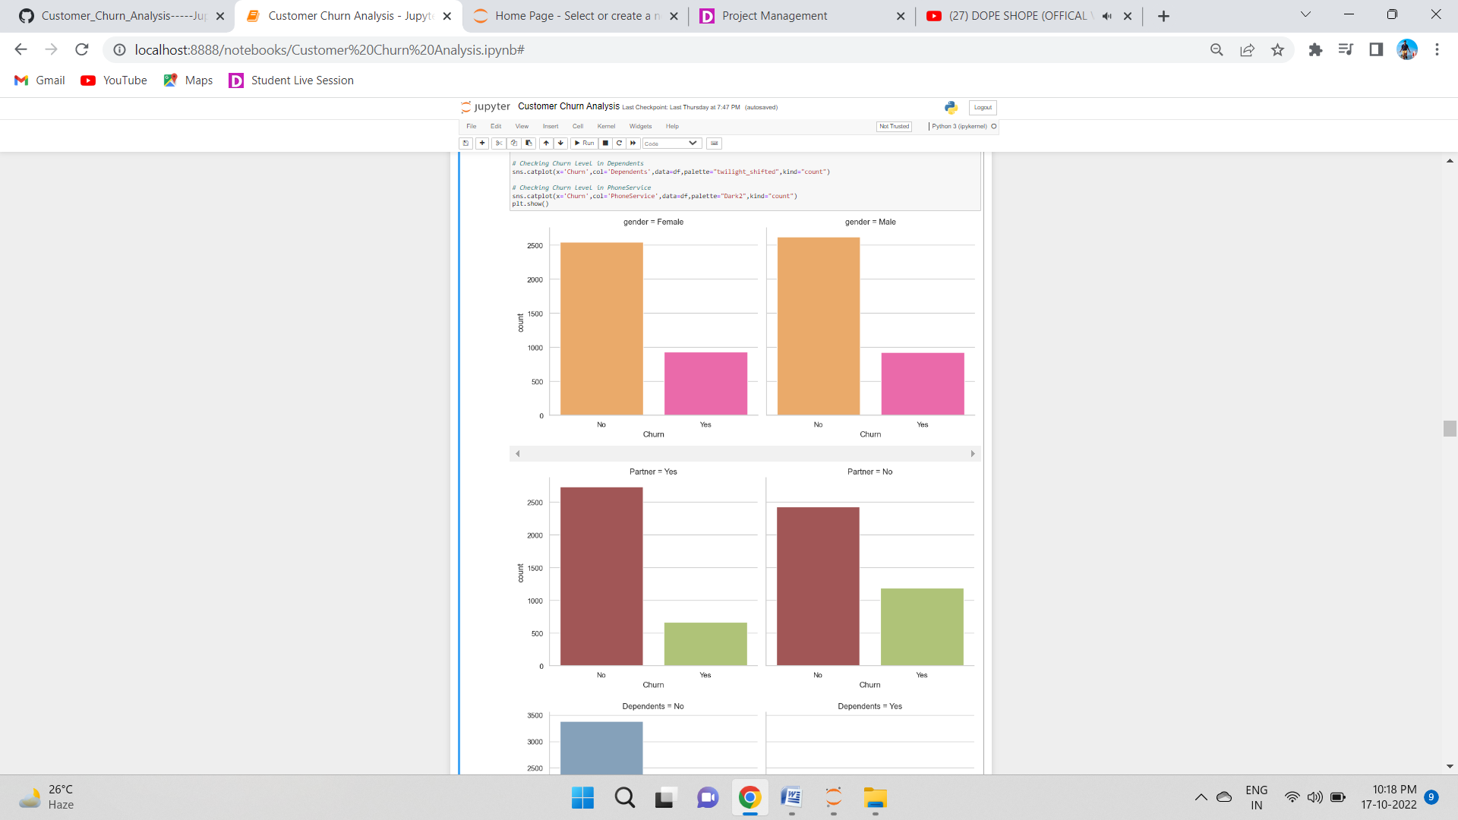 

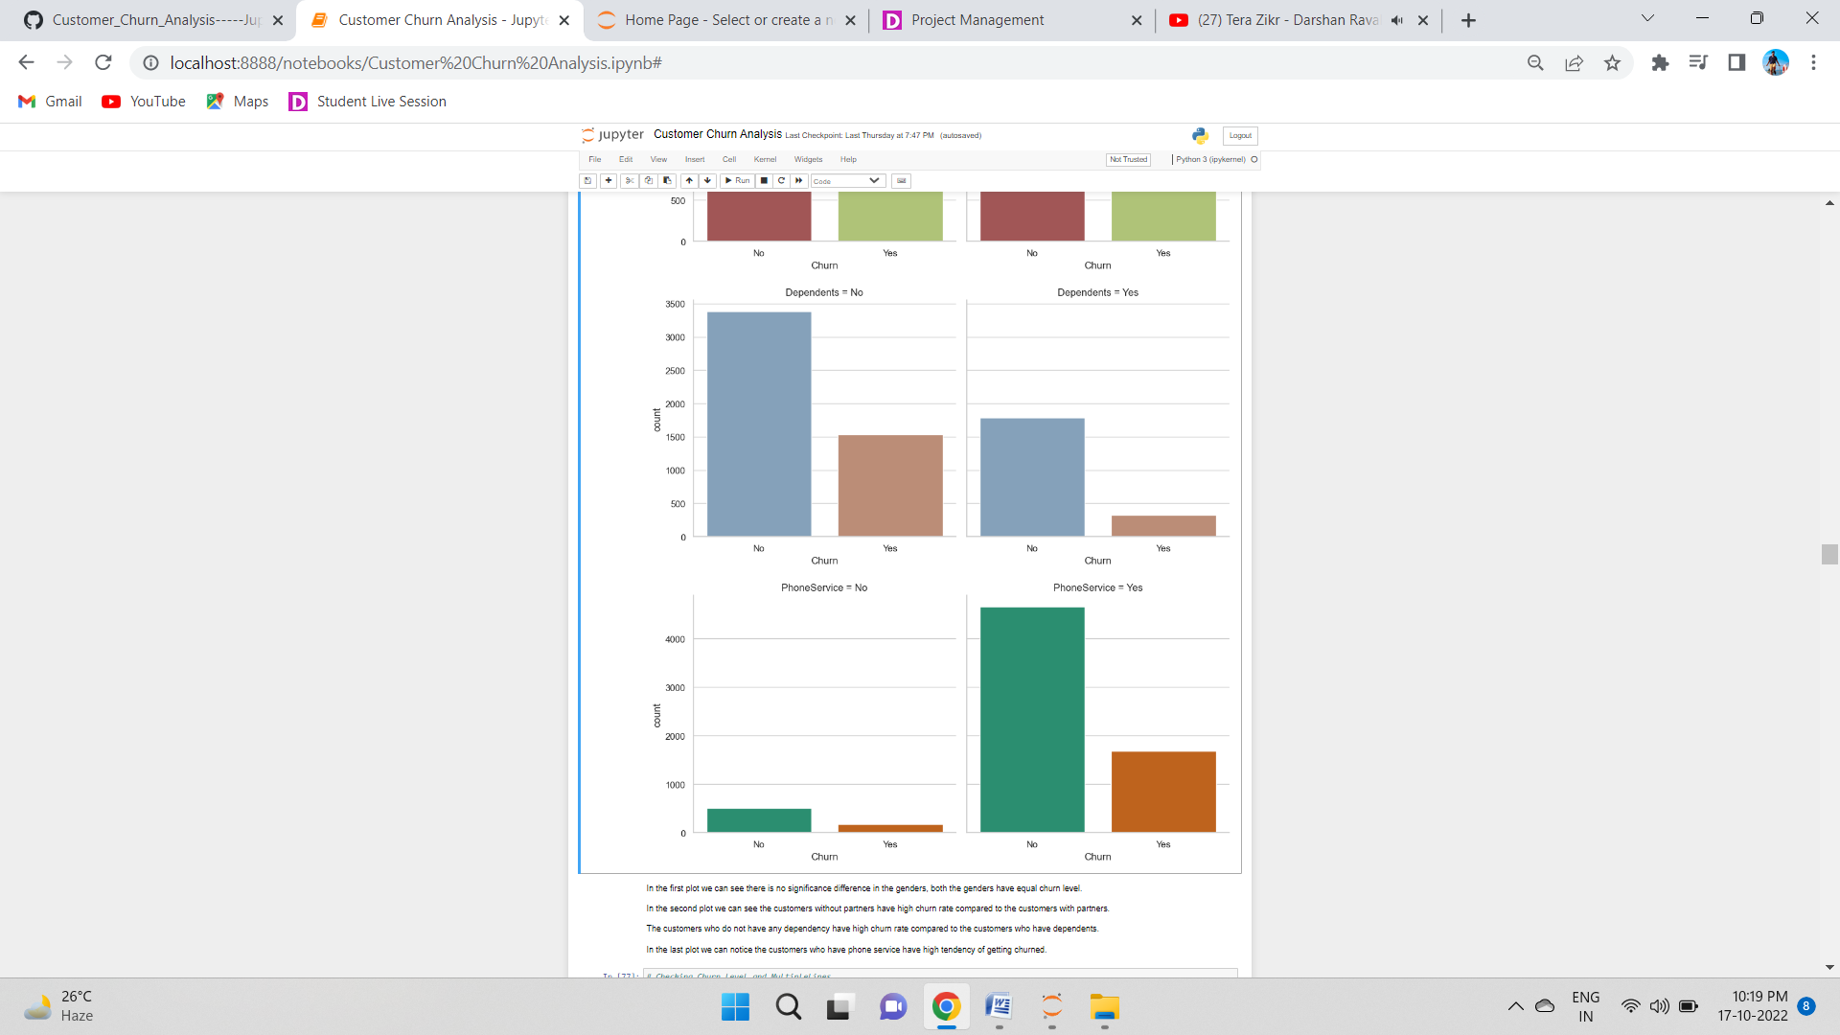



## In the first plot we can see there is no significance difference in the genders, both the genders have equal churn level.

## In the second plot we can see the customers without partners have high churn rate compared to the customers with partners.

## The customers who do not have any dependency have high churn rate compared to the customers who have dependents.

## In the last plot we can notice the customers who have phone service have high tendency of getting churned.

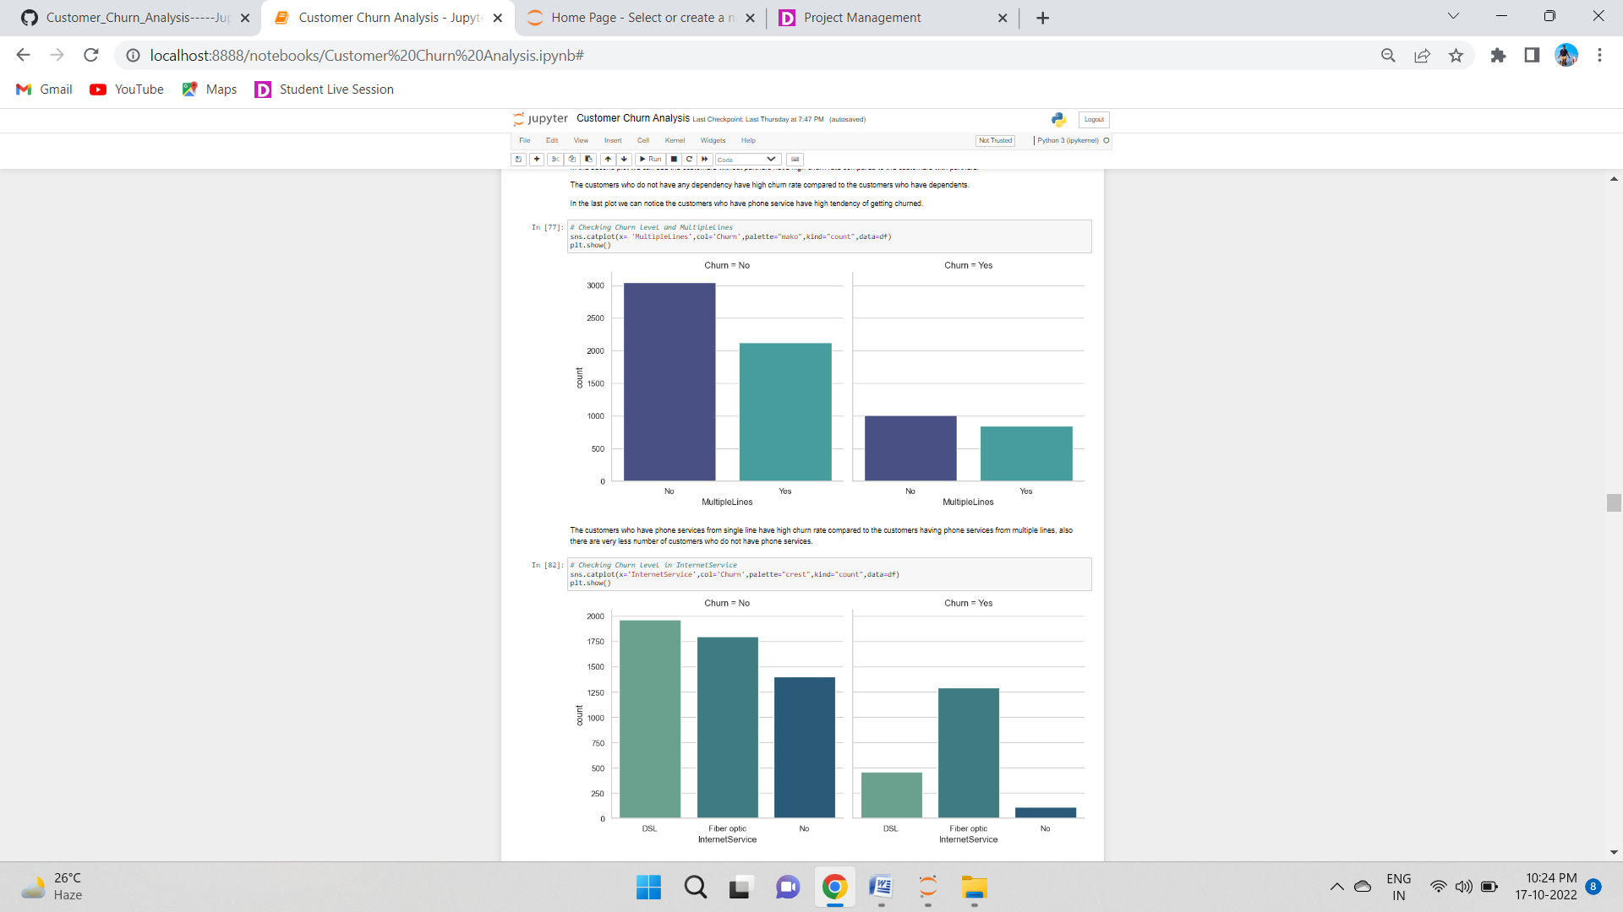

The customers who have phone services from single line have high churn rate compared to the customers having phone services from multiple lines, also there are very less number of customers who do not have phone services.

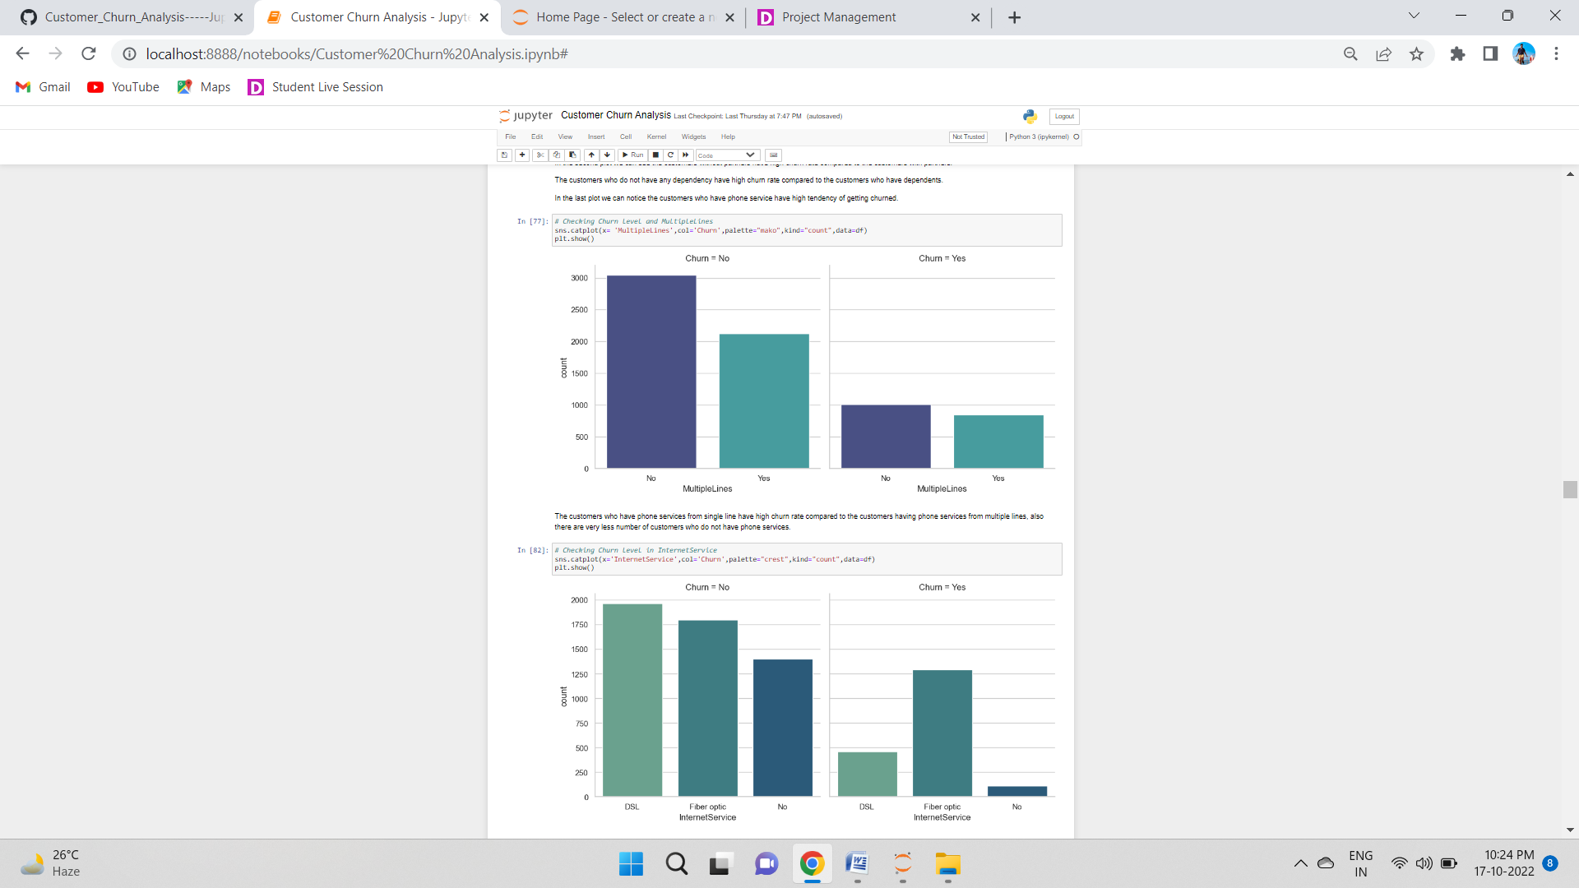

The ratio of churn is high when the customers prefer Fiber optic internet services compared to other services, may be this type of service is bad and need to be focused on. And the customers who own DSL service they have very less churn rate.

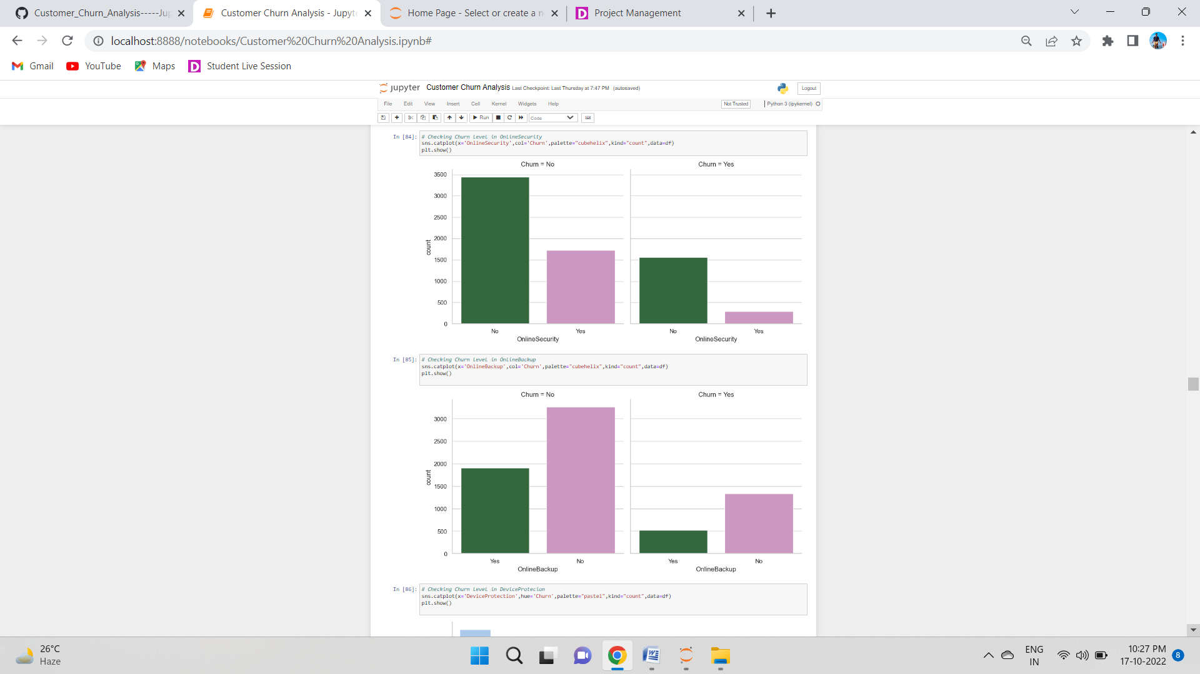

The customers who have no internet service have very less churn rate and the customers who do not have online security services have high tendency to getting churned.



The customers who do not have internet services they do not need any online backup. The customers who do not have online backup services they have high churn rate.

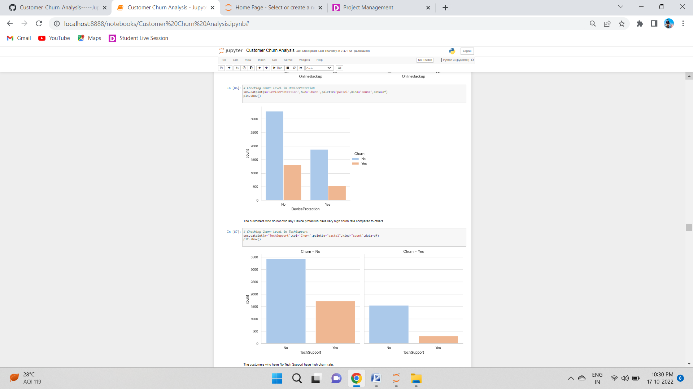

The customers who do not own any Device protection have very high churn rate compared to others.

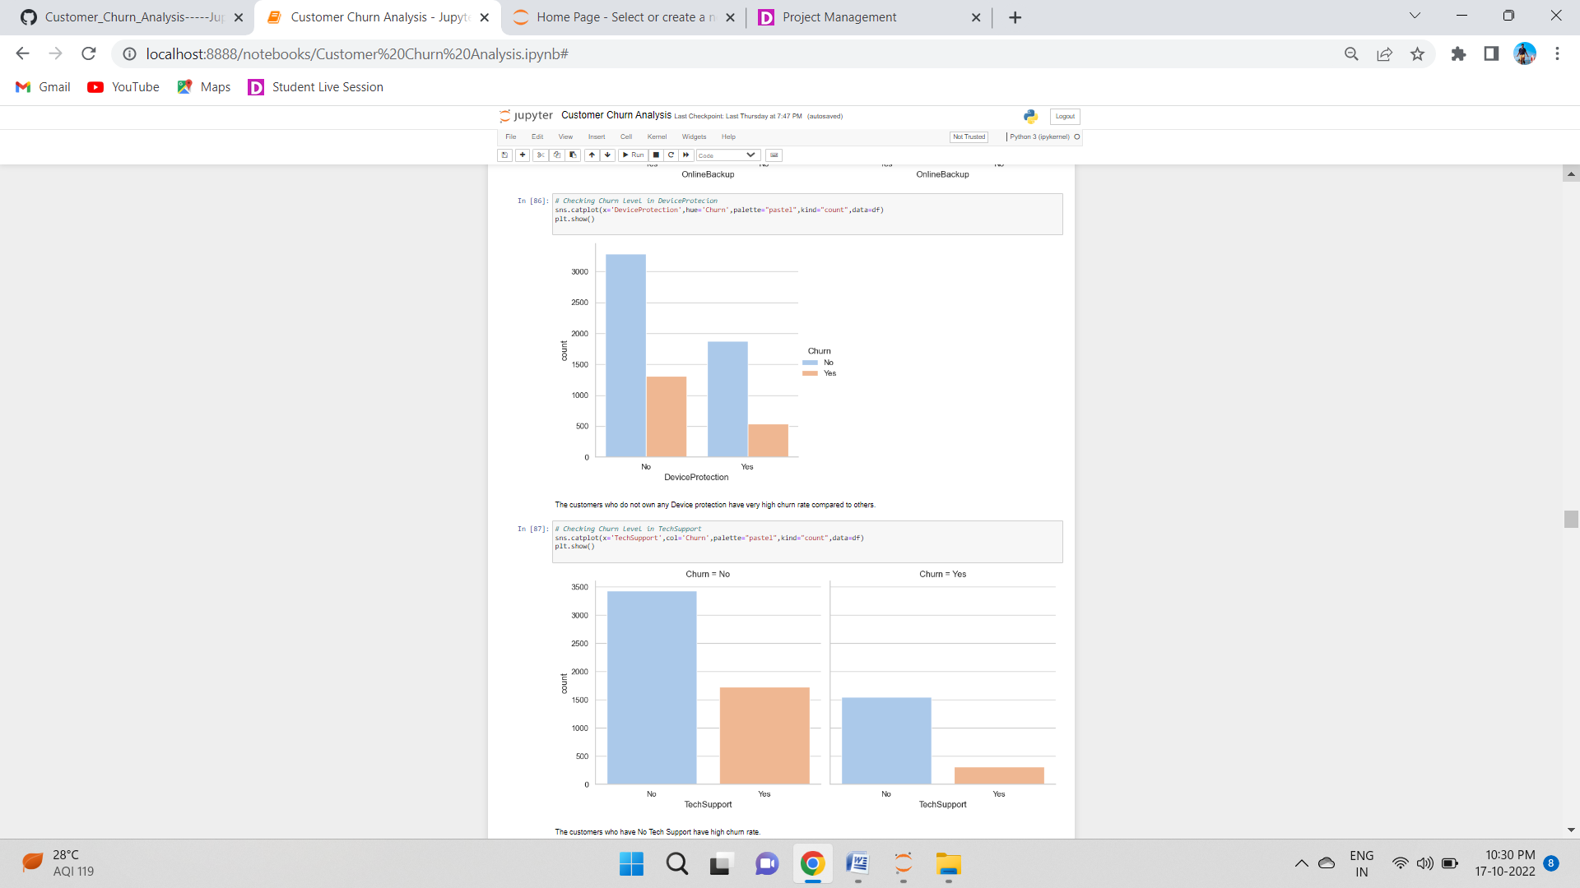

The customers who have No Tech Support have high churn rate.

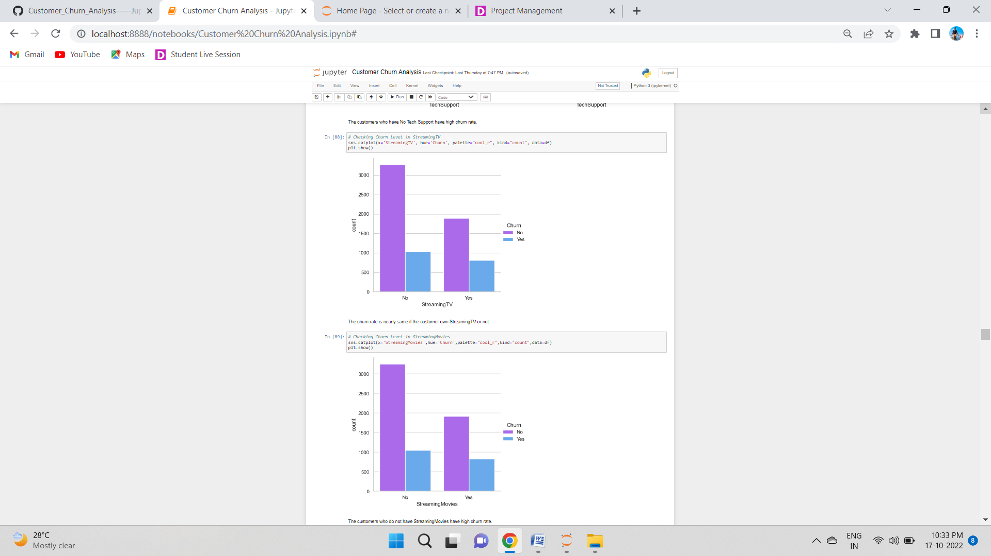

The churn rate is nearly same if the customer own StreamingTV or not.

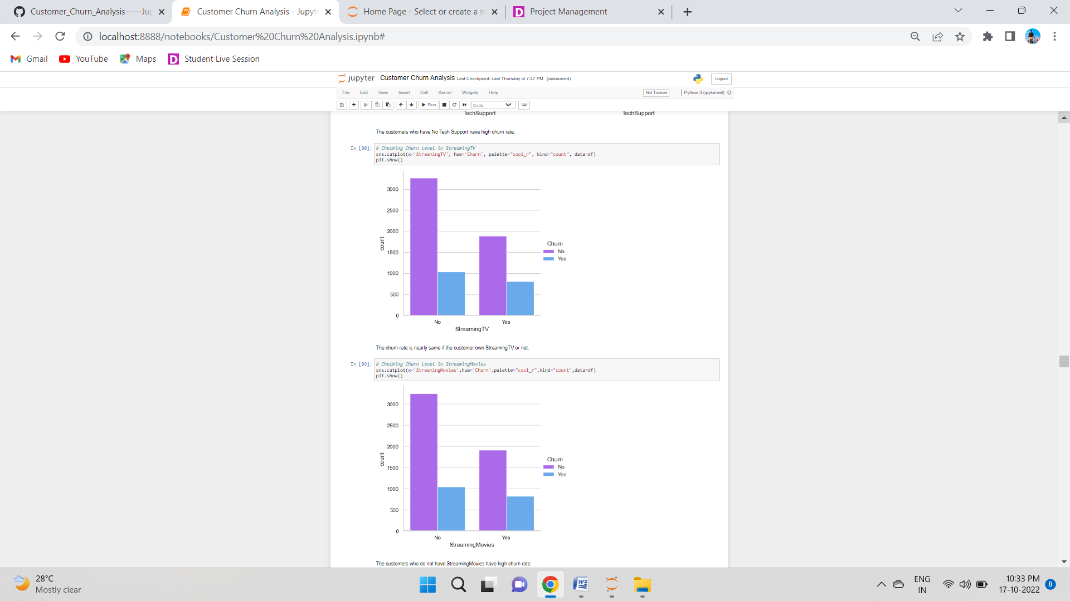

The customers who do not have StreamingMovies have high churn rate.

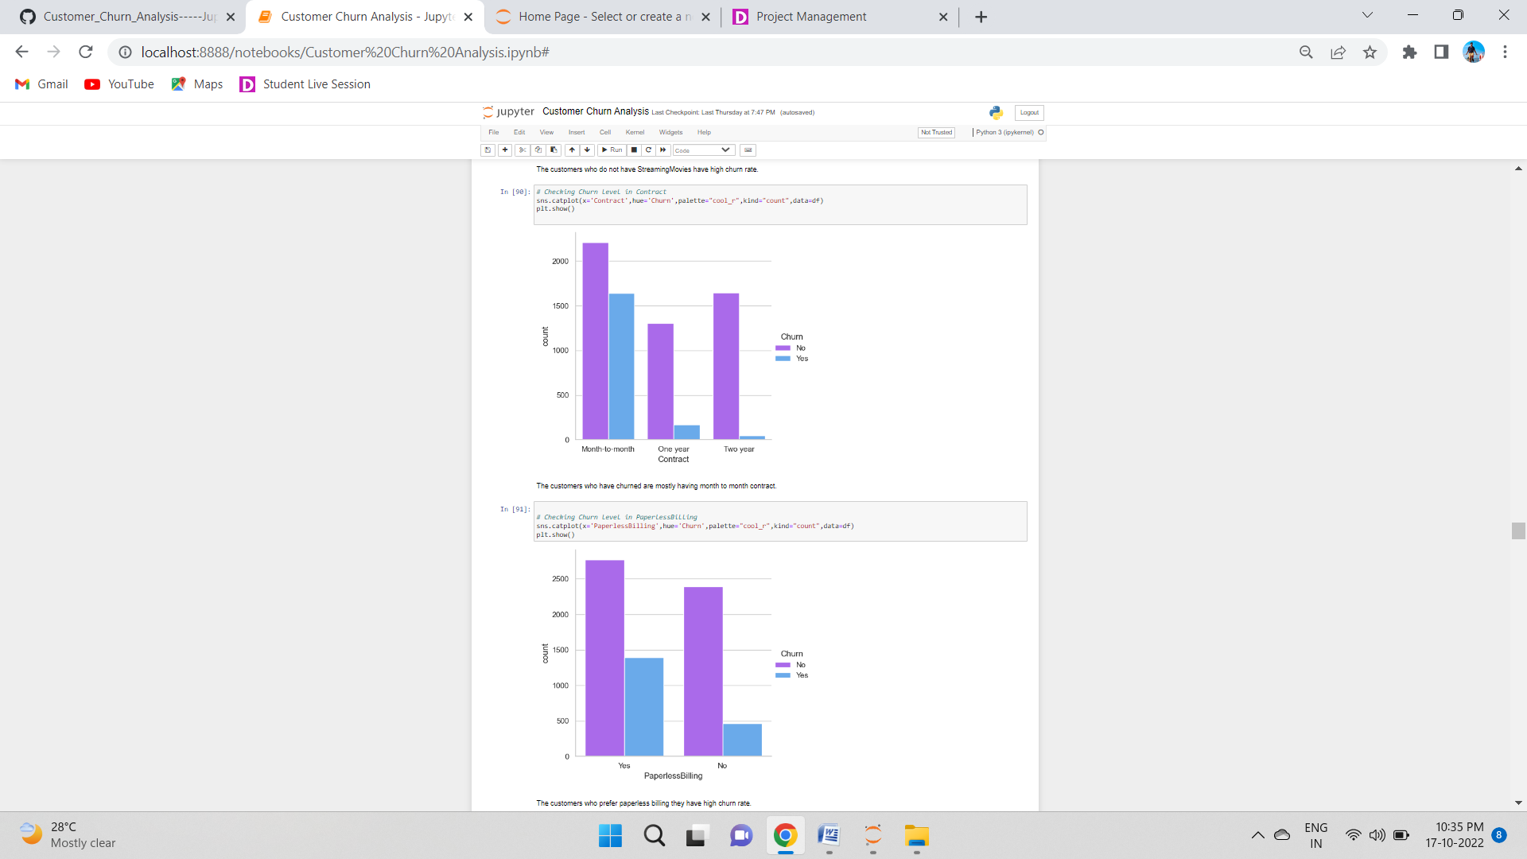

The customers who have churned are mostly having month to month contract.



The customers who prefer paperless billing they have high churn rate.

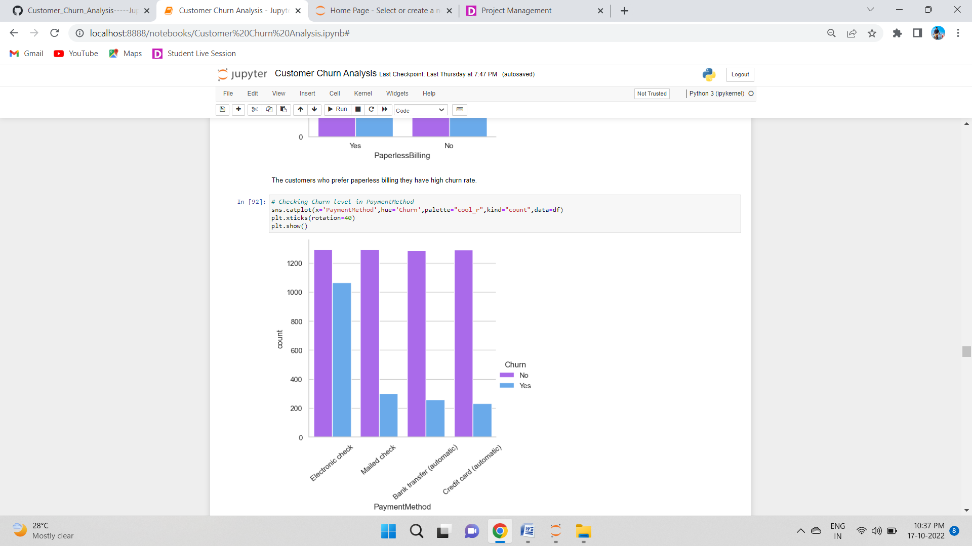

Customers who use "Electronic check" payment have higher churn rate compared to other types of payments.

***Multivariate Analysis***

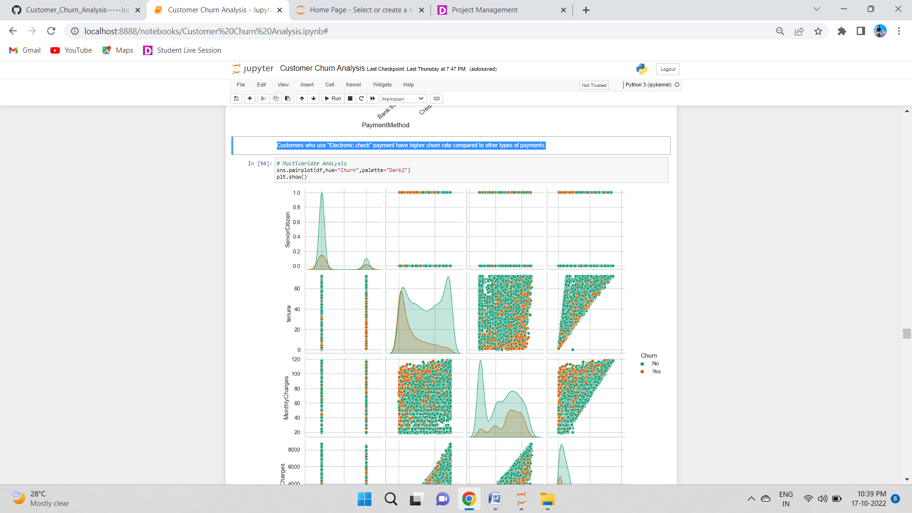

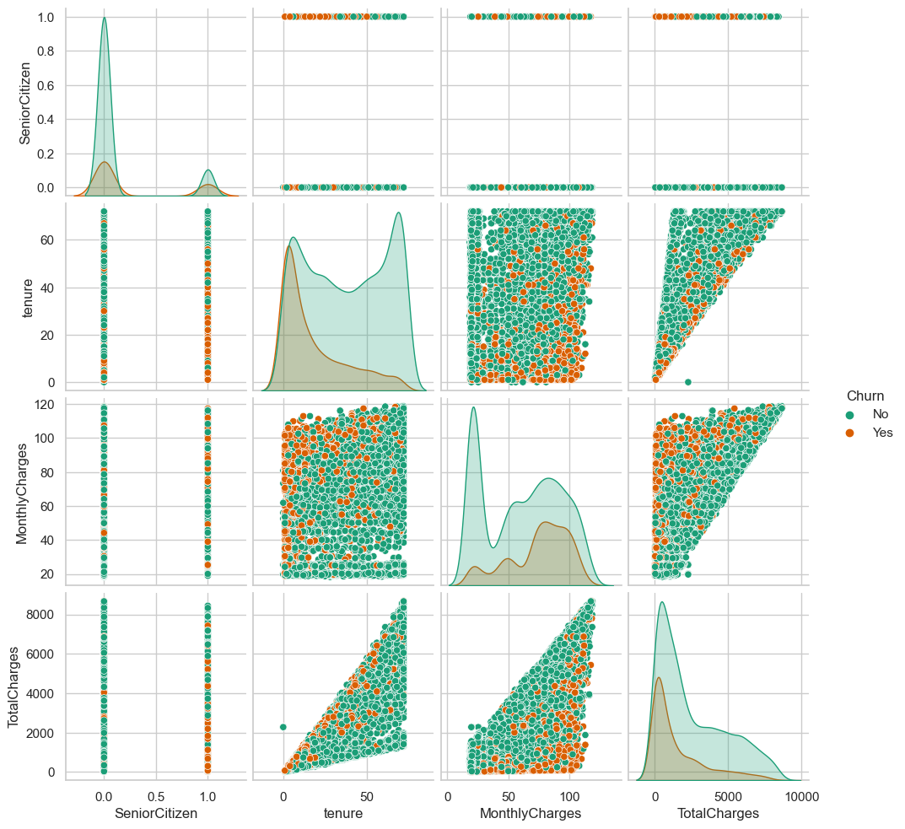

The pairplot gives the pairwise relation between the features on the basis of the target "Churn". On the diagonal we can notice the distribution plots.

The features tenure and TotalCharges, Monthlycharges and TotalCharges have strong linear relation with each other.

There are no outliers in any of the columns but let's plot box plot to identify the outliers.

# Data Preprocessing:

## *Identifying the outliers:*

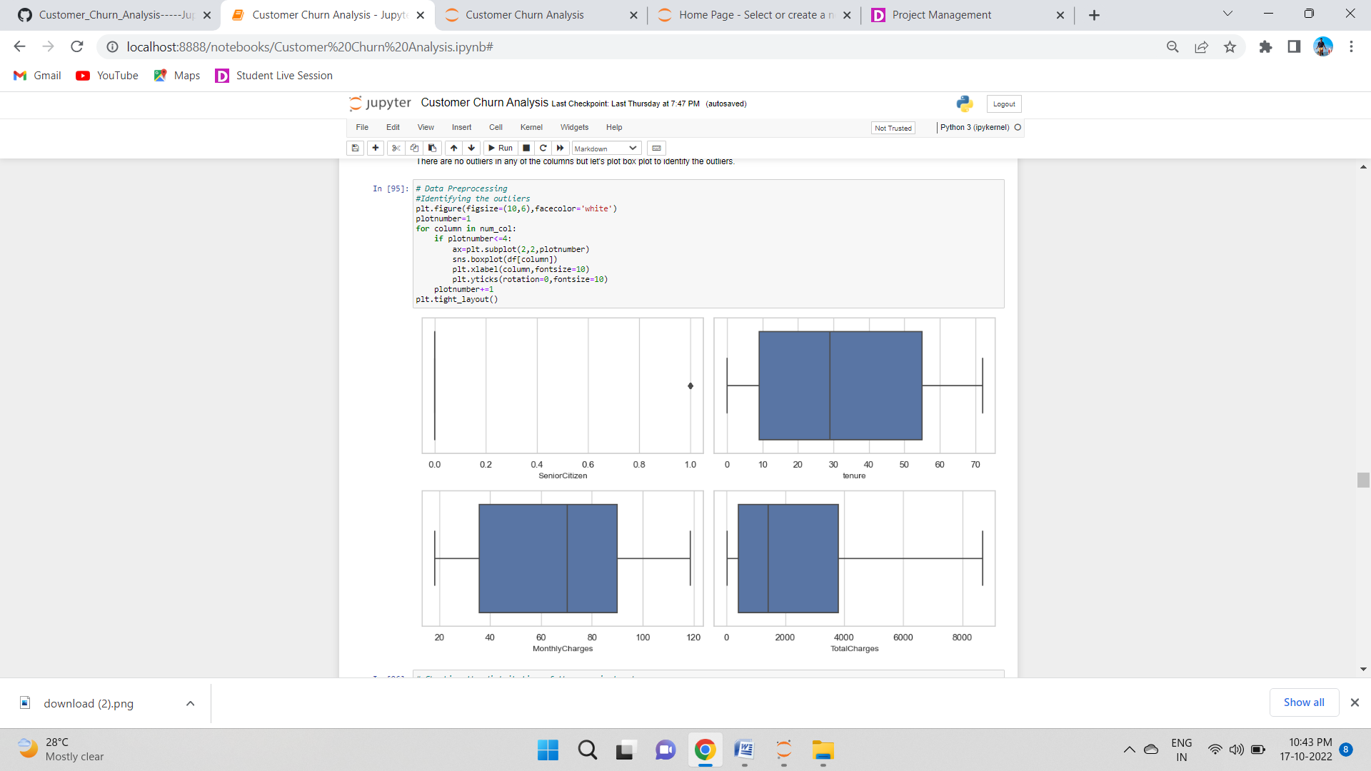

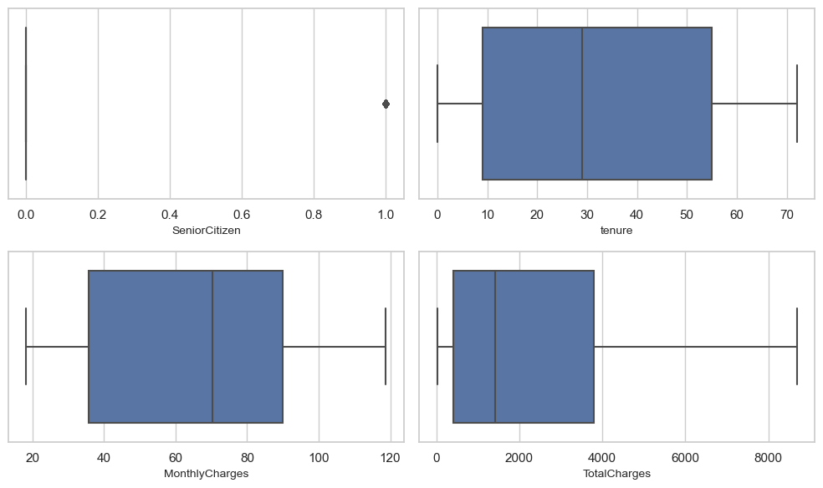

The column Senior Citizen has outliers but it contains categorical data so no need to remove outliers. Apart from this none of the columns have outliers. Since all the other columns are categorical columns Hence we dont have to use z score methodd to remove the outliers.

## Checking the distribution of the numerical columns:

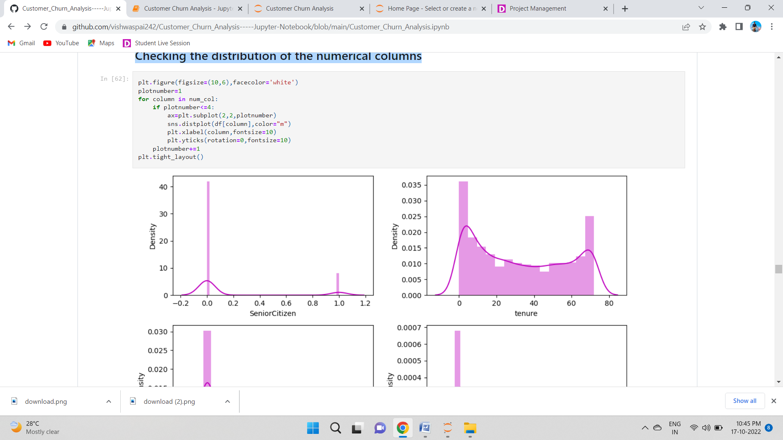

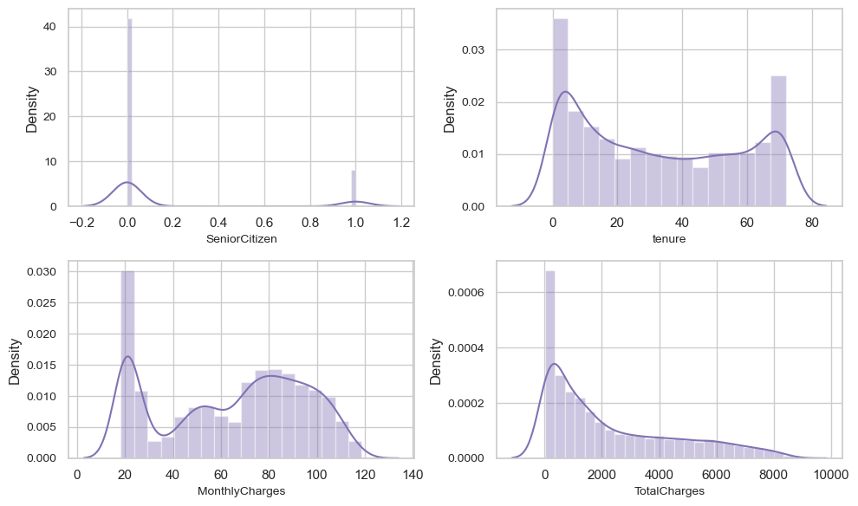

From the above distribution plots we can notice that the data in SeniorCitizen is heavily skewed. And the data in the column TotalCharges is skewed to right. Other two columns tenure and MonthlyCharges do not have much skewness.

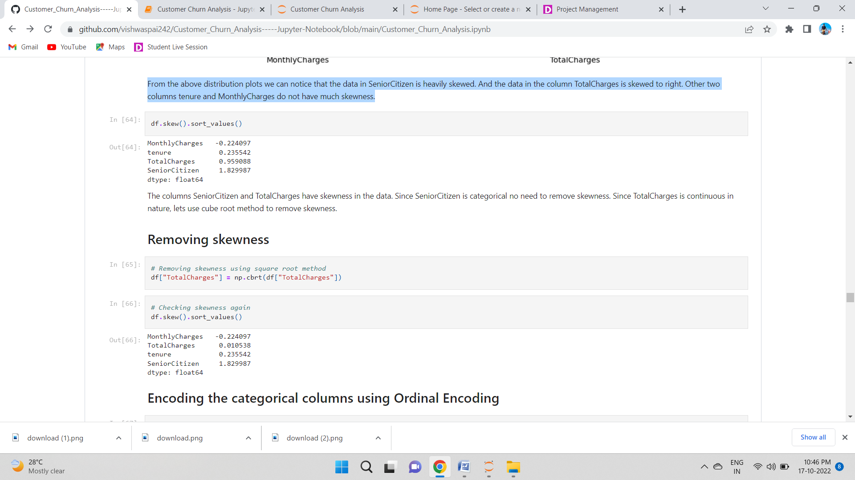

The columns SeniorCitizen and TotalCharges have skewness in the data. Since SeniorCitizen is categorical no need to remove skewness. Since TotalCharges is continuous in nature, lets use cube root method to remove skewness.

## Removing skewness:

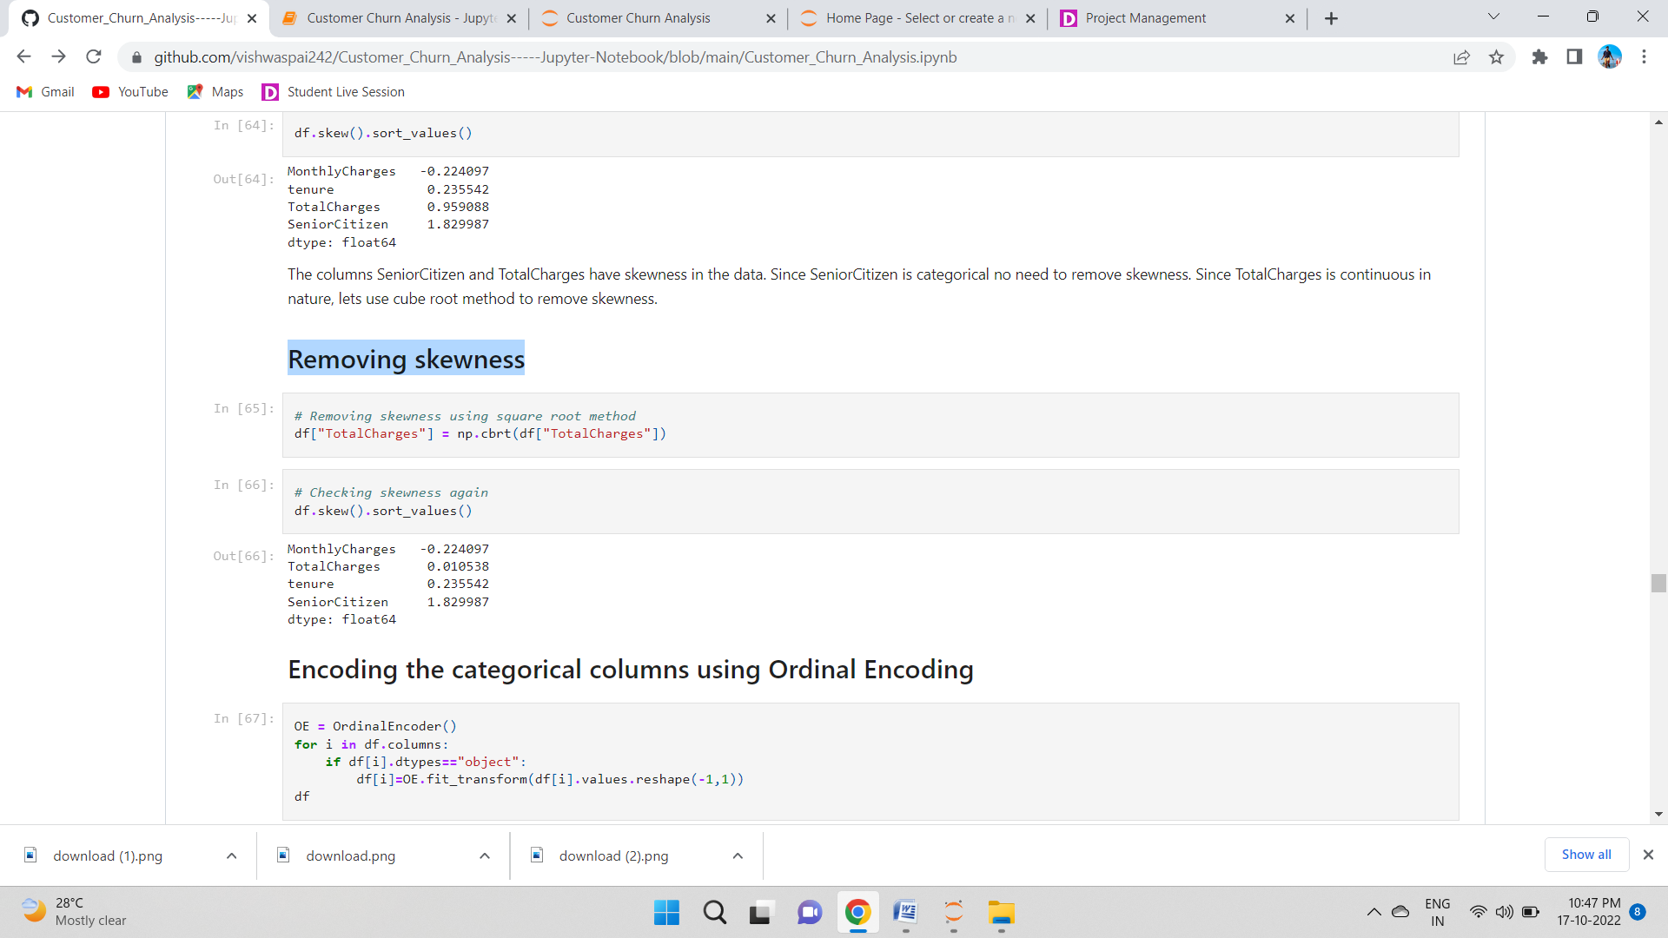

## Encoding the categorical columns using Ordinal Encoding

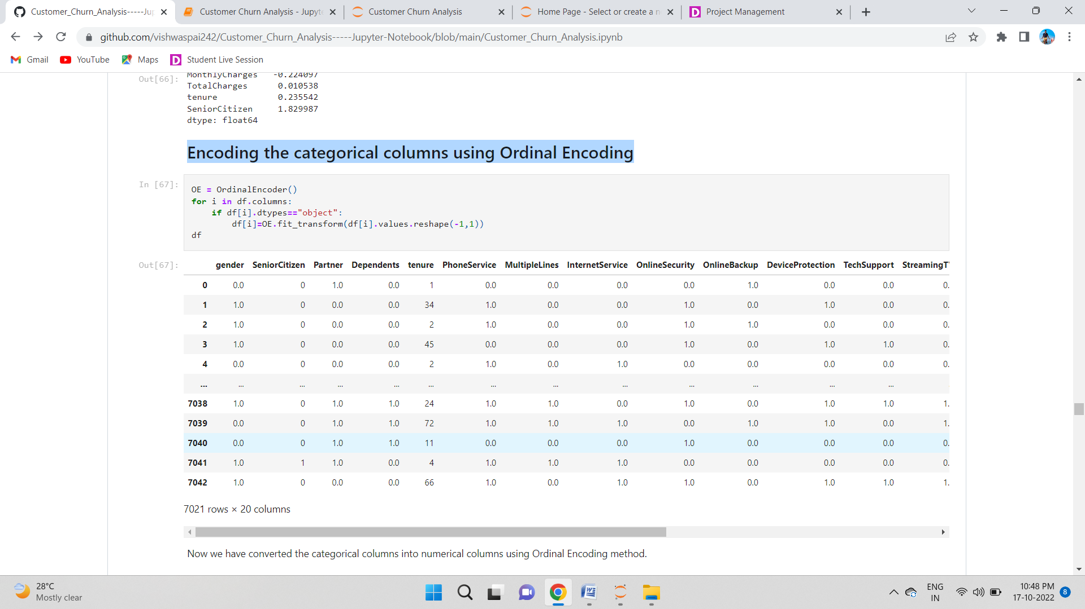

Now we have converted the categorical columns into numerical columns using Ordinal Encoding method.

## Statistical Summary of the DataSet:

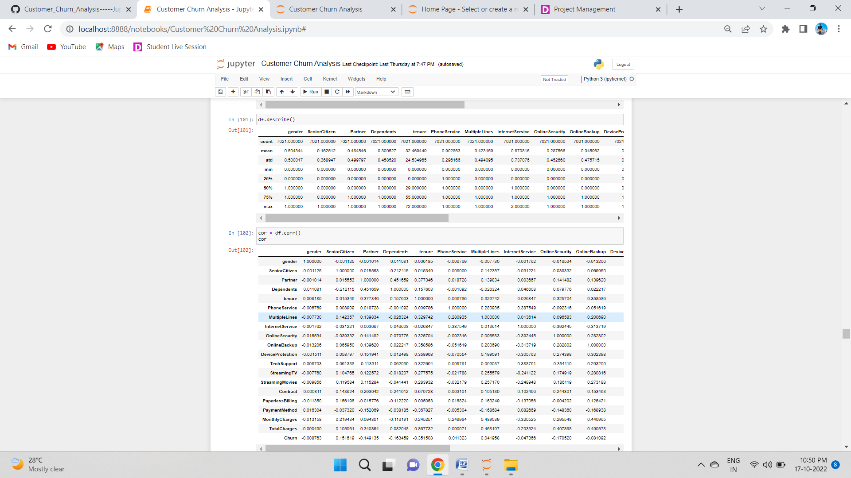

After encoding the categorical column we are able to see all the columns details here. The counts of all the columns are same that means no null values in the dataset. This describe method describes the count, mean, standard deviation, min, IQR and max values of all the columns.

## Checking Correlation:

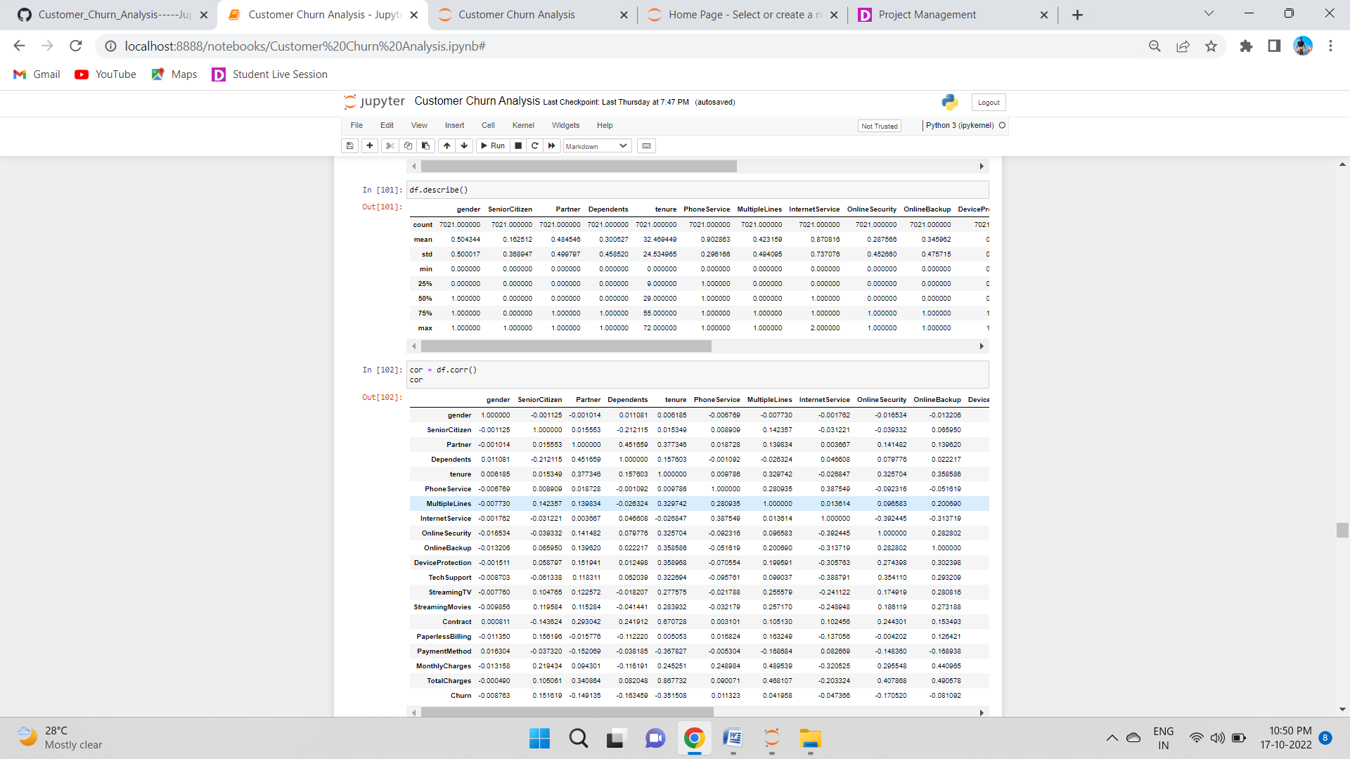

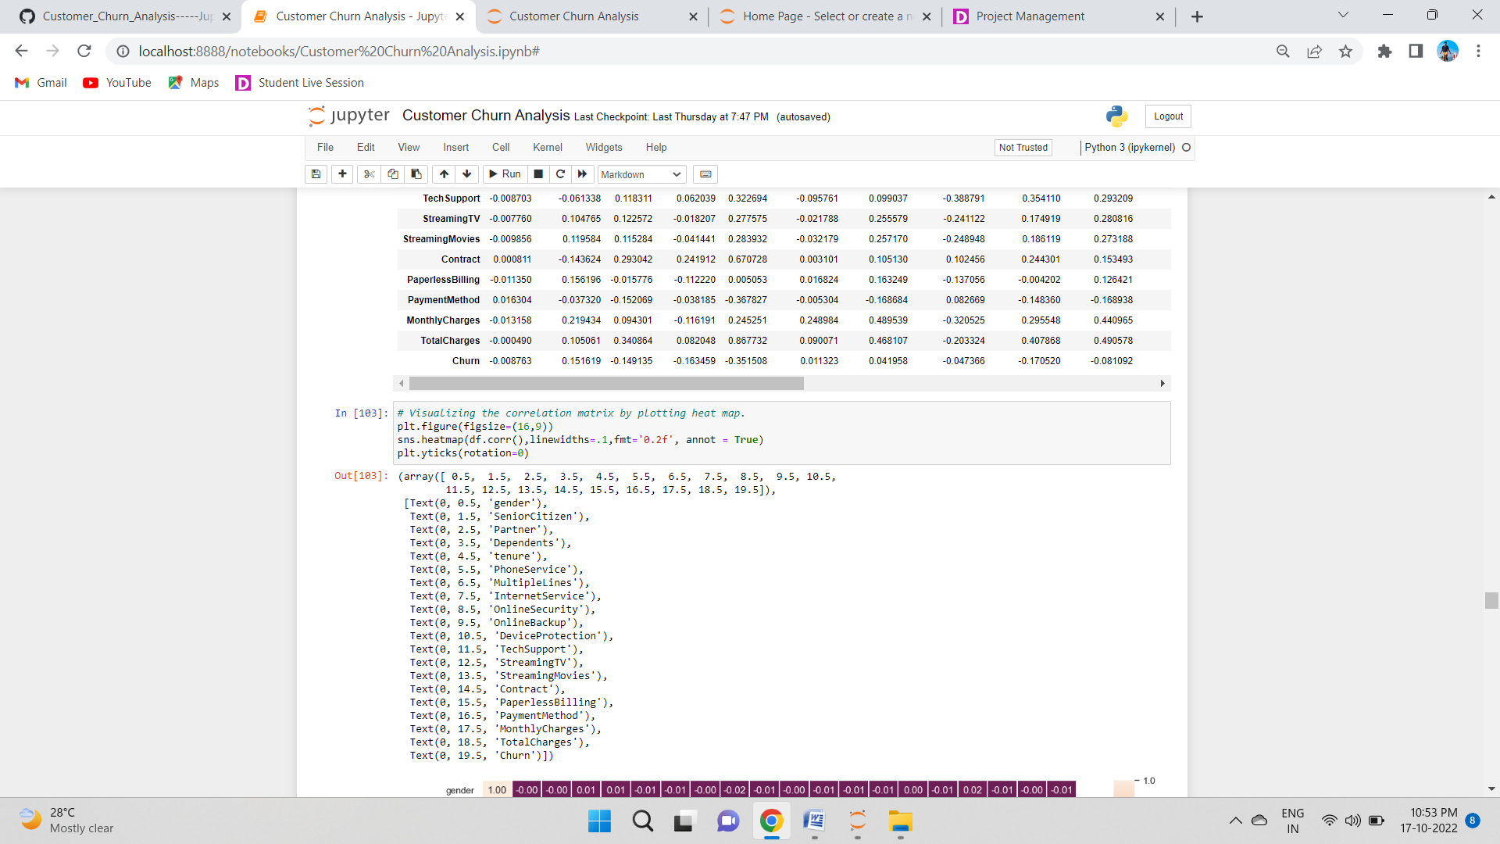

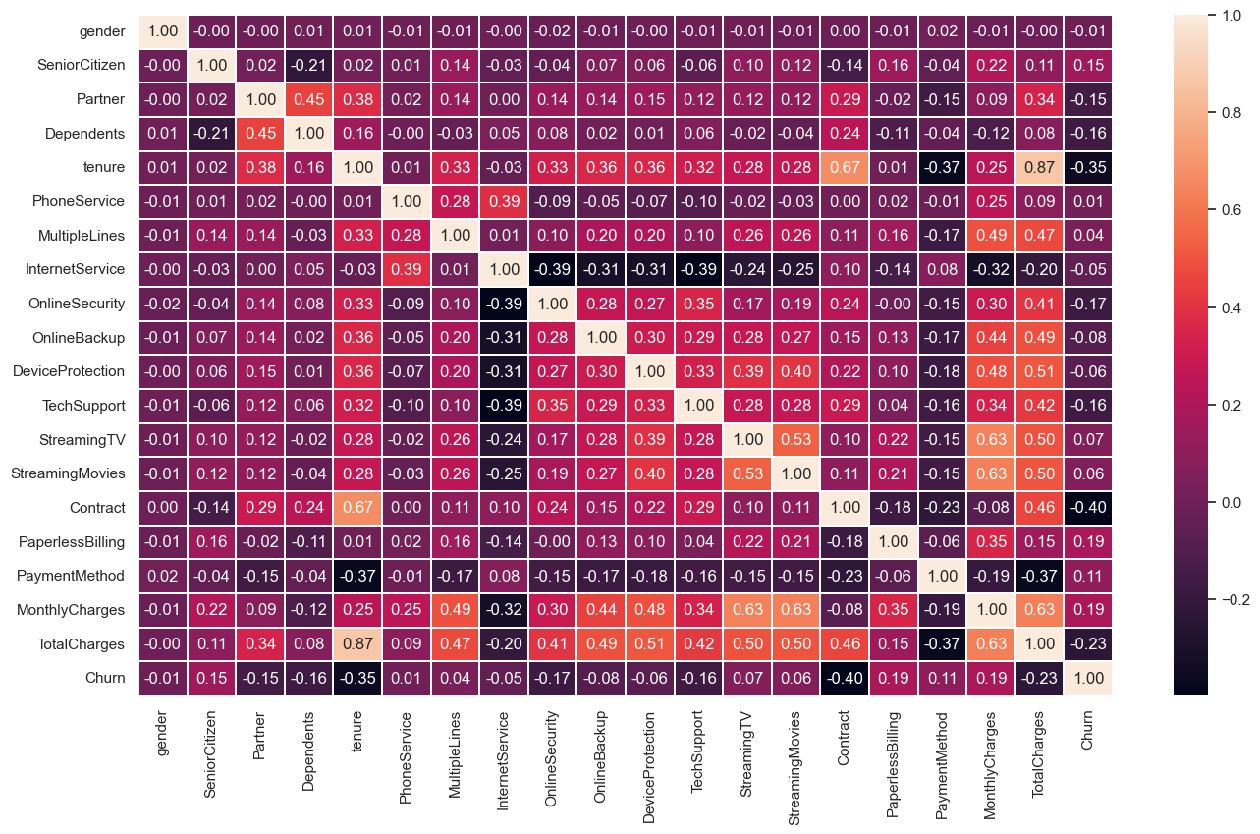

This heatmap shows the correlation matrix by visualizing the data. we can observe the relation between feature to feature and feature to label. This heat mapcontains both positive and negative correlation.

There is no much positive correlation between the target and features.

The columns MonthlyCharges, PaperlessBilling, SeniorCitizen and PaymentMethod have positive correlation with the label Churn.

The label is negatively correlated with Contract, tenure, OnlineSecurity, TechSupport, TotalCharges, DeviceProtection, OnlineBackup, Partner and Dependents.

Also the column gender has very less correlation with the label.The columns TotalCharges and tenure, Contract and tenure, TotalCharges and MonthlyCharges and many other columns have high correlation with each other. This leads to multicolllinearity issue, to overcome with this problem we will check VIF values and then we will drop the columns having VIF above 10.

## Visualizing the correlation between label and features using bar plot:

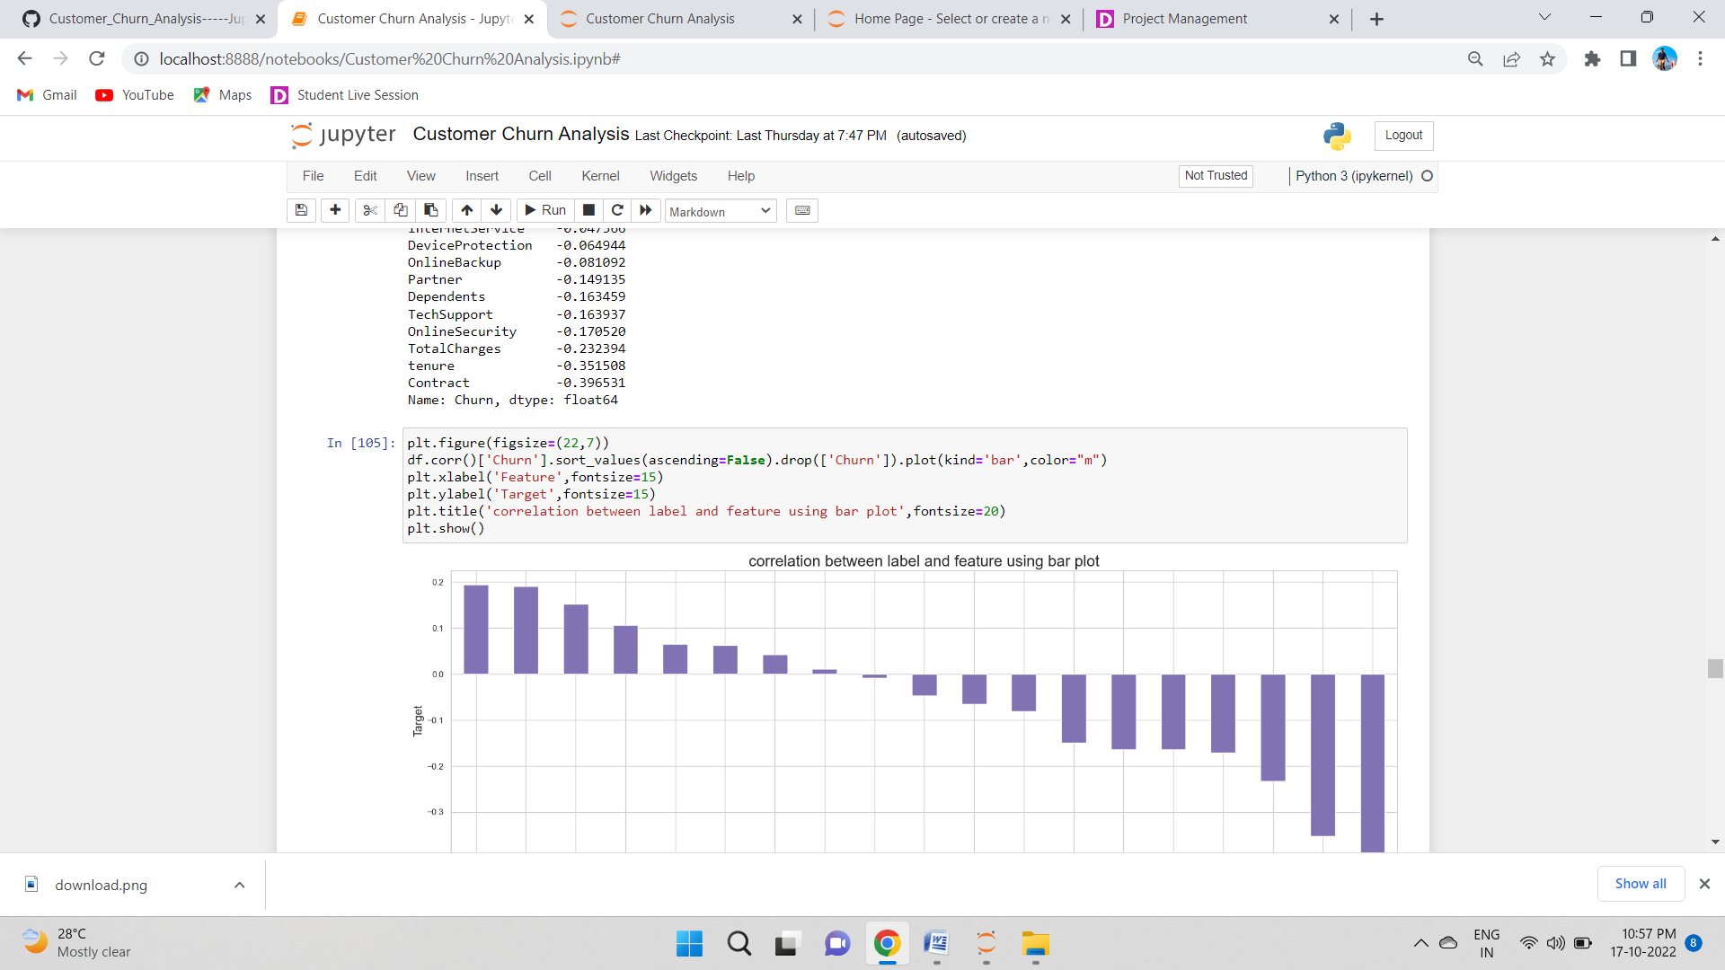

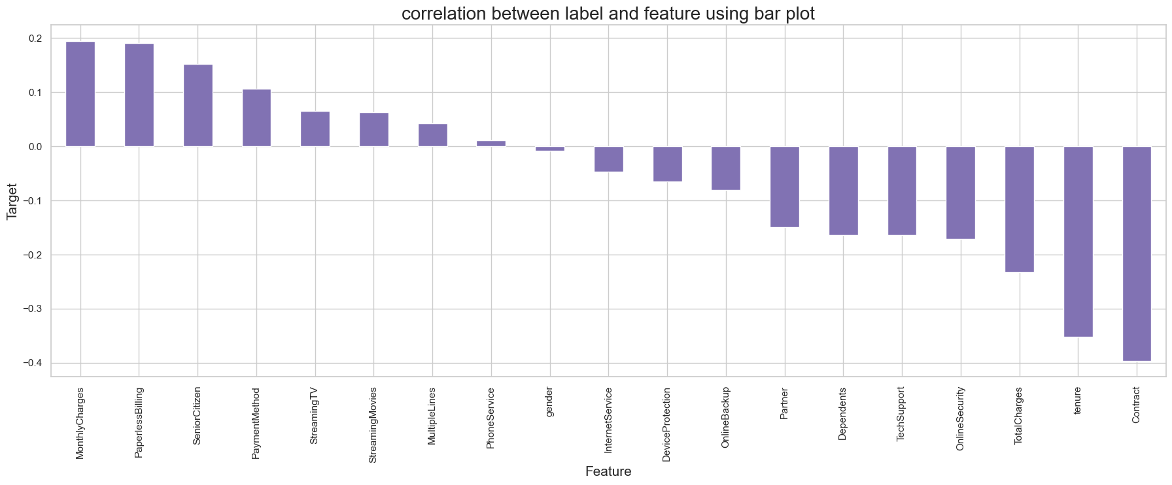

From the above bar plot we can notice the positive and negative correlation between the features and the target. Here the features gender and PhoneService have very less correlation with the column.

## Separating the feature and label into x and y:

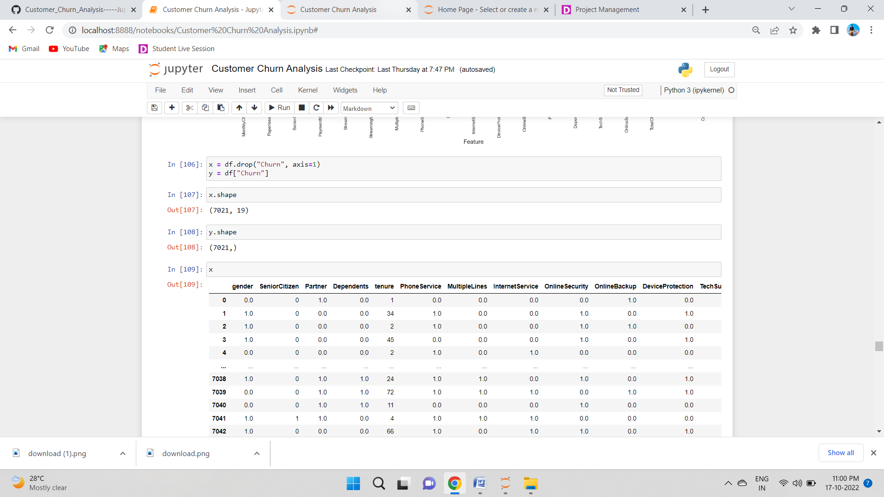

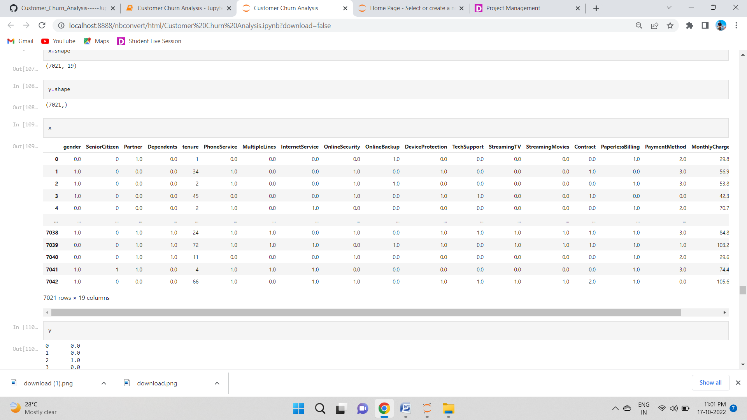

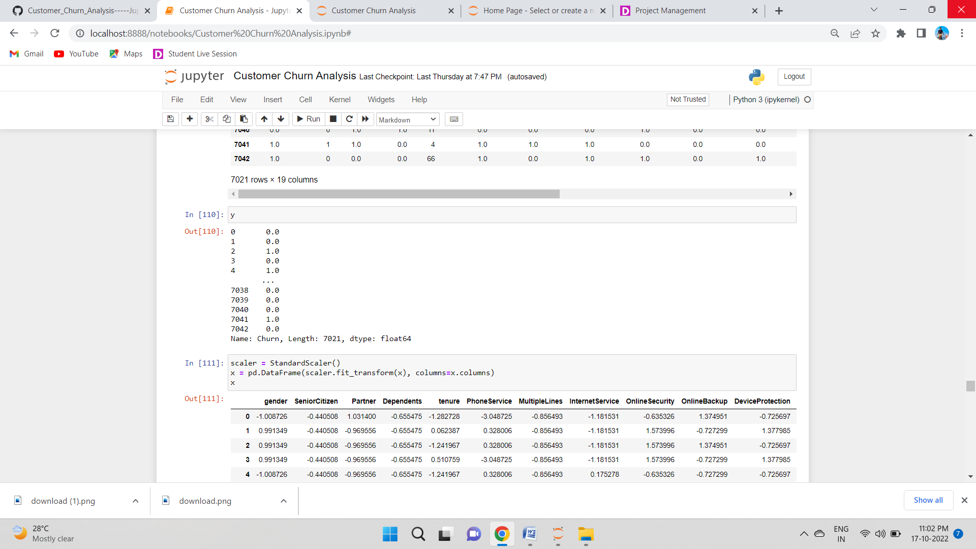

## Feature Scaling using Standard Scalarization:

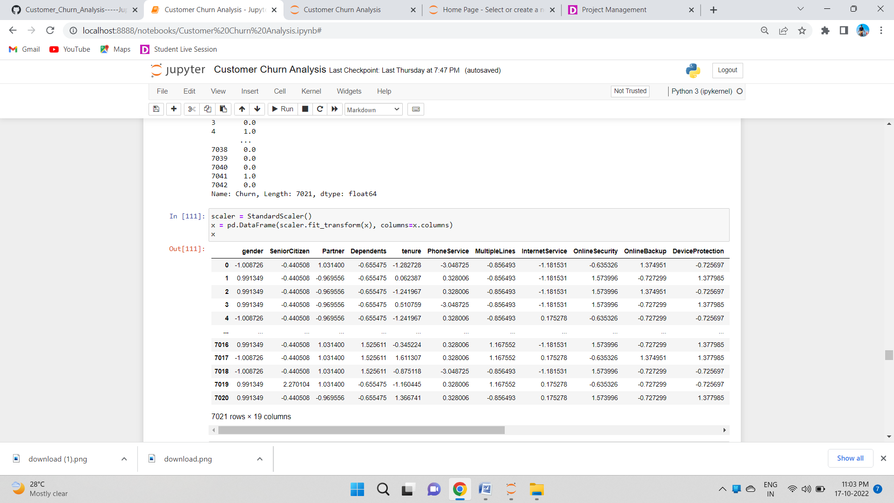



We have scaled the data using standard scalarizaion method to overcome with the issue of data biasness.

## Checking Multicollinearity:

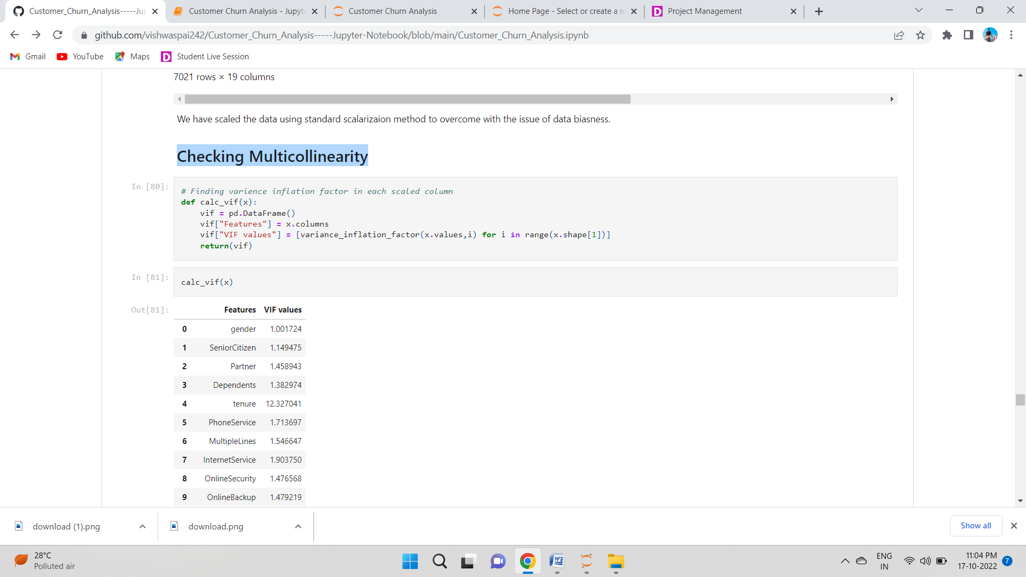

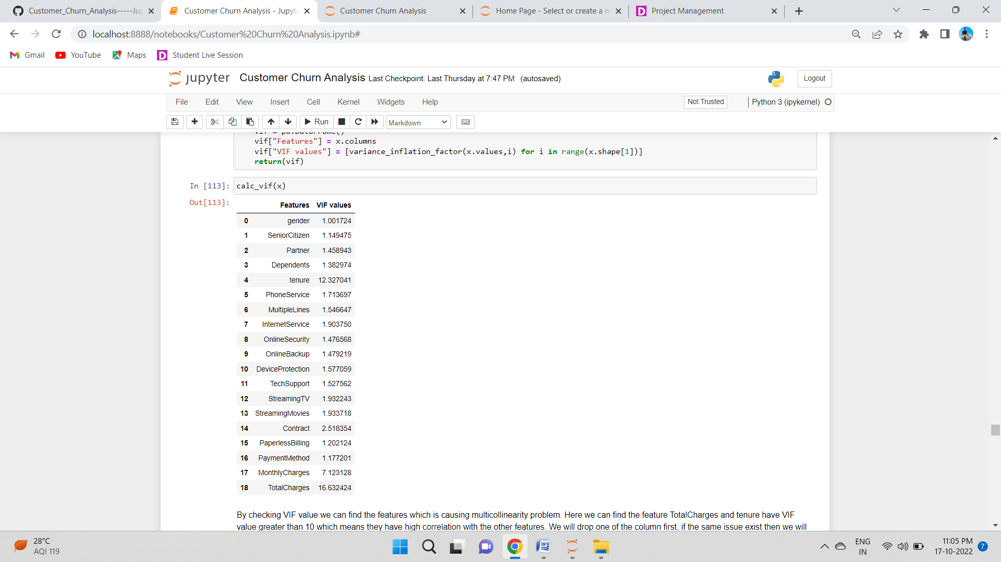

By checking VIF value we can find the features which is causing multicollinearity problem. Here we can find the feature TotalCharges and tenure have VIF value greater than 10 which means they have high correlation with the other features. We will drop one of the column first, if the same issue exist then we will try to remove the column having high VIF(above 10).

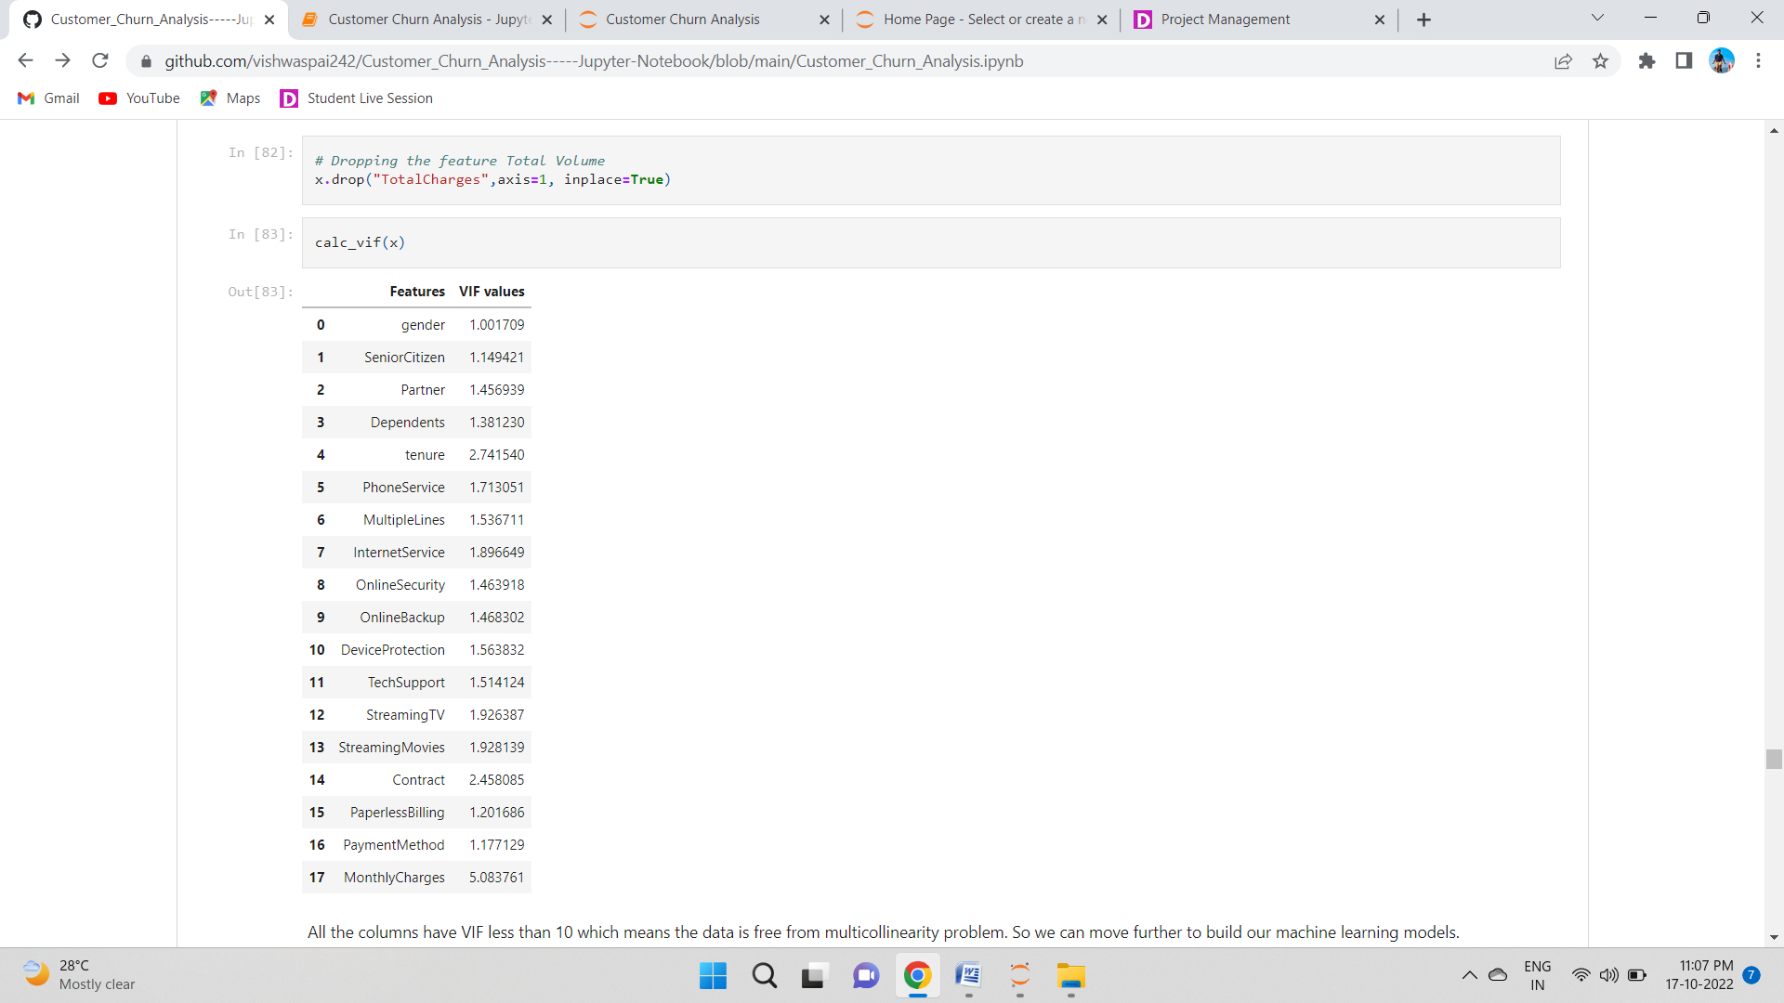

All the columns have VIF less than 10 which means the data is free from multicollinearity problem. So we can move further to build our machine learning models.

## SMOTE:

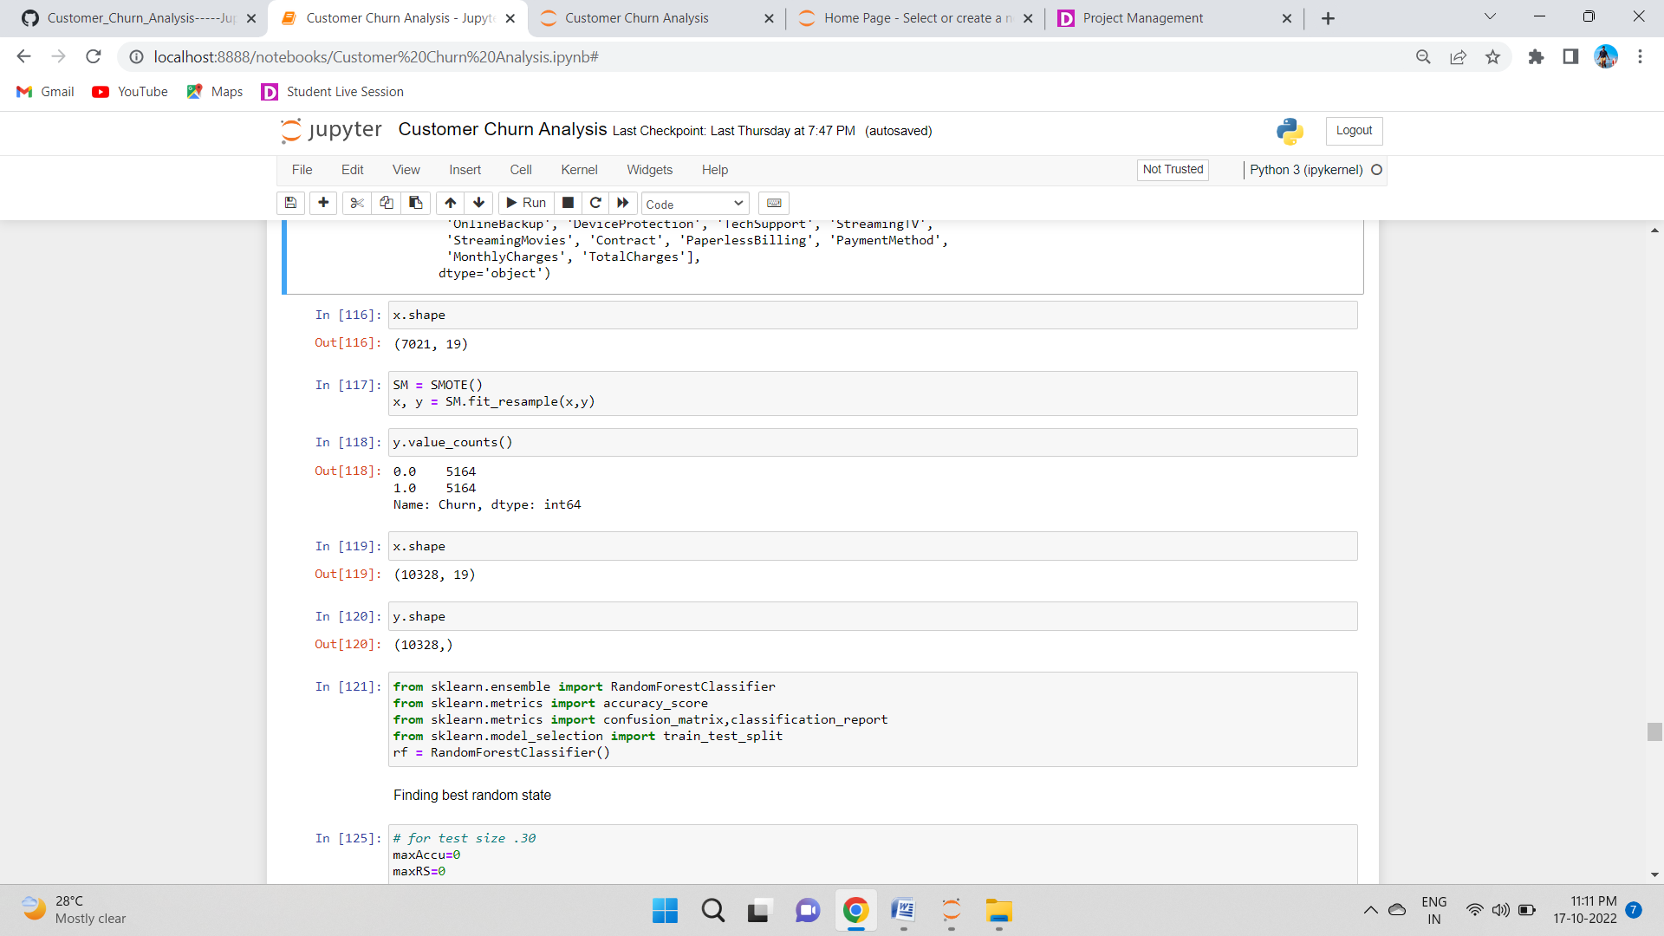

# Machine Learning

### Finding best random state:

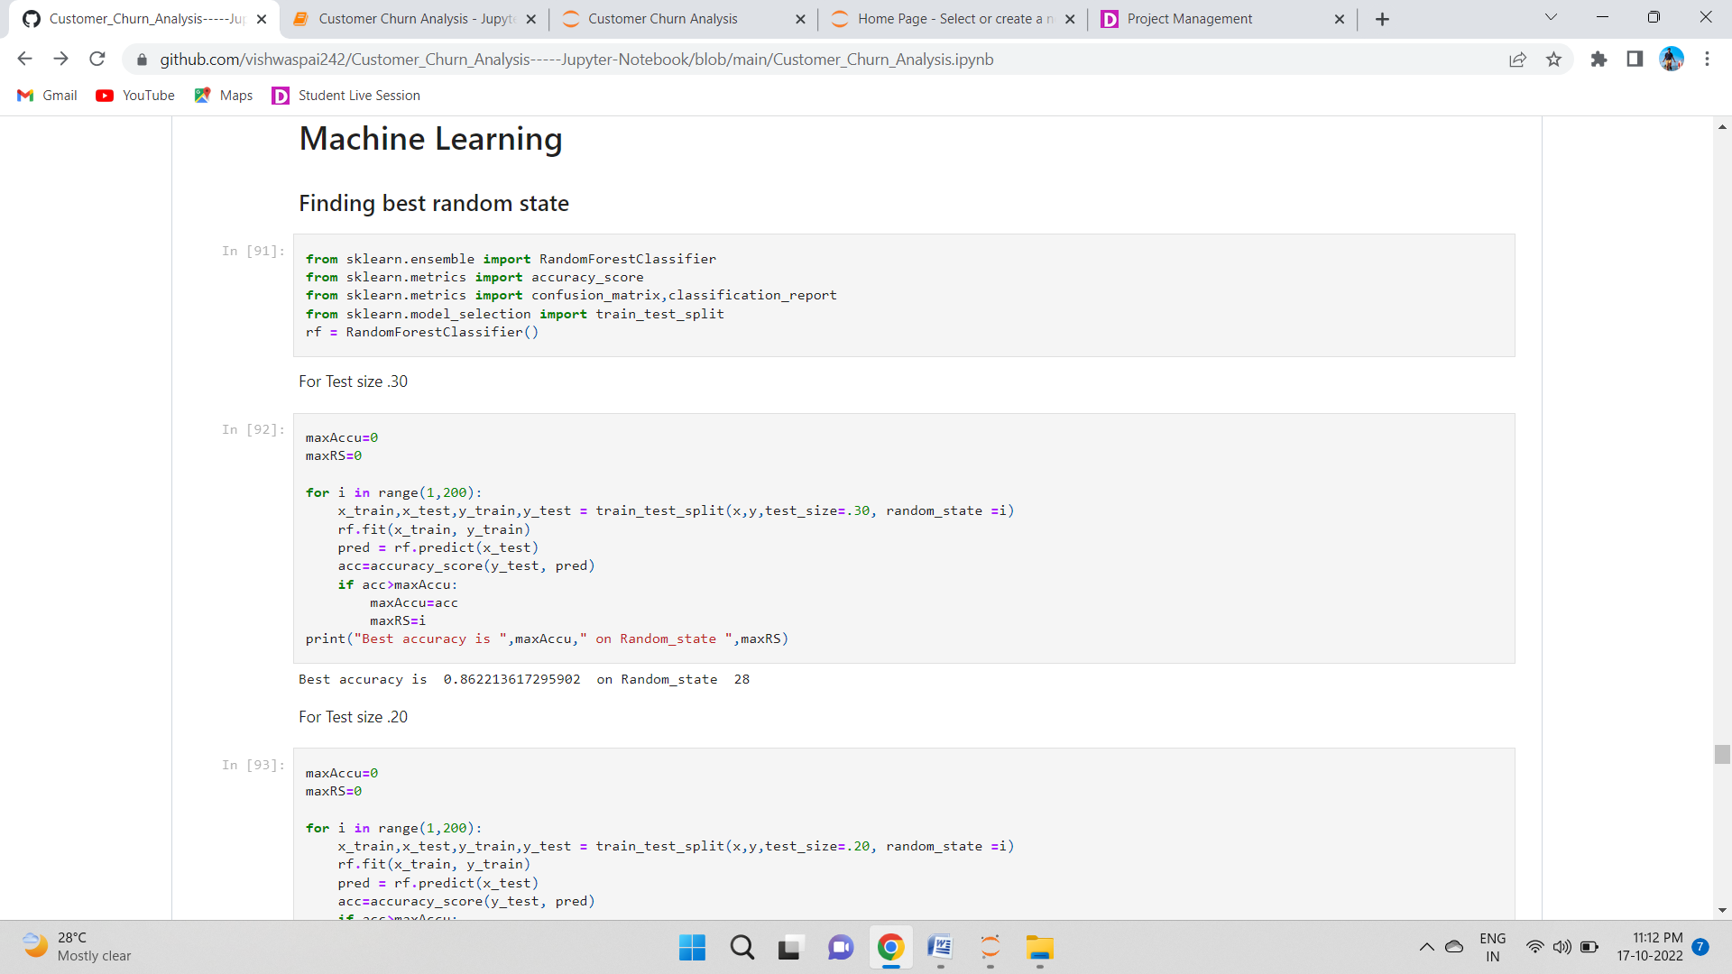

We need to Import Some Library

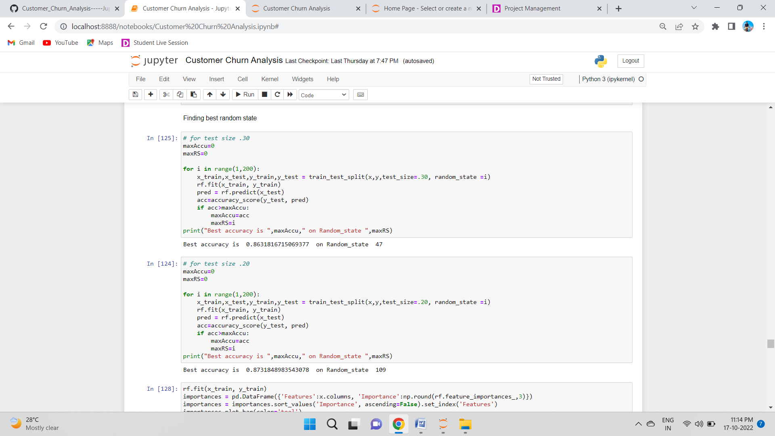

## Feature importance bar graph:

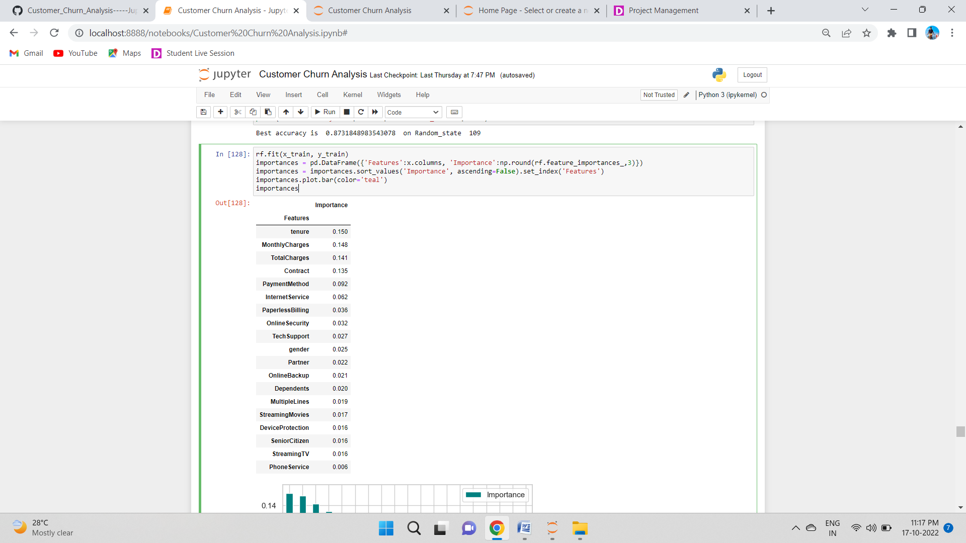

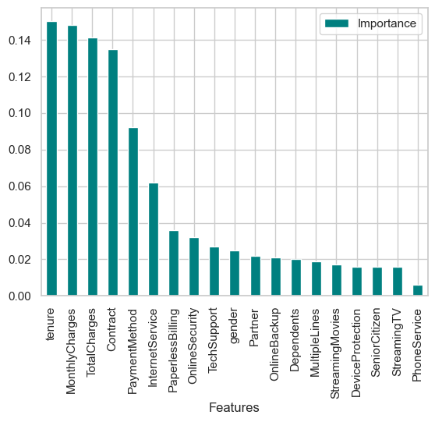

This bar plot shows us the importance of the features using random forest algorithm on predicting our Target variable.

## Creating train_test split:

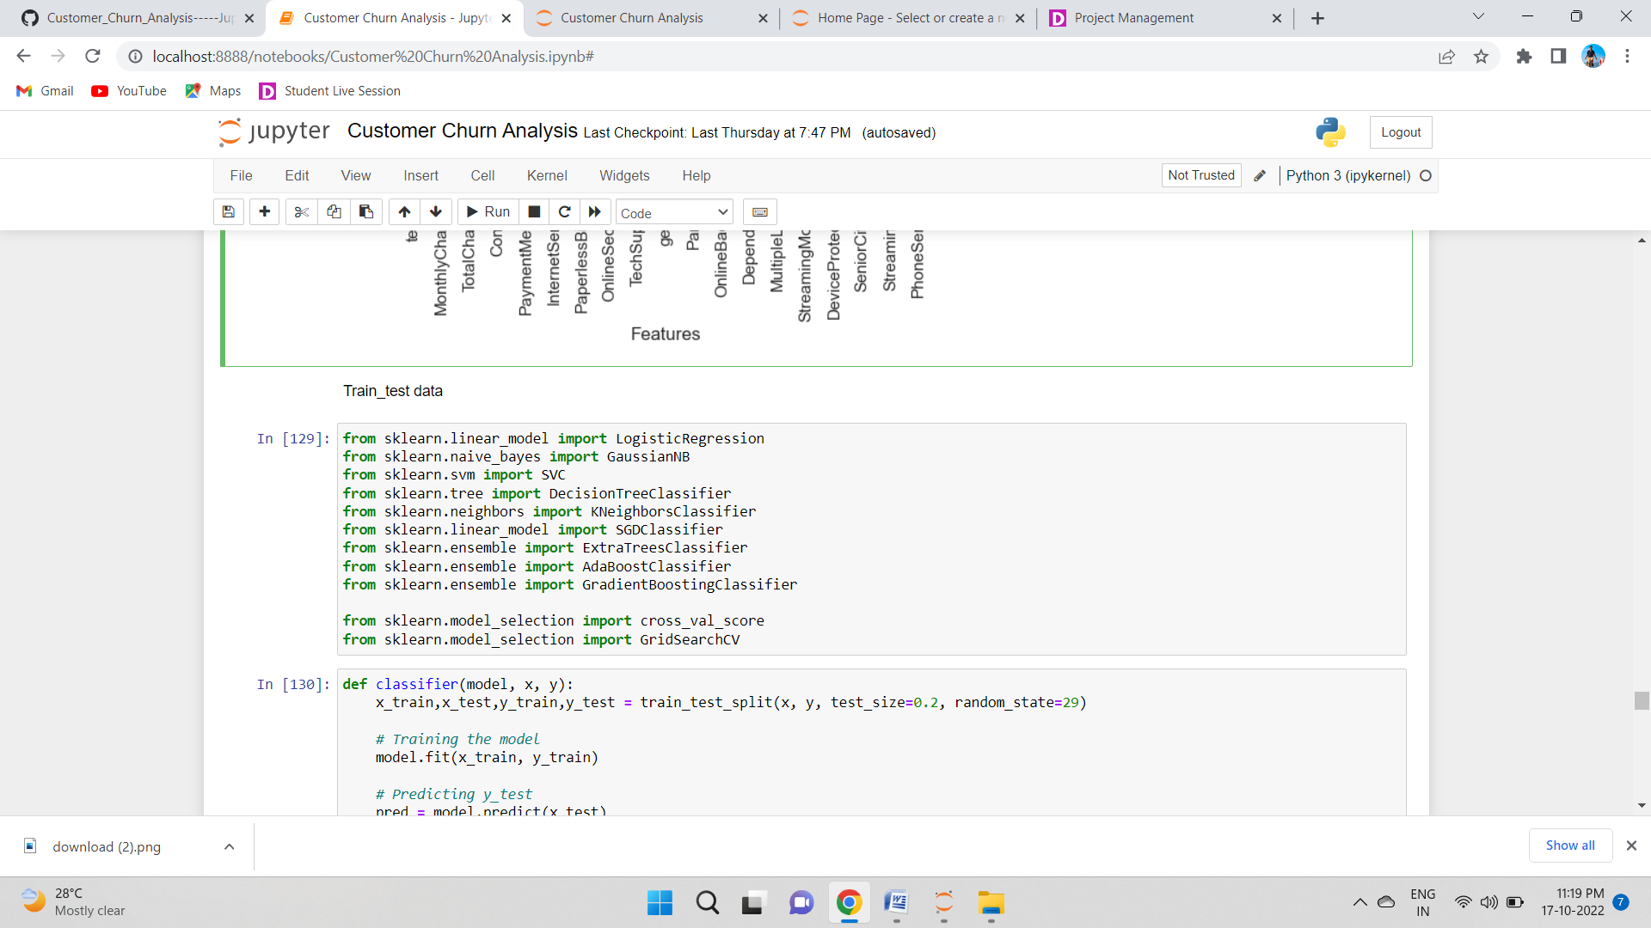

I have created a function which can be used for all the classifier machine learning algorithms and get the Accuracy score, Classification Report, Cross Validation Score and Accuracy Score - Cross Validation Score for comparison between all the algorithms for finding out the best suited algorithm for Hyper Parameter Tuning.

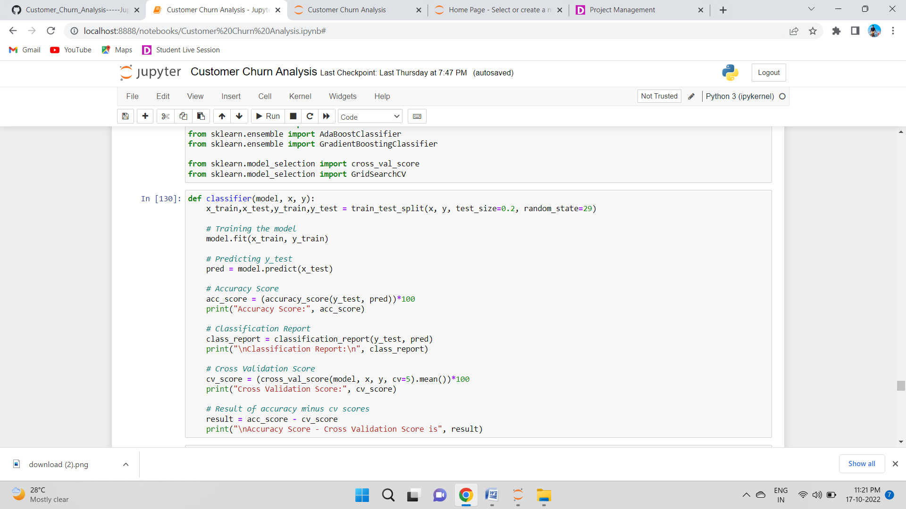

### Logistic Regression:

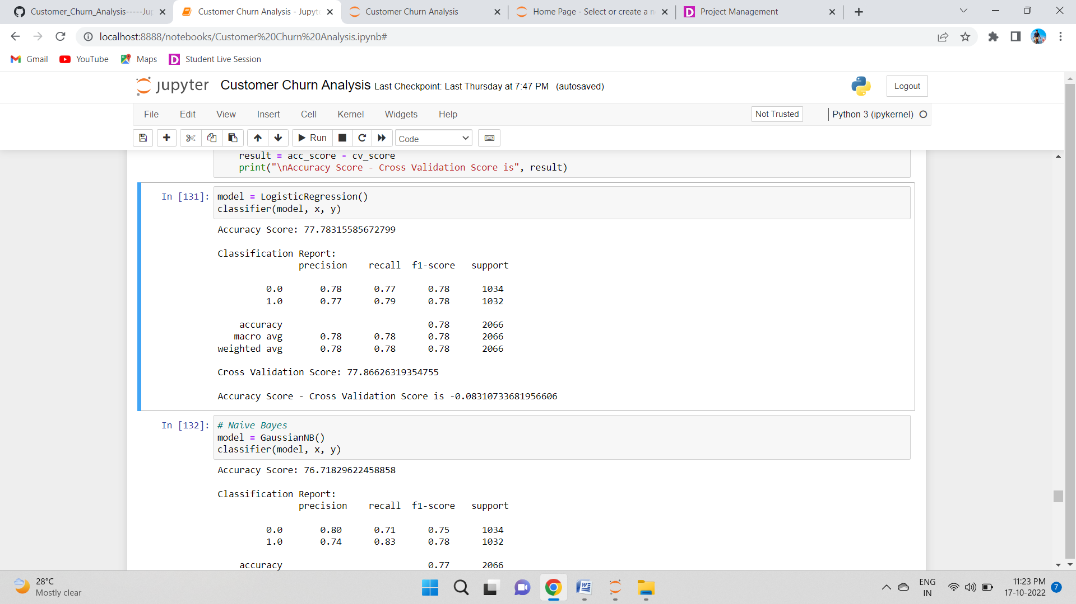

### Naive Bayes

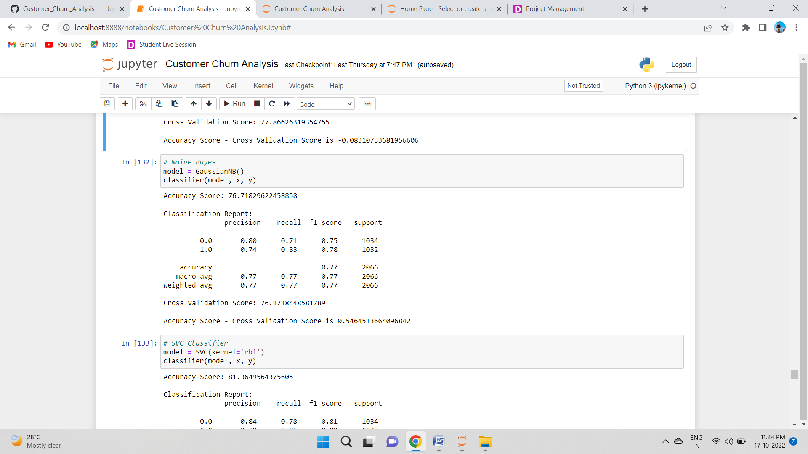

### SVC Classifier

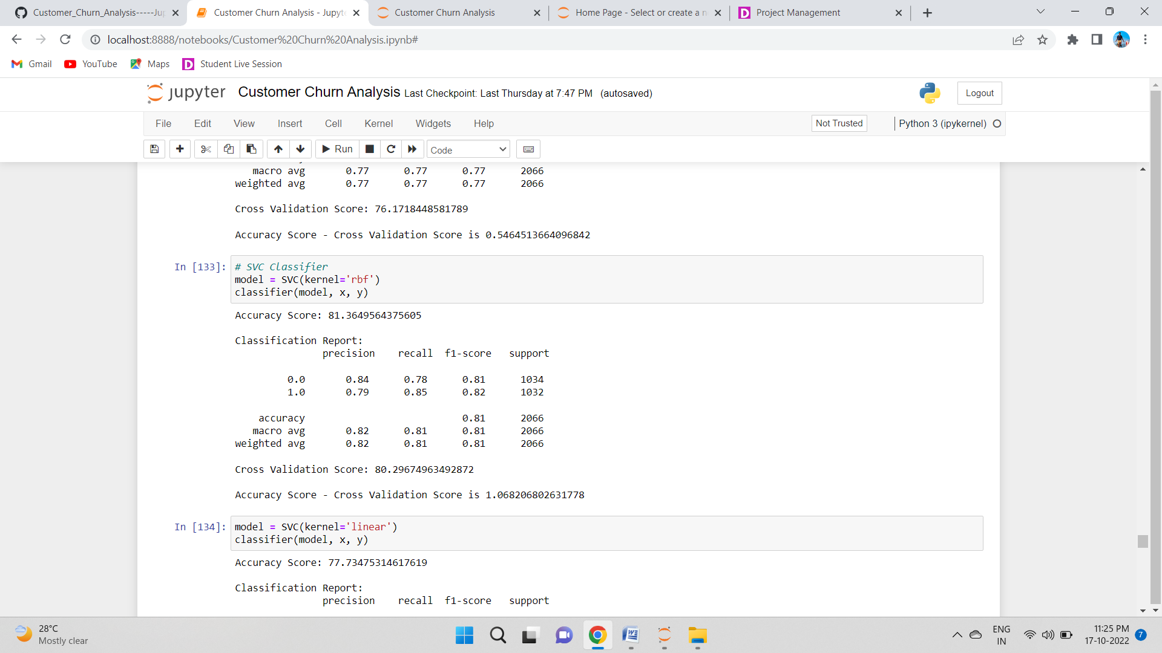

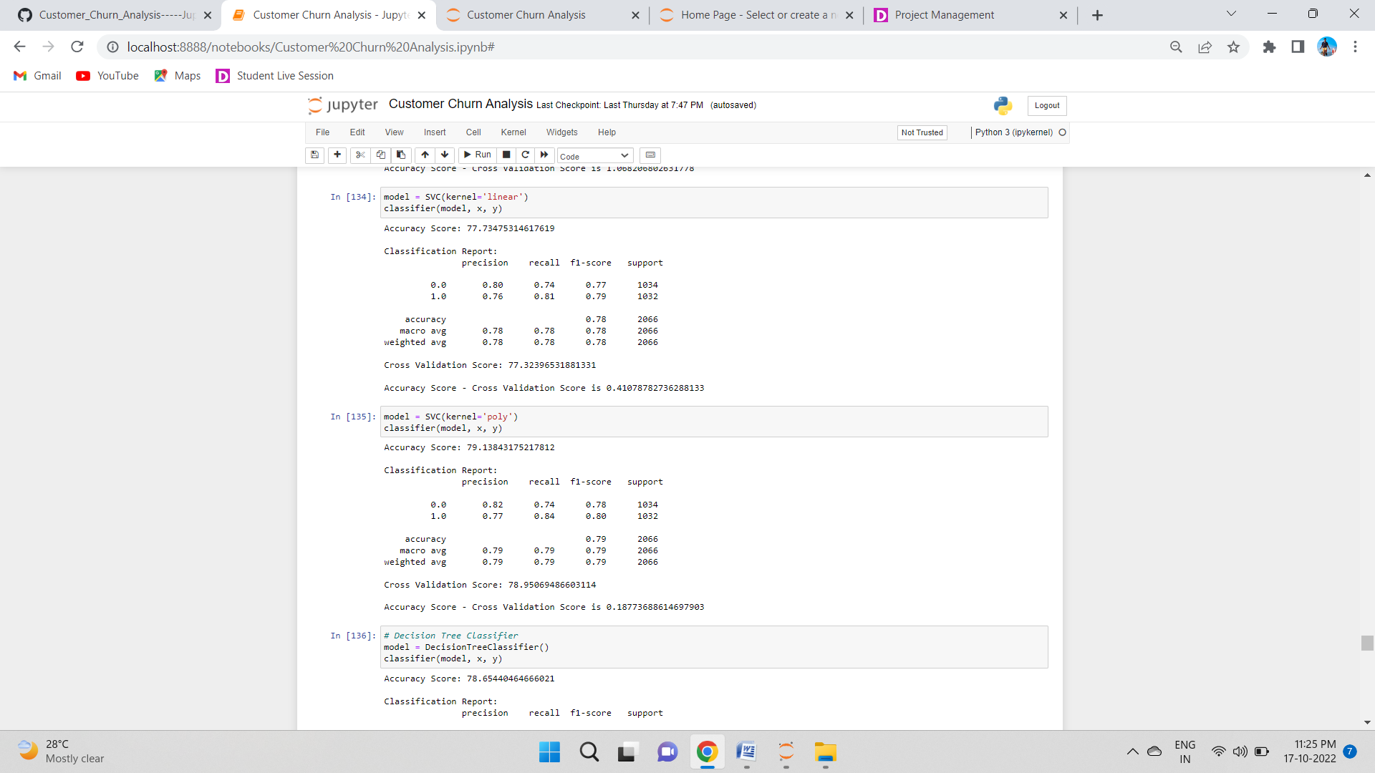

### KNeighbors Classifier

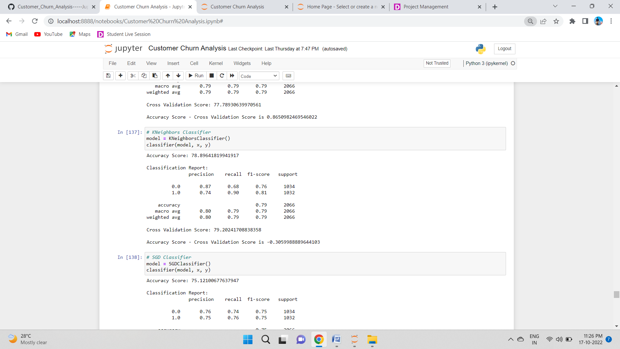

### Decision Tree Classifier

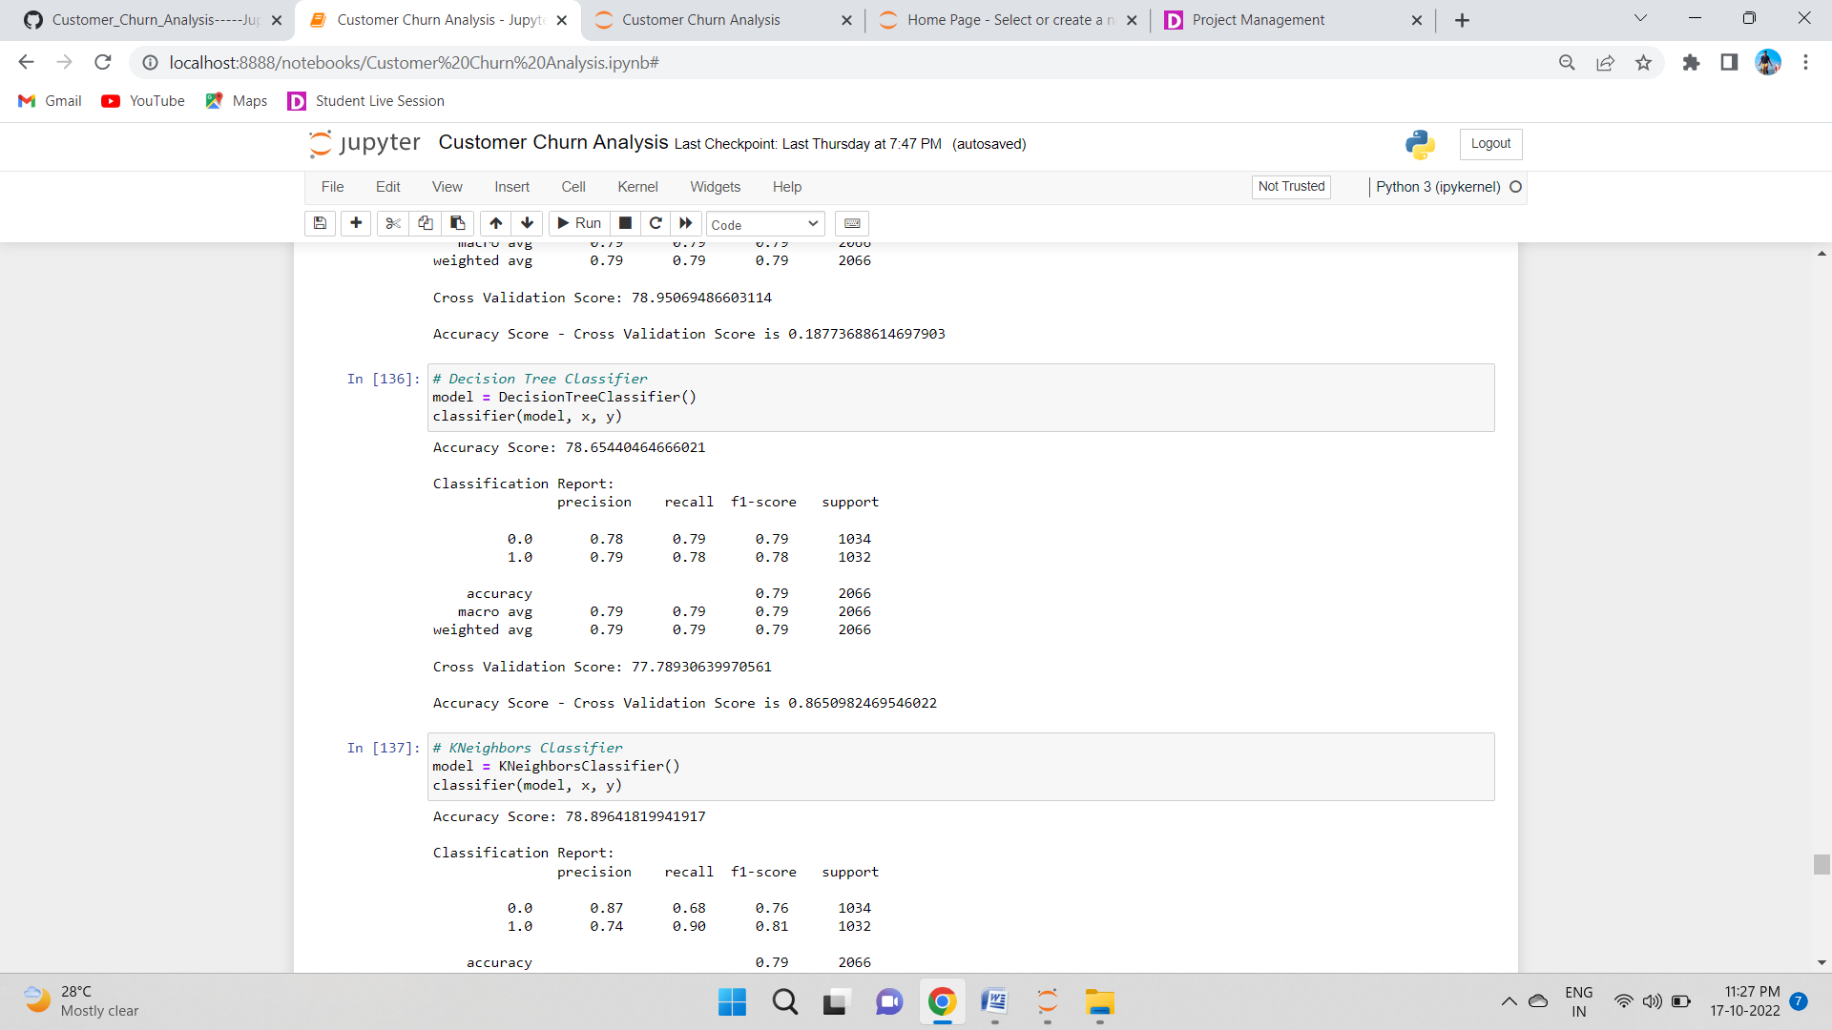

### SGD Classifier

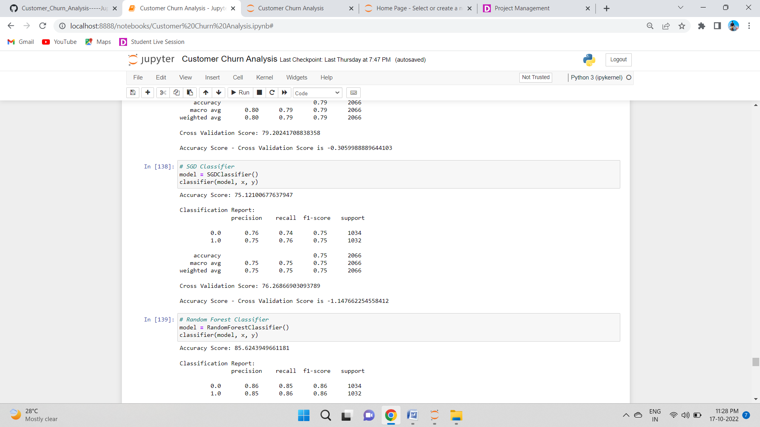

### Random Forest Classifier

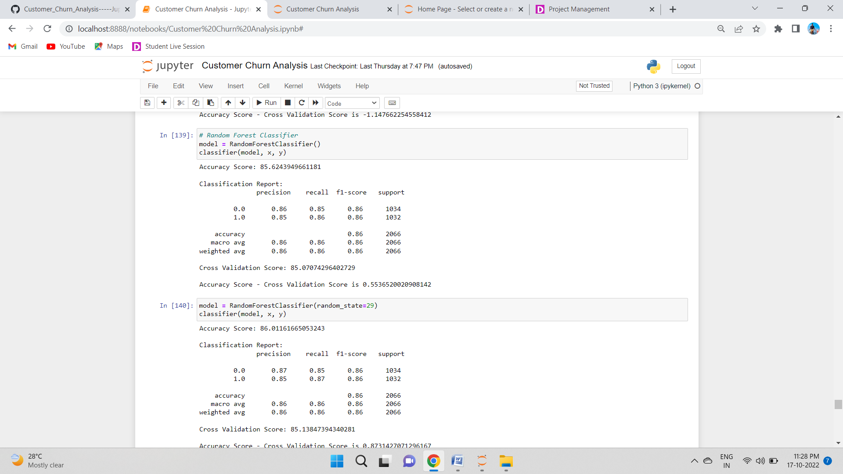

### ExtraTrees Classifier

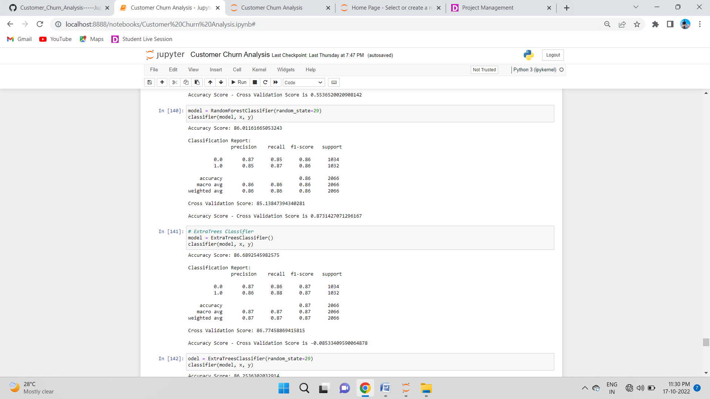

### AdaBoost Classifier

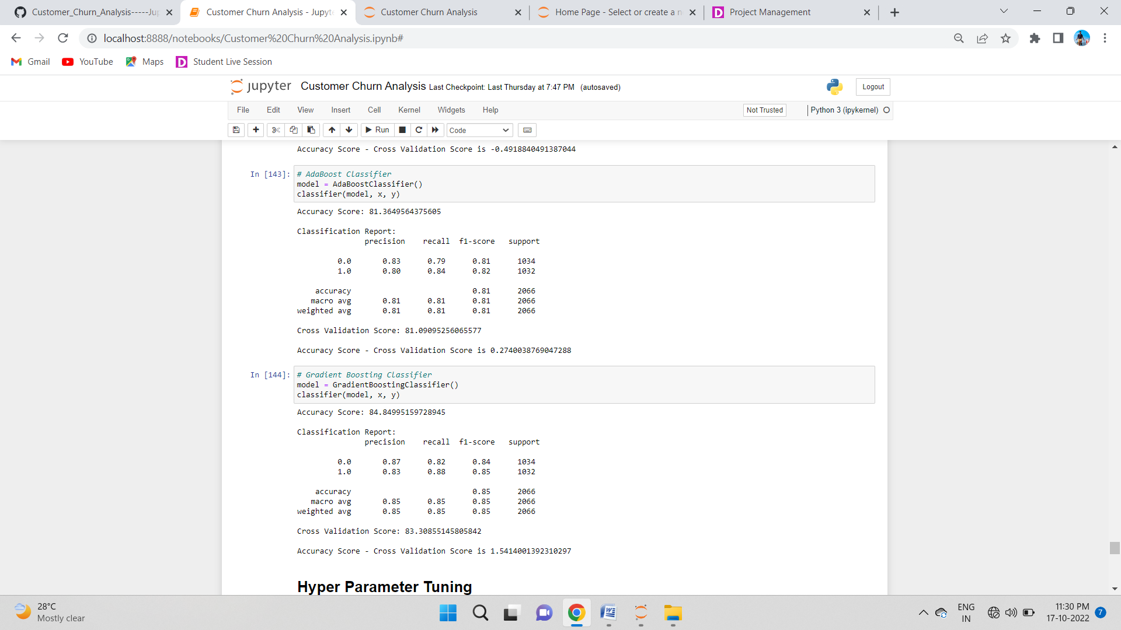

### Gradient Boosting Classifier

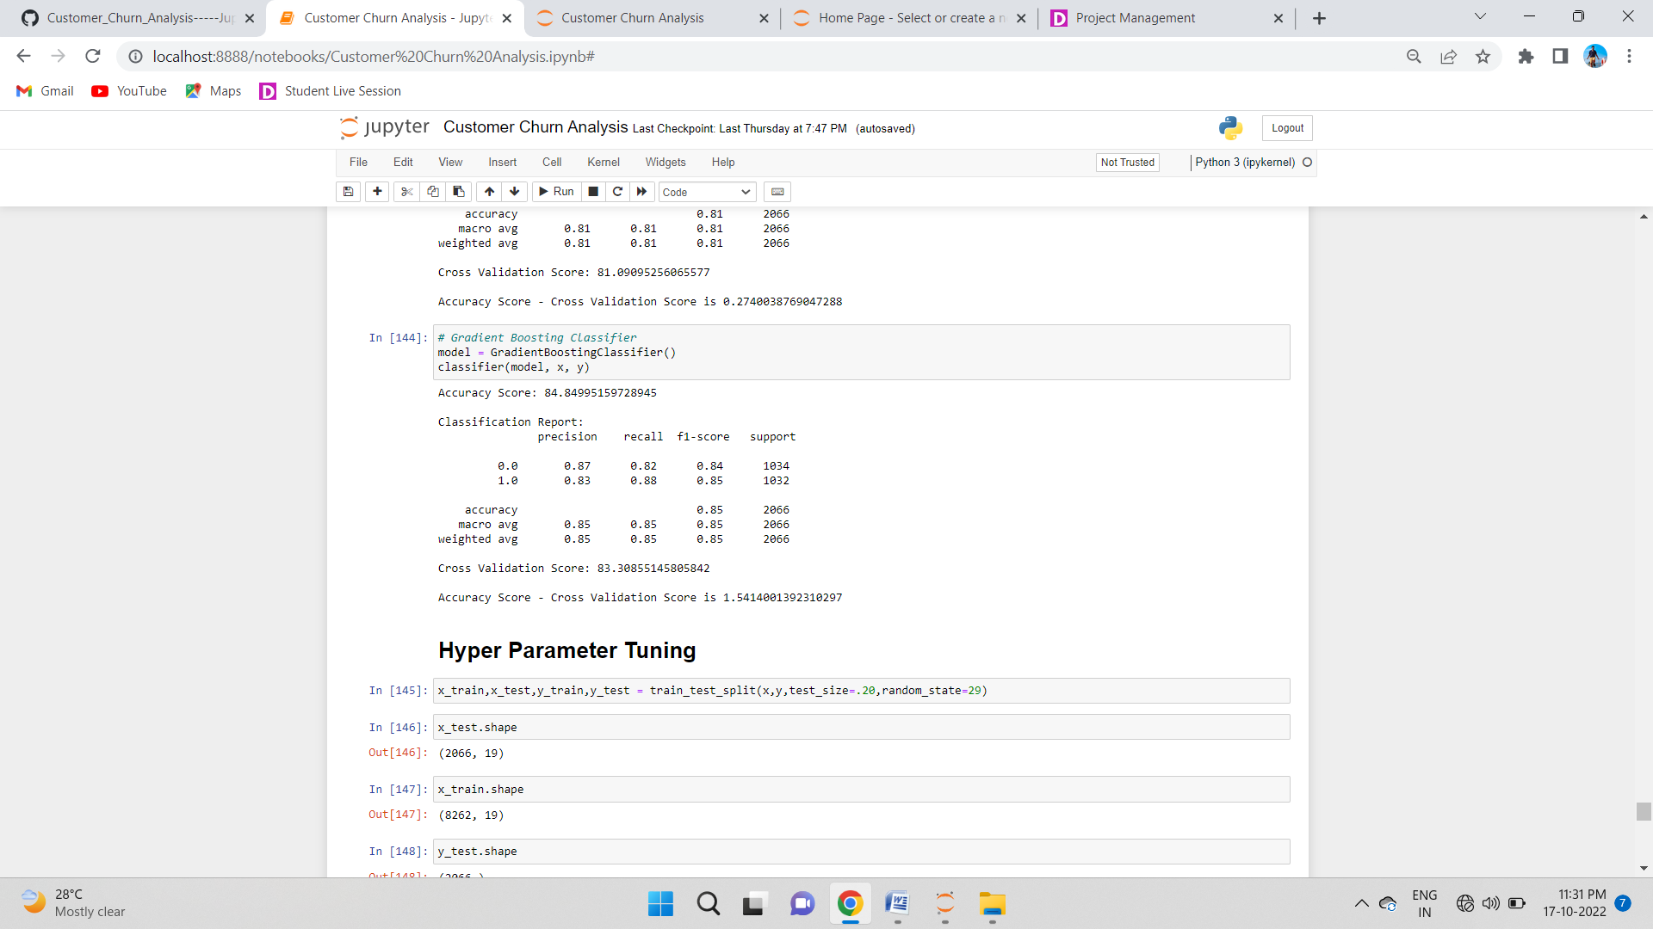

**Hyper Parameter Tuning**

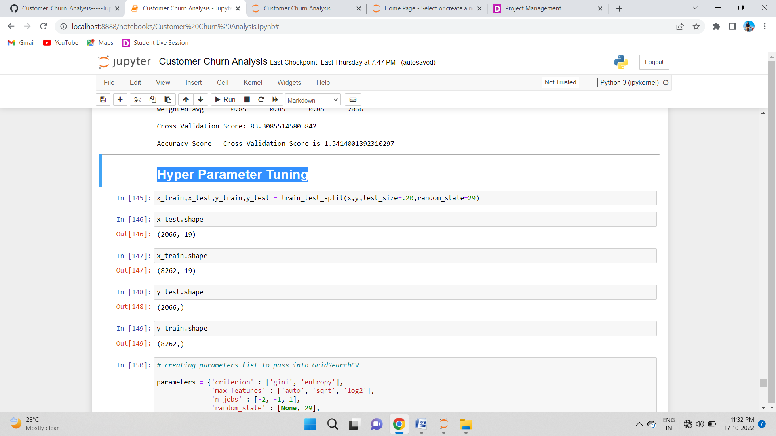

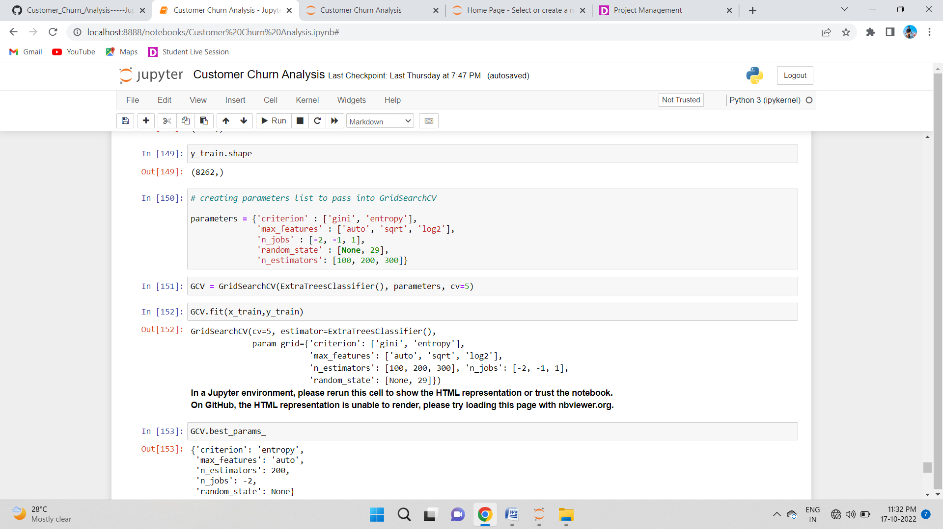

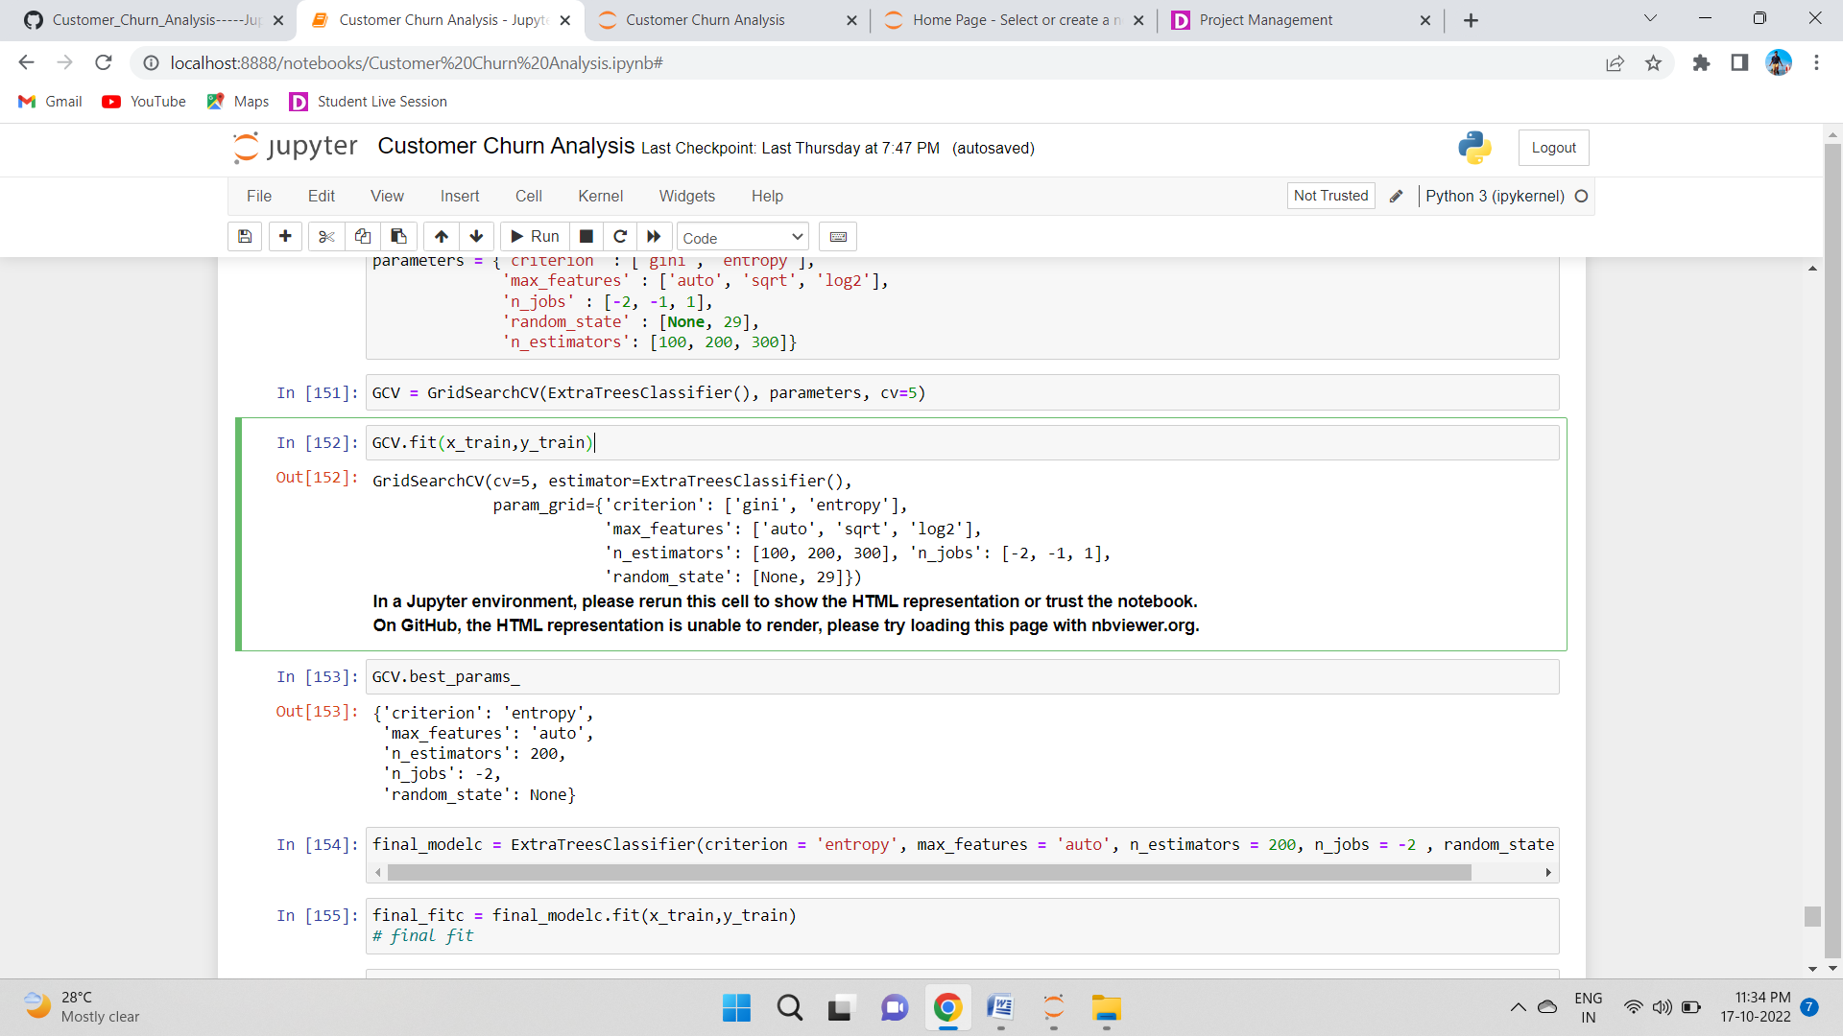

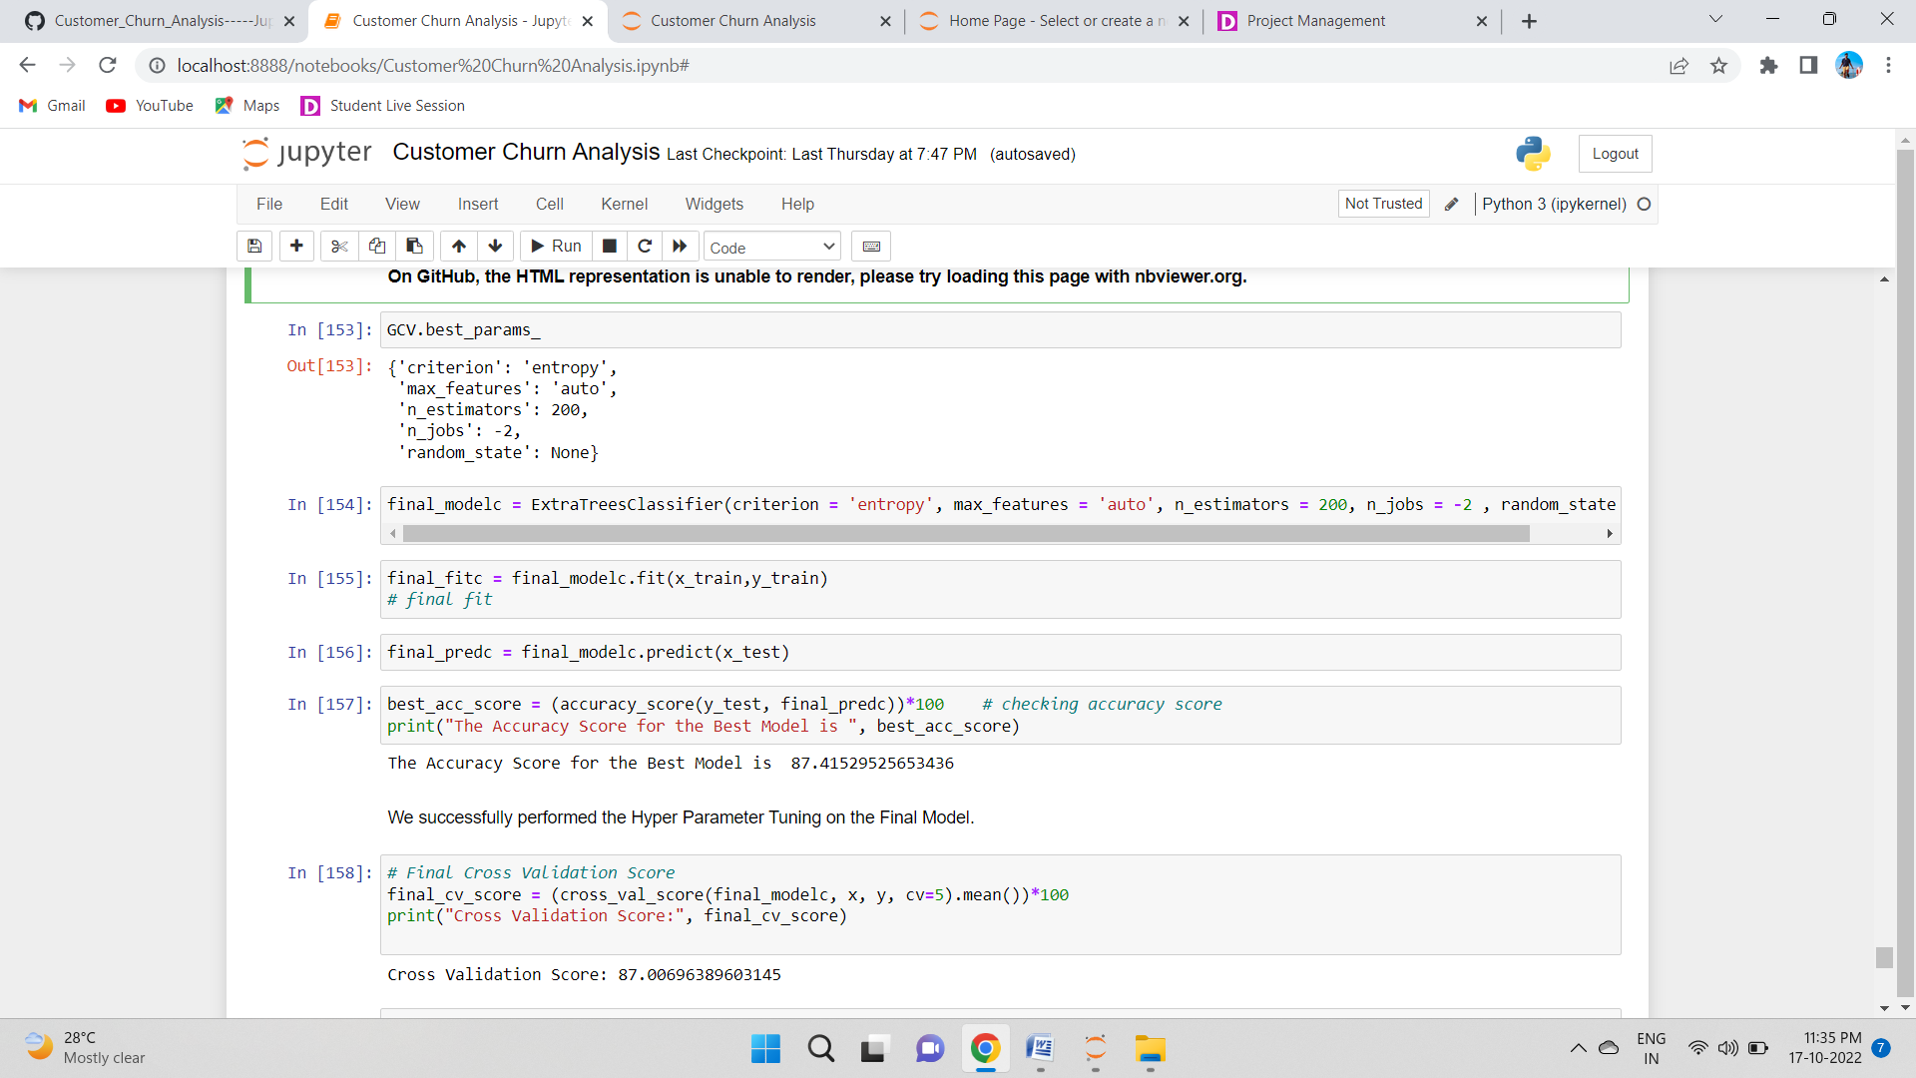

**We successfully performed the Hyper Parameter Tuning on the Final Model.**

## Confusion Matrix

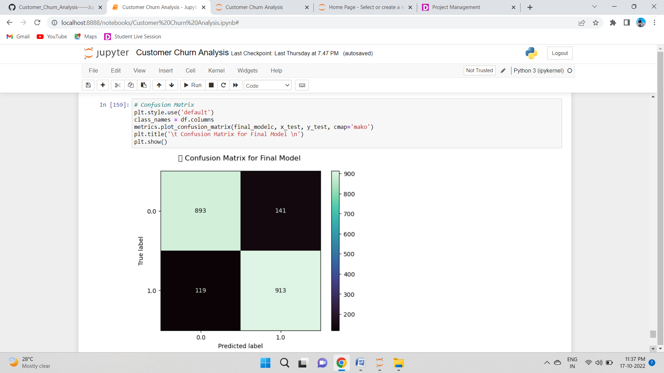

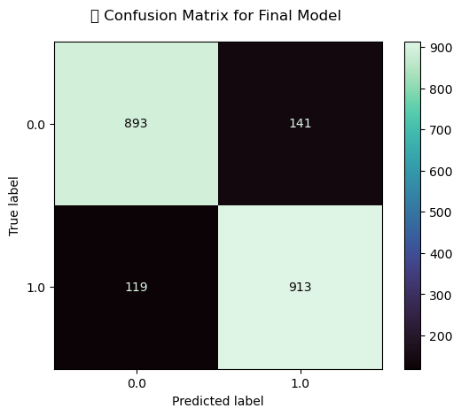

With the help of above confusion matrix I am able to understand the number of times I got the correct outputs and the number of times my ML model missed to provide the correct prediction (depicting in the black boxes).

# AUC ROC curve

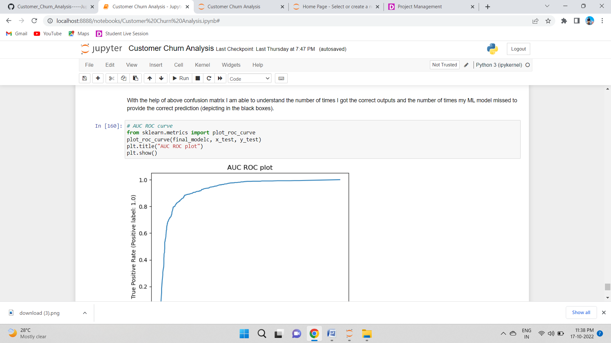

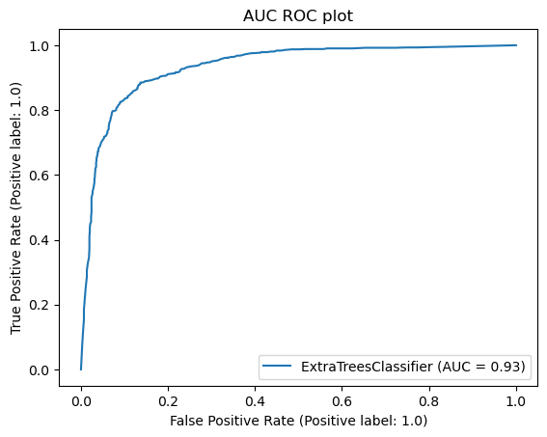

**AUC score is 0.93 which is really good.**

# Saving the model in pickle Format

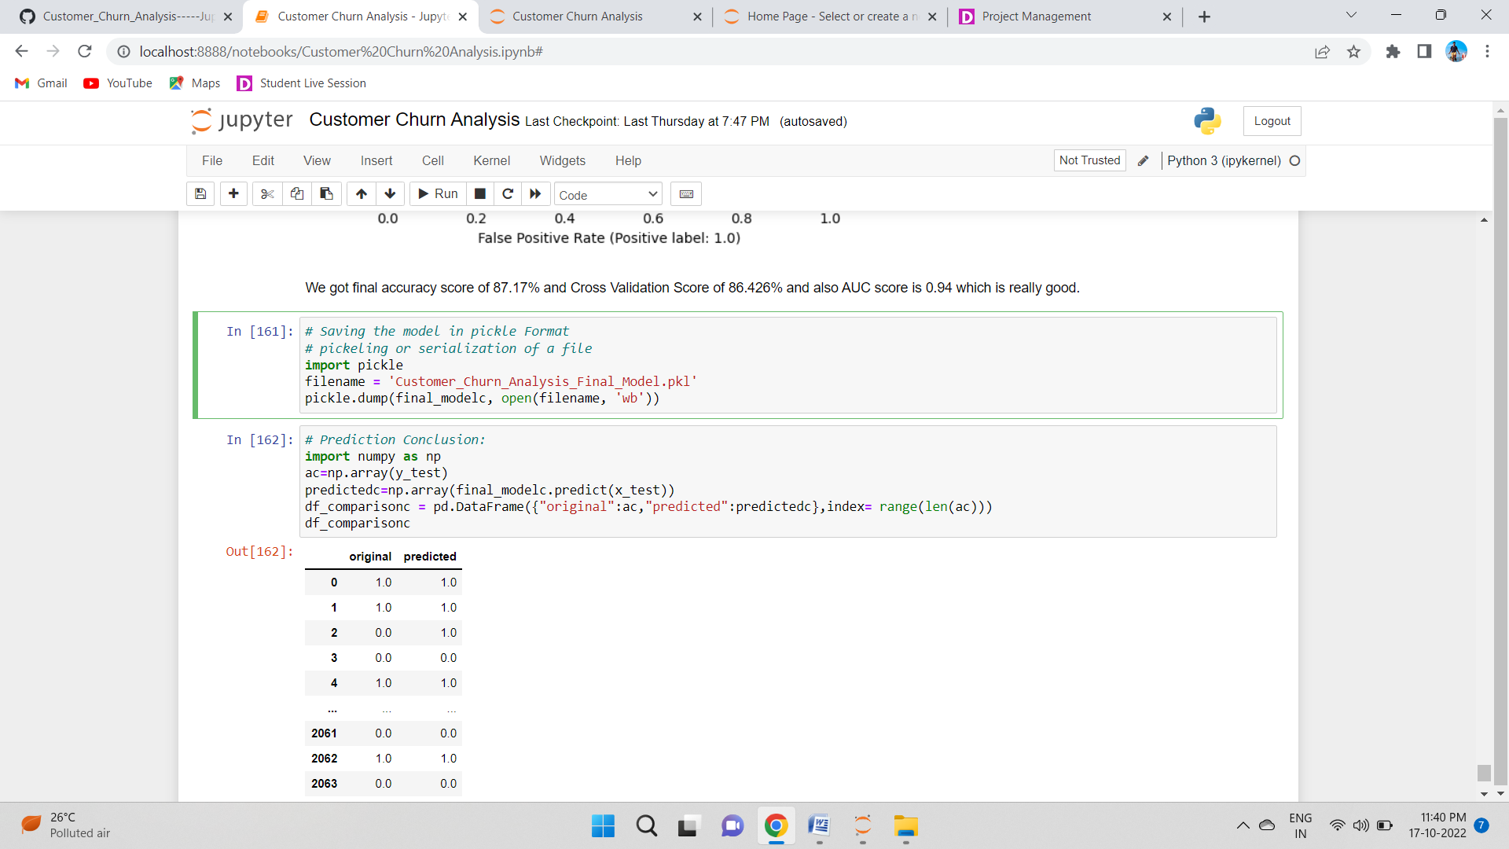

# Prediction Conclusion:

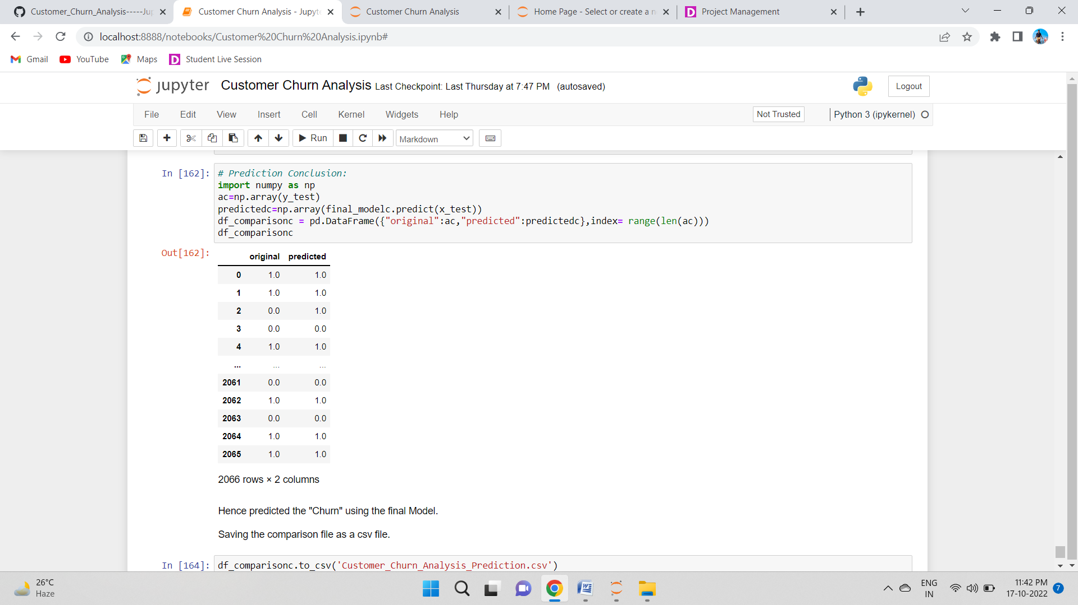

**Hence predicted the "Churn" using the final Model.**

**Saving the comparison file as a csv file.**

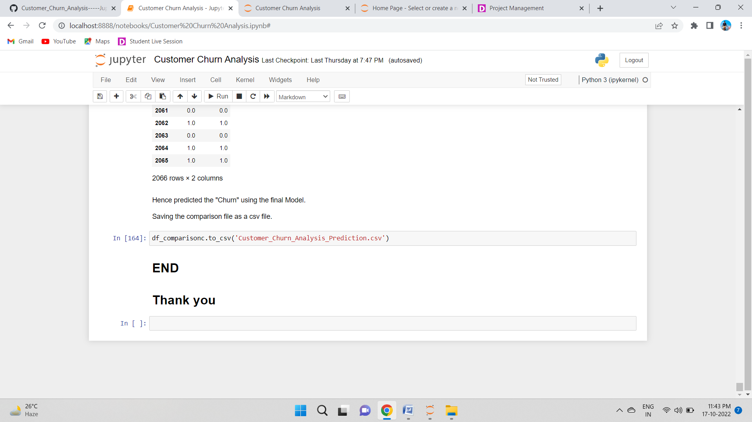

**Concluding Remarks**

In the beginning of the blog, we have discussed about the lifecycle of a Machine Learning Model, you can see how we have touched based on each point and finally reached up to the model building and made the model ready for deployment.

Let’s take a quick recap on all the steps that we went through starting from understanding the Problem Definition then going through the Data Analysis and EDA processes. We went through the necessary Pre-processing Data steps before the final Building Machine Learning Models step came into picture.

**THANK YOU**